**Advanced Business Intelligence**

**and Analytics**

**INFS 5135**

**Wednesday – Group A1**

**Analytic Report**

|  |  |
| --- | --- |
| **Student ID Number** | **Group Member Name** |
| HERKY010 | Hernandez Silveira,Kellen Veridiane |
| HUYTY042 | Huynh,Trung Hieu |
| NIEYY007 | Nien,Yi-Chi |
| SABAY023 | Sabharwal,Aniket |
| SHIMY033 | Shil,Mrittika |

**Date of Submission: November 2024**

TABLE OF CONTENTS

1. Introduction 7

2. Background and motivation 7

3. Material for analysis 8

Data cleaning 9

4. Challenges 9

5. Analytic approaches 10

Logistic regression 10

Light Gradient Boosting Machine 12

Apriori Association Rule Mining Model 13

* Data preparation 13
* Association Rule Mining 13
* Model Specific Controls 14
* Adjustments to Plan 16

K-means Clustering 16

* Data preparation 13
* Association Rule Mining 13
* Model Specific Controls 14

Process mining 17

6. Deployment 20

Presentation of findings | Logistic Regression 20

Presentation of findings | Light Gradient Boosting Machine 21

Presentation of findings | Apriori Association Rule Mining 25

* Confidence of Skill Combinations 25
* Lift for Skill Combinations 26
* Conclusion of Findings 27
* Resulting Model 28

Presentation of findings | K means Cluster Analysis 28

Presentation of findings | Process mining 28

Interpretation of findings | Logistic Regression 34

Interpretation of findings | Light Gradient Boosting Machine 36

Interpretation of findings | Apriori Association Rule 37

* Key Insights from the Analysis 37

Communication and Project Management 37

Business Analysis and Requirements Gathering 37

Business Analysis and Data Analysis 38

Business Analysis and Project Management 38

Communication and Business Analysis 38

* Strengths, Weaknesses and Improvements of Model 38

Strengths: 38

Weaknesses: 39

Possible Improvements: 39

Final Thoughts 39

Interpretation of findings | K- means Cluster 39

Interpretation of findings | Process mining 40

7. Recommendations 41

Implications for Job Seekers 41

Implications for Employers 41

8. References 42

9. Appendices 43

APPENDIX A 43

APPENDIX B | Task Allocation 44

APPENDIX C | Data Dictionary 44

APPENDIX D | Kellen V. H. Silveira – HERKY010 49

Appendix D.1 | Process Mining - Analysis 49

Appendix D.2 | Process Mining - Result of analysis 52

Appendix D.3 | Process Mining - Interpretation of your findings 58

APPENDIX E | Aniket Sabharwal, Sabay023 59

APPENDIX E.1 | Background and Motivation 59

APPENDIX E.2 | Material for Analysis 60

APPENDIX E.3 | Analytical Approach 61

APPENDIX E.4 | Results and Findings 65

APPENDIX E.5 | Interpretations 69

APPENDIX E.6 | Strengths, Weaknesses and Improvements of Model 70

APPENDIX E.7 Recommendations 71

APPENDIX E.8 | Final Thoughts 71

APPENDIX F | Ethan Nien - nieyy007 72

Appendix F.1 | Background and motivation 72

Appendix F.2 | Data Description 72

Appendix F.3 | Data Preparation 73

Appendix F.4 | Model Building 77

Appendix F.5 | Analysis Results and Findings 80

Appendix F.6 | Model Performance Interpretations 84

Appendix F.7 | Final Thoughts 85

Appendix F.8 | Recommendations 85

APPENDIX G | Mrittika Shil , Shimy033 87

APPENDIX G.1 | Background and Motivation 89

APPENDIX G.2 | Material for Analysis 90

APPENDIX G.3 | Analytical Approach 91

APPENDIX G.4 | Results and Findings 95

APPENDIX G.5 | Interpretations 99

APPENDIX G.6 | Strengths, Weaknesses and Improvements of Model 100

APPENDIX G.7 Recommendations 101

APPENDIX G.8 | Final Thoughts 101

APPENDIX H | Trung Hieu Huynh 102

Appendix H.1 | Analysis – Logistic regression 103

Appendix H.2 | Evaluation metrics 109

Appendix H.3 | Interpretation of your findings 115

List of Figures

|  |  |
| --- | --- |
| ***List of Figures*** | ***Page Number*** |
| Figure 1 - Data before cleaning | *7* |
| Figure 2 - Data after Refinement | *8* |
| *Figure 3: Using Python for Data Processing, Modelling, and Evaluation* | *11* |
| *Figure 4: Parameter settings of training model for Binary classification* | *13* |
| *Figure 5: Parameter settings of training model for Multiple classification* | *13* |
| *Figure-6: Data preparation* | *14* |
| *Figure 7- Association Rule Learner* | *16* |
| *Figure 8 - Table Set Finder* | *17* |
| *Figure-9: Output table* | *19* |
| *Figure-10: K-means Cluster model fit* | *20* |
| *Figure-11: Model Specific controls* | *21* |
| Figure 12: High-level visual of process mining | *22* |
| Figure13: Job Posting Process | *24* |
| Figure 14 - The most demanded skills for hiring business analyst | *25* |
| Figure 15: Confusion matrix for Associate level in Binary classification | *26* |
| *Figure 16: Feature importance analysis: Top 10 skills* | *27* |
| *Figure 17: Multi-class classification results* | *28* |
| *Figure 18: Multi-Class Classification* | *30* |
| Figure 19 – Association rules Results | *30* |
| *Figure 20 - Confidence Levels for Skill Combinations* | *31* |
| Figure 21 - Lift for Skill Combinations | *32* |
| Figure 22 – K-means Results | *34* |
| *Figure-23: labelled input used for iterations* | *34* |
| *Figure-24: Elucidian Measurement* | *35* |
| Figure 25: Distance matrix | *36* |
| *Figure-26: Scatter plot* | *37* |
| *Figure-27: Sunburst Chart* | *38* |
| *Figure-28: Histogram for Normalization* | *39* |
| *Figure 29: Top 10 Job Positions Related to BA* | *42* |
| *Figure 30: Hourly Time Distribution of Processed Jobs* | *43* |
| Figure 31- One hiring position requires Project management, analysis, and communication skill. | *47* |

List of Tables

|  |  |
| --- | --- |
| ***List of tables*** | ***Page Number*** |
| *Table 1: Frequency-based Top 10 skills for Business Analyst at all job levels* | *12* |
| *Table 2: Classification model parameters* | *13* |
| *Table-3: Cluster with skillset* | *18* |
| *Table 4: Model Accuracy for different job levels and skill sets* | *26* |
| *Table: 5: Cronbach Alpha* | *36* |
| *Table: 6: Numeric Scores* | *36* |

# **Introduction**

This research is a continuation of our original study, which focused on hiring patterns for business analyst positions in the United States. In this detailed research, we went deeper into market dynamics using a variety of modelling techniques to provide different viewpoints based on present job market. With in depth analysis of the market, we have tried to fit five different models. Our aim is to provide the US Consulting Company with the insights they need to properly navigate the developing industry and provide relevant consulting. The basic metrics we will explore for this project are:

* understanding combination of skills and discover patterns like which skills are commonly required together
* uncover relationships between job levels and required skills.
* explore trends over time or other continuous variables and how it fluctuates
* understanding the flow of operations. For job market analysis, you can apply this to understand how companies' hiring processes evolve over time or how job roles progress within companies
* classify data and find patterns. These techniques would be useful to segment jobs based on job level, geographical region, and skill sets

# **Background and Motivation**

The US consulting firm seeks insights into the U.S. job market for Business Analyst roles with the primary goal to analyse job postings from LinkedIn to uncover key trends, such as the most in-demand skills, top hiring companies, and geographic distribution of job listings in the United States. Our models particularly Association Rule Mining emphasizes on identifying the frequent skill combinations using to provide a deeper understanding, K-means cluster analysis for skill segmentation, process mining to understand the hiring trend , logistic regression to explore relationship between variable and prediction of fluctuation and decision tree for classifying the different variables to find out the ideal skill sets for Business Analyst positions in the United States market as well the trends of these associated skills. By understanding these their relevant metrics, the US Consulting firm can then tailor their strategy to match the industry requirements.

# **Material for Analysis**

The data extracted from LinkedIn needed to be cleaned and filtered in accordance with the scope of our analysis. All the refinement of the data was done using Knime. The data was first cleaned by removing all the redundant columns and joined using the Job Links which can be observed in Figure 9 - Data before cleaning. The data after cleaning was filtered in accordance with our scope, which gave us data on Business Analyst roles in the United States.

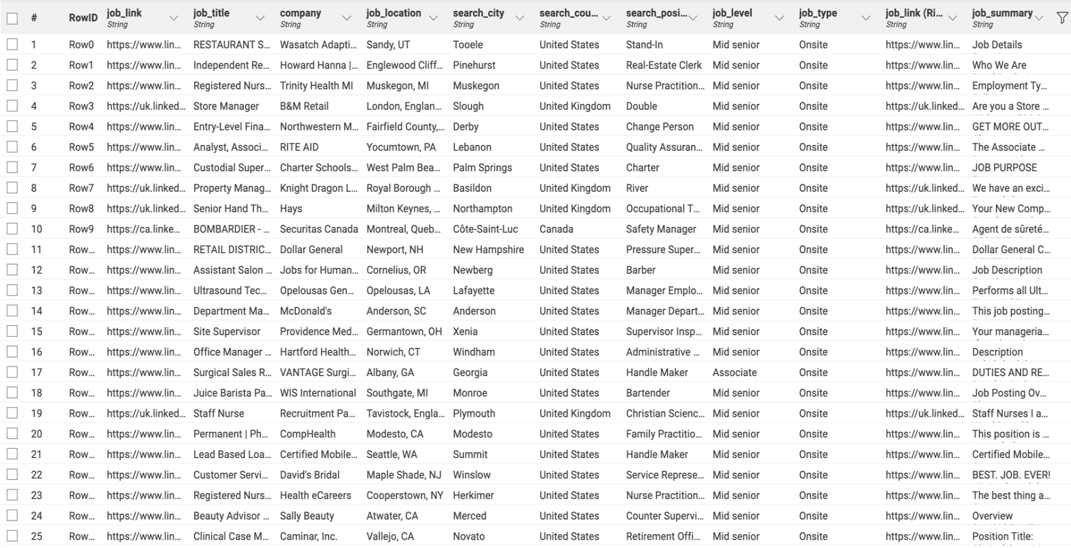

Figure 1 - Data before cleaning

Now that the data was cleaned and filtered, the data was modified in accordance with the relevant models as each model requires data to be modified in different ways. The refined table that was used for all models has been shown in Figure 2 - Data after Refinement.

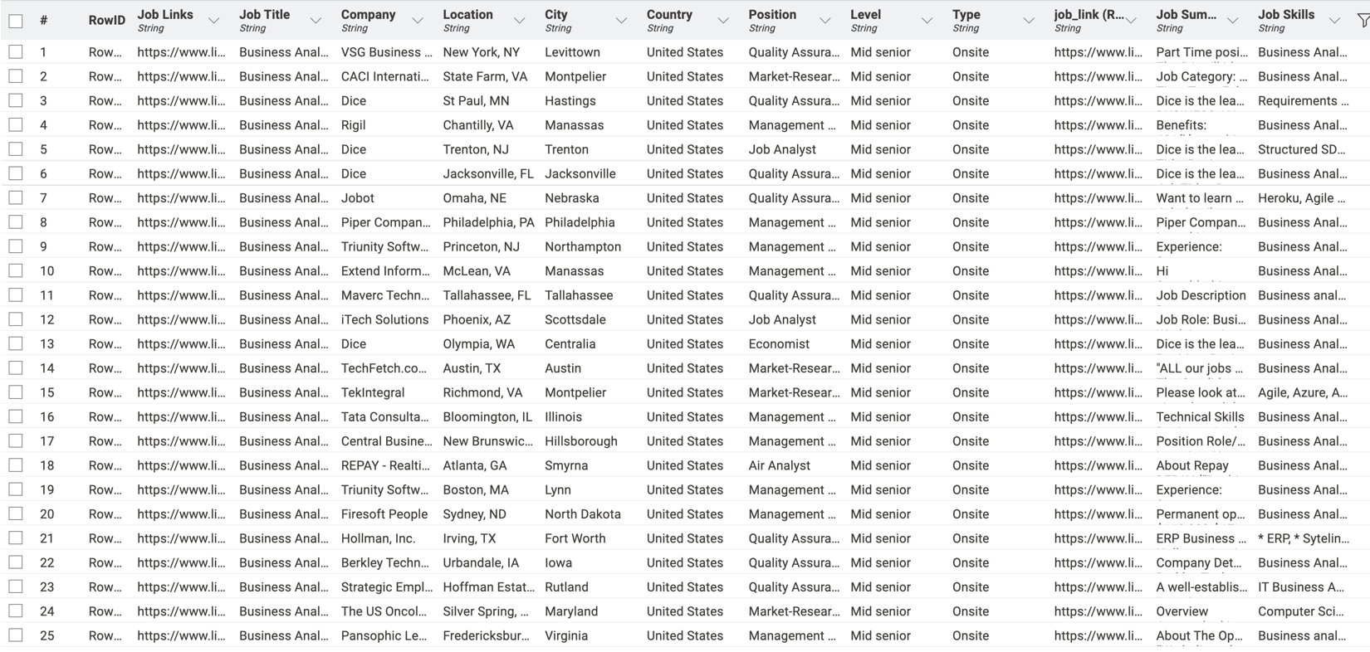

Figure 2 - Data after Refinement

The output could now be used to identify the item set based on the Apriori Algorithm. Once we have the output from the item set finder based on the Apriori Algorithm, we can use it to fabricate results based on our scenario by setting the relevant controls.

# **Challenges**

To handle this project from data cleansing to deployment, we faced so many problems.

1. The first problem we faced is data cleansing. In our A1 report, we followed similar approach to clean our data to make it useful, for developing the model, we went to separate ways based our four different models which was quite challenging.
2. The second challenge was managing data quality, integration, and usability while aligning with business objectives and models.
3. The third challenge was selecting the right model based on our data set and transforming different categories (Numeric/ qualitative) and fitting into the model. Thousands of trials and errors done with the data set and with the model. Confusion arises when we are trying to test and evaluate the results with our pre decided metrics.
4. The 4th challenge of this project is skill gaps, time limitation and scheduling conflicts and we applied technical and strategic skills to make this project successful. To develop the proper interpretation, we went through research paper what was worthful but time consuming.
5. The 5th challenge was selecting the right tool. Initially we wanted to work on KNIME, but for some models we could not develop any metrics and later we approached to other tools (Python/ Weka).
6. The 6th challenge, every model has their own limitations and challenges implementing the model and developing case-based interpretation.

The other challenges, including managing large volumes of data, decomposing the list of skills into usable formats, and matching those skills to the respective job descriptions. The comprehensiveness of data set is also questionable and ask for adding / joining new data set which might not relevant to the current models.

# **Analytic Approaches**

In this analytic approach, we will present our models developed by each of the group members and analyse and interpret the finding and resulting models.

## 5.1 Logistic regression

Logistic Regression (or Logit Model) is a popular used statistical for binary classification tasks, where the goal is to predict one of two possible outcomes (e.g., yes/no, true/false) (Easter H and Hemming K, 2021). It is also a strong technique for measuring the relative relevance of factors that influence outcome (Pal, 2021). Logistic regression can help do a quite range of mission such as analysing customer data to identify factors that influence purchasing decisions, weather forecasting for special events, and identifying the risk in financial services like loan defaults or fraudulent transactions (Resonio, n.d).

Logistic regression is different from linear regression as the latter utilizes continuous variables for its targets, while logistics regression focuses on a binary value or categories. And there are three types of logistic regression: binary, multinomial, and ordinal (Ramakrishnan, 2024).

Binary: Predicts the relationship between a binary dependent variable (e.g., success/failure, yes/no) and an independent variable.

Multinomial: Analyzes a dependent variable with two or more discrete outcomes (e.g., predicting the most popular transport type: train, bus, car, bike).

Ordinal: Examines a dependent variable with a meaningful order and two or more categories (e.g., shirt size: S/M/L/XL or poll options: Agree/Disagree/Neutral).

Logistic regression will determine the job title, whether a business analyst is or not, based on the required skills in hiring advertisements.

## 5.2 Light Gradient Boosting Machine

LightGBM (Light Gradient Boosting Machine) is a decision tree-based boosting algorithm known for its efficiency in processing large-scale data sets and high-dimensional features. Unlike a single decision tree, LightGBM improves prediction accuracy by integrating multiple decision trees while maintaining strong interpretability of features. Research by Liu et al. (2021) indicates that LightGBM adopts the histogram algorithm in the feature selection of the decision tree and the determination of the segmentation point. This approach bins the original continuous feature values and uses these bins to construct the model, which significantly reduces the time consumption of split point selection and improves both training and prediction efficiency. Due to these advantages, this analysis uses Python and LightGBM as the primary tools for predicting job levels based on skill dataset. The below screenshot as Figure e shows the process of conducting research using a Python script.

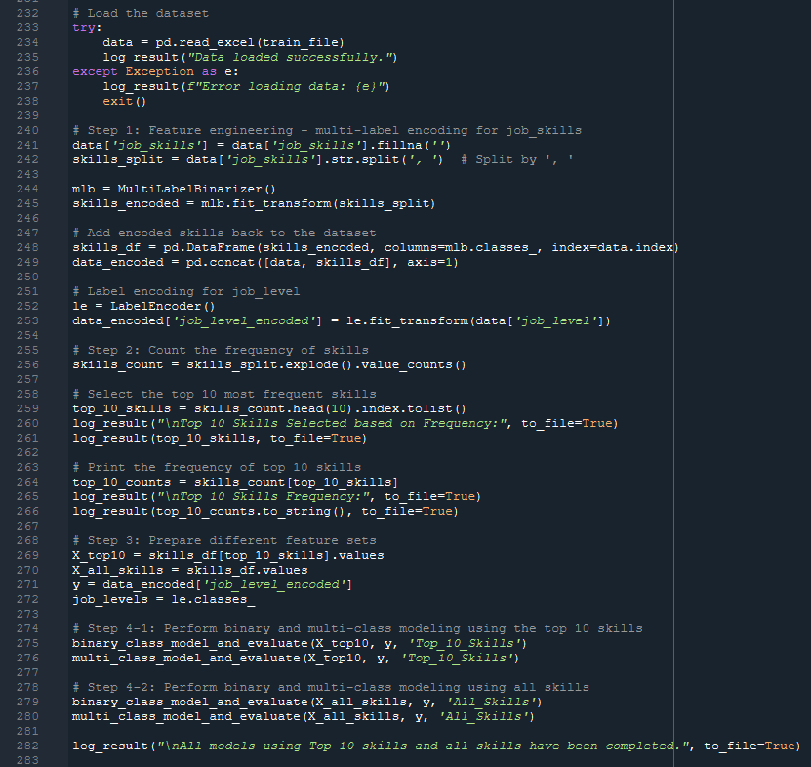Figure 3: Using Python for Data Processing, Modelling, and Evaluation

**Feature Engineering:**

Since the skill field is a text data type, in the feature engineering stage, this method needs to encode it and build features so that the model can better understand and predict the impact of different skill combinations on job levels.

**Top 10 skills**

To streamline the analysis and emphasize the most relevant skills, this approach identifies the top 10 skills based on their frequency within the dataset. By prioritizing these high-frequency skills, the analysis aims to handle class imbalance, reduce noise, select meaningful features, and ultimately enhance model performance. These top 10 skills will also be used to compare with the model for all skills, with the top 10 skills selected and their respective frequencies as follows (see Table 1):

|  |  |
| --- | --- |
| Skill | Count |
| Business Analysis | 855 |
| Communication | 705 |
| Project Management | 663 |
| SQL | 622 |
| Data Analysis | 553 |
| Agile | 328 |
| Requirements Gathering | 324 |
| Problem Solving | 323 |
| Teamwork | 302 |
| Business Analyst | 289 |

Table 1: Frequency-based Top 10 skills for Business Analyst at all job levels

Through LightGBM's feature importance analysis, this modelling approach is able to identify the most influential skills, providing valuable references for companies to formulate recruitment strategies and optimize job seekers' skills improvement.

**Model selection and training**

This model aims to predict the job skills required at different job levels using both binary and multi-class classification models with the parameter 'objective'. The binary classification models focus on distinguishing a specific job grade from other grades to identify key characteristics that best reflect the skill requirements of the position. In contrast, the multi-class classification model predicts all job levels simultaneously, offering a comprehensive view of the hierarchical distribution of job levels and their associated skill characteristics. Both classification methods divide the data set into training and test sets in a ratio of 80:20 to ensure that the class distribution of the two data sets is balanced.

**Key Parameters Selection**

The following parameters, listed in Table 2, are used in this method to ensure the model's adaptability to different classification tasks:

|  |  |  |  |  |
| --- | --- | --- | --- | --- |
| Parameter | | Definition | Usage | |
| objective | | Specifies the type of learning task. | 'binary': For binary classification. | |
|  |  | 'multiclass': For multi-class classification  (predicting multiple job levels simultaneously). | |
| num_class | | Indicates the number of the target class. | The value is to match the dataset's unique job levels. | |
| random_state | | Controls the randomness for reproducibility. | Set 42 to ensure consistent results across multiple runs. | |

Table 2: Classification model parameters

The following screenshots f-1 and f-2 show the actual parameter settings used for training the model in the Python script:

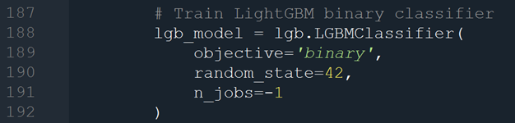

Figure 4: Parameter settings of training model for Binary classification

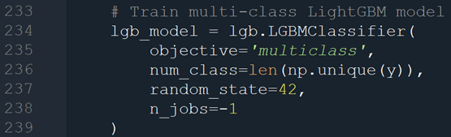

Figure 5: Parameter settings of training model for Multiple classification

## 5.3 Apriori Association Rule Mining Model

The Apriori Association Rule Mining Model was used to get the top 5 skill combinations for the given dataset.

## Data Preparation for the model

## Figure-6: Data preparation

The data extracted from LinkedIn needed to be cleaned and filtered in accordance with the Apriori Association Rule Mining Model. All the refinement of the data was done using Knime. The data was first cleaned by removing all the redundant columns and joined using the Job Links. The data after cleaning was filtered in accordance with our scope, which gave us data on Business Analyst roles in the United States.

Now that the data was cleaned and filtered, the data was modified in accordance with the Apriori Association Rule Mining which required the job skills to be interpreted as a single transaction, but the current dataset has skills mentioned as ‘string’. We split the skills as converted the output as a list which could now be used for the association model. (Kantardzic, 2019)

The output could now be used to identify the item set based on the Apriori Association Rule Mining. Once we have the output from the item set finder based on the Apriori Association Rule Mining, we can use it to fabricate results based on our scenario by setting the relevant controls.

### Association Rule Mining

We applied Apriori Association Rule Mining to identify frequent skill combinations with respect to our scope of Business Analyst Role in the United States. The Apriori Association Rule calculates the following metrics:-

Support: The support tells us how often a certain combination of skills appear in the processed dataset. (Kantardzic, 2019)

Confidence: The confidence represent how likely is the presence of the identified combination of skill. It will help us to analyse the probability of various skills being associated with the presence of another skill. (Kantardzic, 2019)

Lift: Lift will tell us about the likelihood of any of the combinations occurring compared to the independent occurrences. (Kantardzic, 2019)

### Model Specific Controls

To get the desired results from our model, we need to set specific controls which would give us accurate and relevant data. (Bao et al., 2021 The first control particular to Apriori Association Rule was set in the Item Set Finder where we restricted the set size to a maximum and minimum of 2 indicating we need a set of 2 skills with a minimum support of 10% which will only give us sets that are present in at least 10% in the given data. Similar limits and controls were set in the Association Rule Learner with a Minimum Rule Confidence of 10% to run and get results in accordance with the Apriori Association Rule Mining. The Knime Node Configurations with the relevant controls can be seen in Figure 7 - Table Set Finder and Figure and Figure 6- Association Rule Learner.

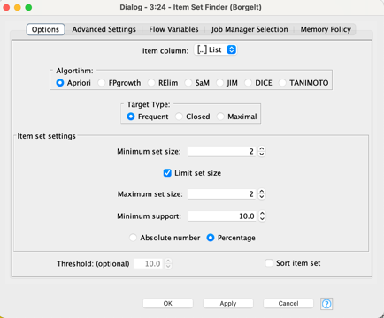

Figure 7 - Table Set Finder

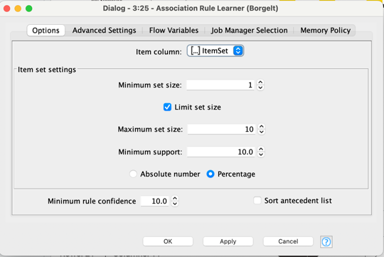

Figure65- Association Rule Learner

### Adjustments to Plan

In our initial plan, we were just planning to work on the induvial occurrence of skills and the relevant areas of analysis. We have now refined our analysis to various models to best utilise the strengths of various models to find the most accurate data.

## 5.4 K-means Clustering

For this project, we also chose K-means clustering because this tool that can identify hidden patterns (Govender & Sivakumar, 2020), segment data (Vijay Kumar Trivedi et al., 2022), grouping (Abdullah et al., 2021), detect anomalies (Pu et al., 2021), and improve feature relevance (Pu et al., 2021). It helps identify common job market trends, segment data into meaningful groups, detect outliers, and ensures consistency within clusters. It also minimizes within-cluster variance, highlighting the most relevant attributes each job cluster. This comprehensive analysis provides actionable insights into skills, locations, and job types that shape the employment landscape.

**Metric selection**

For this project, we have decided my scope of analysis. The main job market is United States and Job title is Business Analyst and jobs skills are the major areas to play with modelling techniques. Metrics are to explore from this analysis are given below:

* Clustering of related skills/ skills segmentation based on priori algorithm
* Find out relationship between Job skills and other variables (Job level, types)

**Tools for Analysis**

For Analysis, we have tried three different tools (stata, spss, smart pls) which has some restriction on nominal dataset and conversion and finally fit the model using KNIME Analytics platform for finalization which is easier than other tools to use and convert the data set.

**Data Conversion & Model Fit**

For applying this modelling technique (K-Means), we need to convert the data from nominal value to numeric. we applied some techniques such as cell splitter for job skills variable which a complete nominal data and only separated by comma in a row which was not useful for this modelling. With the help of *cell splitter*, we spited all the skills into column and in total we got 79 separate columns and used column rename node to name them as skill1, skill 2 and skill79. Then I wanted to count the frequency of repeated skills such as business analysis/ Business Analysis counting as same skills. we set the *rule engine* node to count and applied numbers to each of common skills sets. After applying rule engine, we found “predictive skills” column to analyse.

My dummy numbers applied to rule engine:

Table-3: Cluster with skillset

|  |  |  |
| --- | --- | --- |
| Skills | Name of Skills | Dummy number |
| Skill-1= Cluster-0 | Business Analysis/ business analysis related skills | 1 |
| Skill-2: Cluster 1 | Requirement Gathering/ requirement gathering/ requirement specification/requirement engineering and related and Data analysis/ data visualization/data presentation/data tools/ data techniques and other data related skills | 2 |
| Skills-3= Cluster-2 | Communication/ presentation/ contacting stakeholders/ client engagement/ customer call/ customer facing and others, Project Management/ project management/ agile/ scrum/ ITIL and related skills | 3 |

For converting other variables such as Country [1 for U.S AND 2= other country], level [Associate=2,Mid senior=1],job type [1= onsite, 2=others] I applied category to number nodes and converted them into numerical value. Here is the output table

Figure-9: Output table

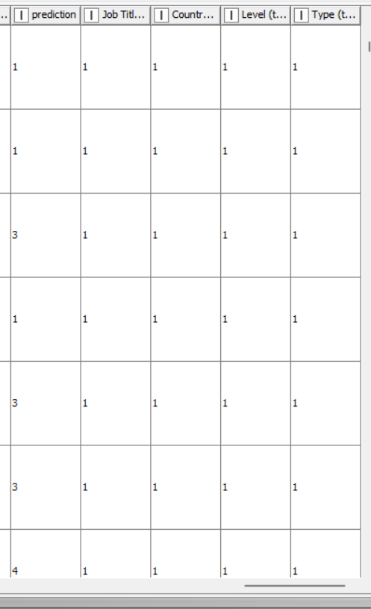

The next challenge is having missing values because for applying rule engines, many of the columns showing question mark (?) because of non-identification of skills which was not mentioned in the rule engine algorithm and detecting missing value. K-means clustering unable to generate output if any missing columns are there. Then we applied *group by node, missing value node and column filter* to replace the missing value with dummy zero (0), so that every missing column replaced with 0 as a string value. In total, 20 rows have some sort of missing value and replaced with dummy zero. Here is the out put table.

Figure-10: Missing value replacement

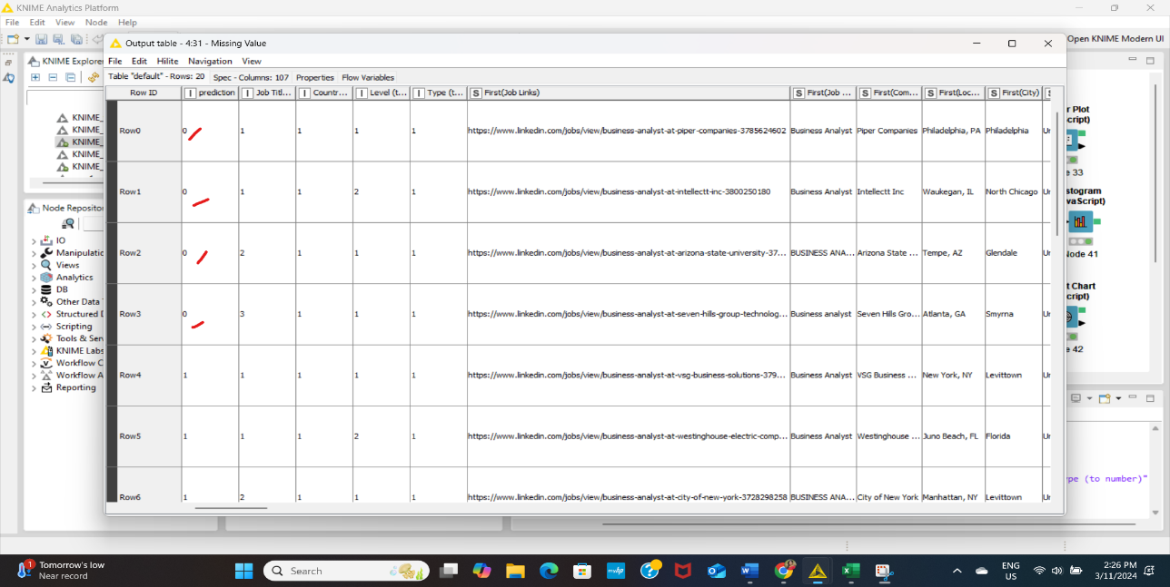

Now, dataset is completely ready for K-means clustering. Then we applied *K means node, color manager, shape manager and some model evaluating techniques (Numeric scorers, Cronbach alpha, Numeric distance and simple correlation)* to understand the how strong association exists in the cluster and applied some visualization techniques (scatter plot, histogram, sunburst diagram) to see the cluster. Here is the overall Knime workflow we work with to fit modelling techniques.

Figure-11: K-means Cluster model fit

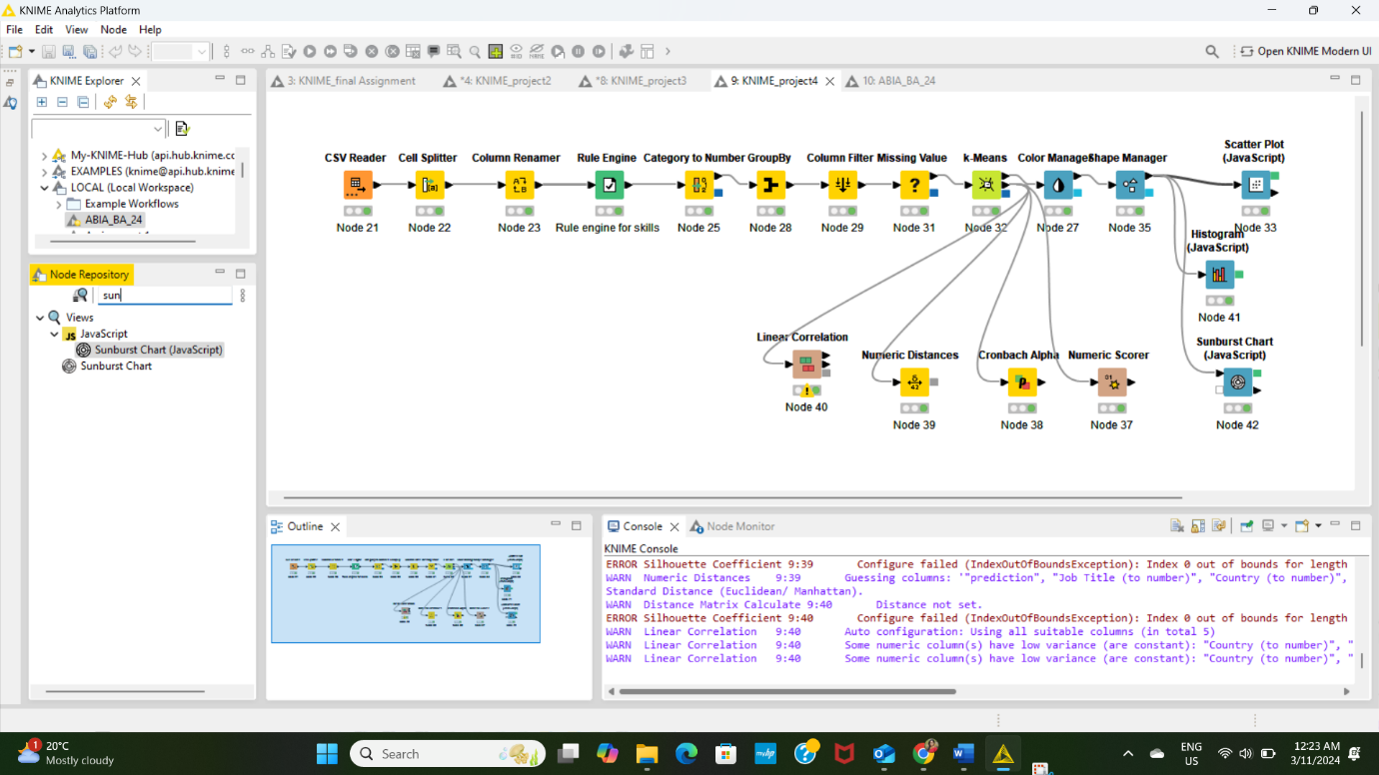

## K -means Clustering Model Specification

We applied k means clustering which is also a Apriori algorithm to identify frequent skill weight with respect to our scope of Business Analyst Role in the United States. The k means calculates the following metrics: -

**Cluster centroids**: K-means clustering uses a centroid as the center of each cluster, representing the average position of all points within the cluster across all dimensions.

**Inertia:** Inertia measures cluster compactness by calculating squared distances between data points and their cluster's centroid. Lower inertia indicates more compact clusters, while k-means algorithm aims to minimize inertia to enhance clustering quality.

**Distance/ numeric scores**: Euclidean distance, a measure of the straight-line distance between two points in multi-dimensional space, is frequently utilized in k-means clustering to determine the distance between each point and the cluster centroids.

## K-Means Model Specific Controls

To get the expected outcome of the k-means, I set specific controls to get specific response from application. I set 3 clusters based on five specific skill categories, hillite mapping and random initialization and number of iteration 20.

Figure-11: Model Specific controls

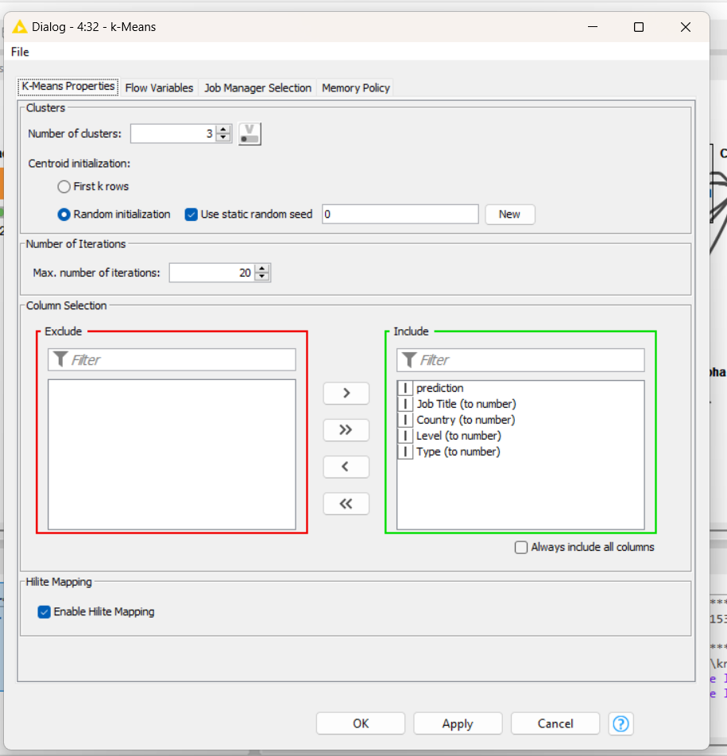

In case of adjustment, we have the plan to change the number of iterations and check how cluster changes and adjusting as per model specification.

## 5.5 Process Mining

Accordantly to Bozkaya et al. (2009), process mining analyses event logs to offer insights into how processes are carried out. It helps organisations understand the actual process flow, identify bottlenecks, check if logs conform to specifications, and explore collaboration patterns. Key areas include performance metrics, process discovery, conformance checking, and social networks. These insights assist organisations in assessing their control over processes and ensuring it accurately reflect business operations (Van Eck et at., 2015).

Figure 12 illustrates a process mining workflow, starting with events, which are refined through filtering. These filtered events are then used in process mining to generate a discovered model, while a manual model can be developed alongside. Both models are compared in a map step. The process includes data visualisation, which draws from the events and feeds into a combined map/data visualisation. The workflow integrates steps of filtering, mining, modelling, and visualising to analyse and map event data (Van der Aalst et al., 2011).

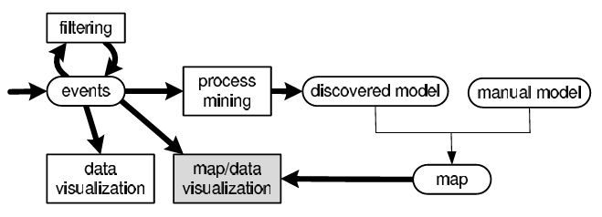

Figure 12: High-level visual of process mining

Process mining involves various techniques for extracting, visualising, and analysing process information from event data recorded in event logs. Its main focus is on analysing end-to-end business processes. By using data collected during process execution, it generates models that depict how these processes are carried out and monitors their ongoing performance.

This method provides organisations with ‘behavioural visibility’, allowing analysts to identify specific actions and individuals that may require further investigation, especially when a process does not perform as expected (Badakhshan et al., 2022).

There are three core components in process mining (Andreswari et al., 2022):

1. Process Discovery: using event logs to generate a visual model of the process.
2. Conformance Checking: comparing the discovered process model to a pre-defined model to detect deviations.
3. Performance Analysis: identifying bottlenecks, throughput times, and inefficiencies within the process.

In the context of the US consulting firm seeks insights into the U.S. job market for Business Analyst roles case study, process mining helped understand the entire journey of job seekers or how companies recruit candidates. It also allowed to analyse patterns and identify how numerous factors such as employers, skills, and locations interact with each other in the job market for Business Analyst qualifications.

The dataset ([Kaggle - 1.3M LinkedIn Jobs and Skills 2024](https://www.kaggle.com/datasets/asaniczka/1-3m-linkedin-jobs-and-skills-2024)) focuses on job postings for Business Analyst positions, providing valuable insights into key trends and patterns across required skills, job locations, seniority levels, job types, first time seen and last processed time. By analysing these elements, it was possible to understand the job market demand for Business Analysts and the expectations companies have for this role.

The dataset contains job postings and associated skills. While it is not a traditional process mining event log, process mining principles were applied to extract insights related to recruitment flows, such as:

* Company Hiring Patterns: identify which companies post more jobs, for which positions, and the associated skills.
* Skills Sets Analysis: analyse which skills are most in demand and the companies that prefer specific skill sets.
* First Time Seen: identify when an applicant first saw the positions. This insight can highlight the initial interest in a job and how quickly applicants engage with new listings.
* Last Processed Time: indicate the most recent date and time when a jon position was updated.

Process mining is an emerging technique that leverages data analytics and process management principles to examine the flow of activities within a dataset. This technique provides insights into how processes are carried out, revealing common patterns, deviations, and inefficiencies. In the context of analysing job postings, process mining allowed to explore recruitment patterns, identifying what employers seek in Business Analyst candidates, the types of positions they offer, and the skills they prioritise.

To apply process mining to a dataset of job postings, each job listing was treated as an individual case or process instance. Each attribute within the dataset, such as the job title, company, location, skills, job level, job type first time seen and last processed time, were viewed as a stage or component of the recruitment process for filling Business Analyst-related roles. By deploying process mining techniques, it was mapped out common themes and variations in the recruitment practices across different employers.

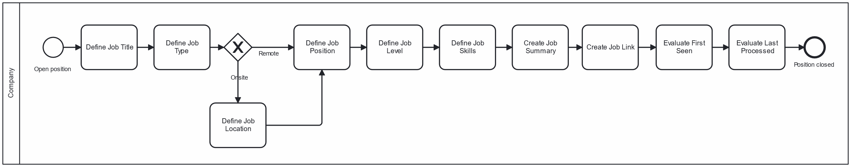

Figure13: Job Posting Process

Figure 2 represents the process discovery, process mining core element, it refers to the construction of a visual representation of the recruitment process specifically for Business Analyst roles. In this visualisation, we can trace the lifecycle of job postings, from the moment a position is opened to the skills and location, among others specified.

Additionally, process discovery allowed to delve into the skills most associated with Business Analyst positions. By examining the dataset, it was possible to determine the skills, such as SQL, data analysis, or project management, are frequently listed alongside "Business Analyst" in job postings. Process discovery thus uncovers recruitment patterns that are consistent across different employers, industries, and locations, while also revealing variations in attributes such as job level or skill requirements.

Conformance checking is a process mining technique that compares actual recruitment practices to an expected or idealised model. In this case, conformance checking was used to assess whether companies adhere to a standardised approach when recruiting for Business Analyst roles.

One aspect of conformance checking involves examining the consistency in required qualifications. By scrutinising the dataset, it was possible to determine if different employers follow similar criteria when specifying required skills for Business Analyst candidates. This comparison revealed whether certain qualifications, certifications, or experiences are universally valued in the industry, or if there are considerable differences between companies.

Performance analysis focused on identifying inefficiencies, bottlenecks, or delays in the recruitment process. The "First Time Seen" variable served as a pivotal timestamp within the job positions dataset, specifically indicating when an applicant first encountered a particular job listing. This detail played an essential role in analysing applicant behaviour and the lifecycle of job postings.

The "Last Processed Time" variable was a vital timestamp within the job positions dataset that records the most recent date and time when a specific job listing was updated or reviewed.

Process mining provided a comprehensive method for analysing job postings data, enabling an in-depth understanding of recruitment patterns for Business Analyst roles. By applying process discovery, conformance checking, and performance analysis to the dataset valuable insights were provided into employer preferences, skill requirements, and job location trends. Key metrics such as employer patterns, geographical trends, and skill decomposition further enhance the analysis, offering a structured approach for identifying significant trends.

# **Deployment**

## Presentation of findings | Logistic Regression

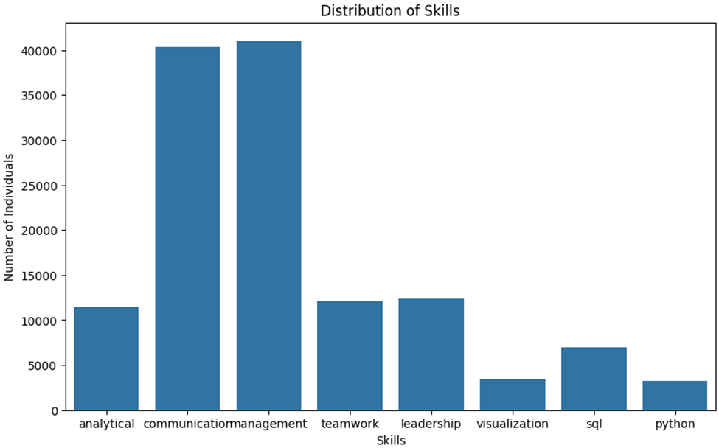

Figure 14- The most demanded skills for hiring business analyst.

Figure 14 is the result from logistic regression model showing that technical skills are not really required on the market. A business analyst is a bridge between the business side and the technical or data teams. They translate business ideas into actionable plans or insights that technical team can work on that, therefore, communication skill is one of the most important one.

## Presentation of findings | Light Gradient Boosting Machine

The analysis results used the LightGBM model to split the dataset into 80% for training and 20% for testing and validating the model's prediction accuracy. In addition, job_skills are used as feature sets and two different classification models are used: binary classification and multi-class classification to evaluate different feature sets and predict job_level.

According to the results in Table 3 below, the accuracy of all models is above 85%, which shows that whether the top 10 skills or all skills are used for classification, the model performs quite well in predicting job level.

|  |  |  |  |
| --- | --- | --- | --- |
| Model Type | Skill Set | Job Level | Accuracy (%) |
| Binary Classification | Top_10_Skills | Associate | 86.1 |
| Binary Classification | Top_10_Skills | Mid-Senior | 86.31 |
| Multi-Class Classification | Top_10_Skills | All Levels | 86.31 |
| Binary Classification | All_Skills | Associate | 85.48 |
| Binary Classification | All_Skills | Mid-Senior | 85.68 |
| Multi-Class Classification | All_Skills | All Levels | 85.68 |

Table 4: Model Accuracy for different job levels and skill sets

**Binary Classification - Associate (Top 10 Skill**s)

According to the confusion matrix results in Figure g below, the model clearly lacks discrimination in classifying the associate job level. Although it achieved extremely high accuracy (99.76%) for the classification of the “Not Associate” category, the recognition of the “Associate” category almost completely failed, and all “Associate” category were incorrectly classified as “Not Associate”. Such a result may be mainly affected by the following two factors: First, the number of “Associate” is relatively small, making it difficult for the model to learn enough characteristics of “Associate” during the training process. Secondly, the skill requirements of different positions are highly overlapping, making it difficult for the model to distinguish “Associate” from other positions at the feature level, further exacerbating the difficulty of classification.

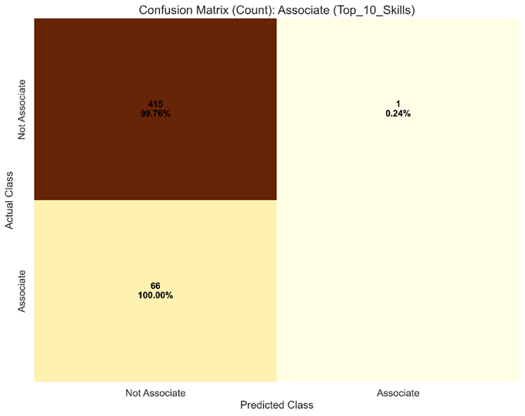

Figure 15: Confusion matrix for Associate level in Binary classification

To further confirm the above hypothesis, this report analyses the importance of skills at different job levels, as shown in Figures h-1 and h-2 below. The results show that there is a significant overlap in the feature importance of the top ten skills for each position, which to some extent confirms the impact of skill overlap on the model's classification ability. This finding not only provides insight into model performance but also points to room for improvement in dataset sampling strategies.

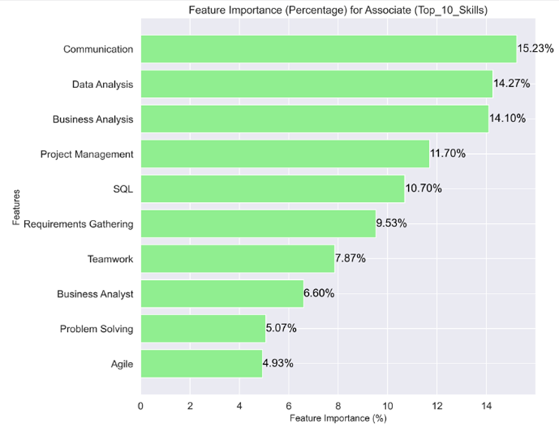

Figure 16: Feature importance analysis: Top 10 skills

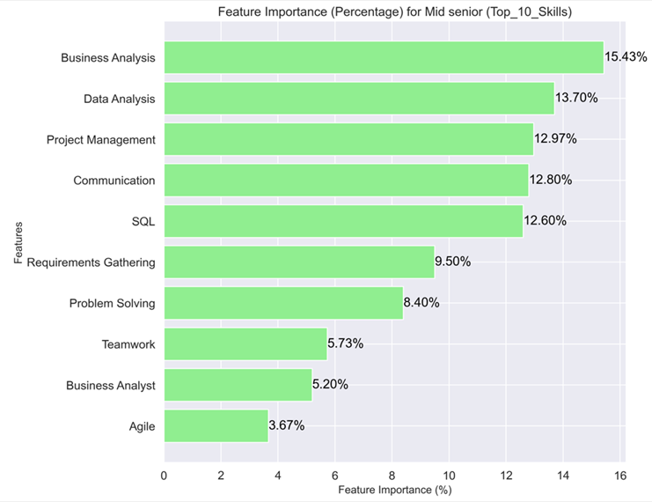

Figure 17: Multi-class classification results

**Importance of Feature for Top 10 Skill Requirements**

It can be clearly observed from the feature importance chart that there is a high overlap in feature importance in skills for “Mid-Senior” and “Associate”. Specifically, Business Analysis, Data Analysis, and Communication show high rankings in both roles and contribute similarly at over 12%. This overlap in skills not only makes it difficult for models to distinguish between different positions but may also be one of the main reasons for misclassification in previous confusion matrices. General skills with universal applicability, such as Business Analysis and Data Analysis, contribute to a certain extent in all positions, which weakens the discriminative power of the model and makes it impossible to classify specific positions accurately.

In the analysis of the importance of features for “Associate”, Communication and Data Analysis showed the highest contribution, accounting for more than 14% each. This further supports the model’s reliance on general skills when predicting “Associate”. However, this dependence also limits the model’s performance in identifying “Associate”. In order to improve the recognition effect of “Associate”, future improvement directions should focus on adding skills that are more characteristic of “Associate”, such as the introduction of some basic skills or specific task characteristics that are closely related to “Associate”. Such improvements not only help reduce the model's over-reliance on general skills but also enhance its discriminative power in classifying “Associate”, further improving the prediction accuracy of the overall model.

**Multi-Class classification (all skills):**

In the result of multi-class classification, which is shown in Figure i below, the model showed obvious confusion when processing the classification of “Associate” and “Mid-senior”. Although the identification of “Mid-senior” has relatively high accuracy (97.84%), in the “Associate” category, the model only successfully identifies a very small number of samples, and only about 9.09% of the actual “Associate” category was correctly identified. Most of the “Associate” category was incorrectly classified as “Mid-Senior”, which illustrates the model's serious deficiencies in discriminating between these two positions. Judging from the distribution of feature importance, many core skills have similar proportions between “Associate” and “Mid-Senior”. A similar situation occurs again, where there is a certain ratio between general skills such as Business Analysis and Data Analysis, which may lead to misclassification. In addition, the model's classification of categories may be affected by the dominance of larger categories in the dataset, thus weakening the ability to identify “correlation” between categories in small samples.

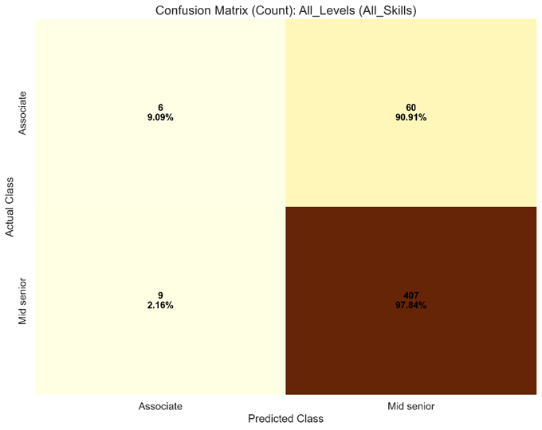

Figure 18: Multi-Class Classification

## Presentation of findings | Apriori Association Rule Mining

After all the refinement of the data in accordance with the Apriori Association with all the relevant controls, we got the desired results. We got all the relevant metrics to analyse the top skill combinations along with their supporting metrics. The output table from Knime has been shown below as Figure 5 - Knime Results, showing the top 5 skill combinations.

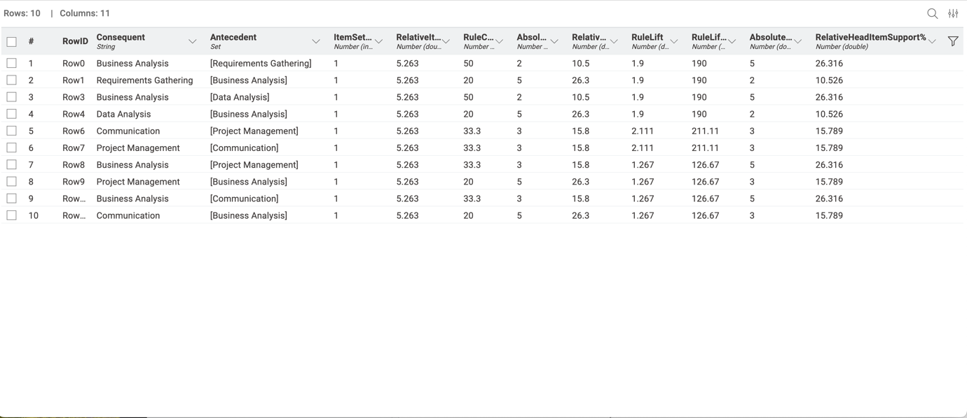

Figure 19 – Association rules Results

### Confidence of Skill Combinations

The bar chart shown below as Figure 6 - Confidence Levels for Skill Combinations depicts the visual representation of the results of the model in accordance with the top 5 skill combinations.

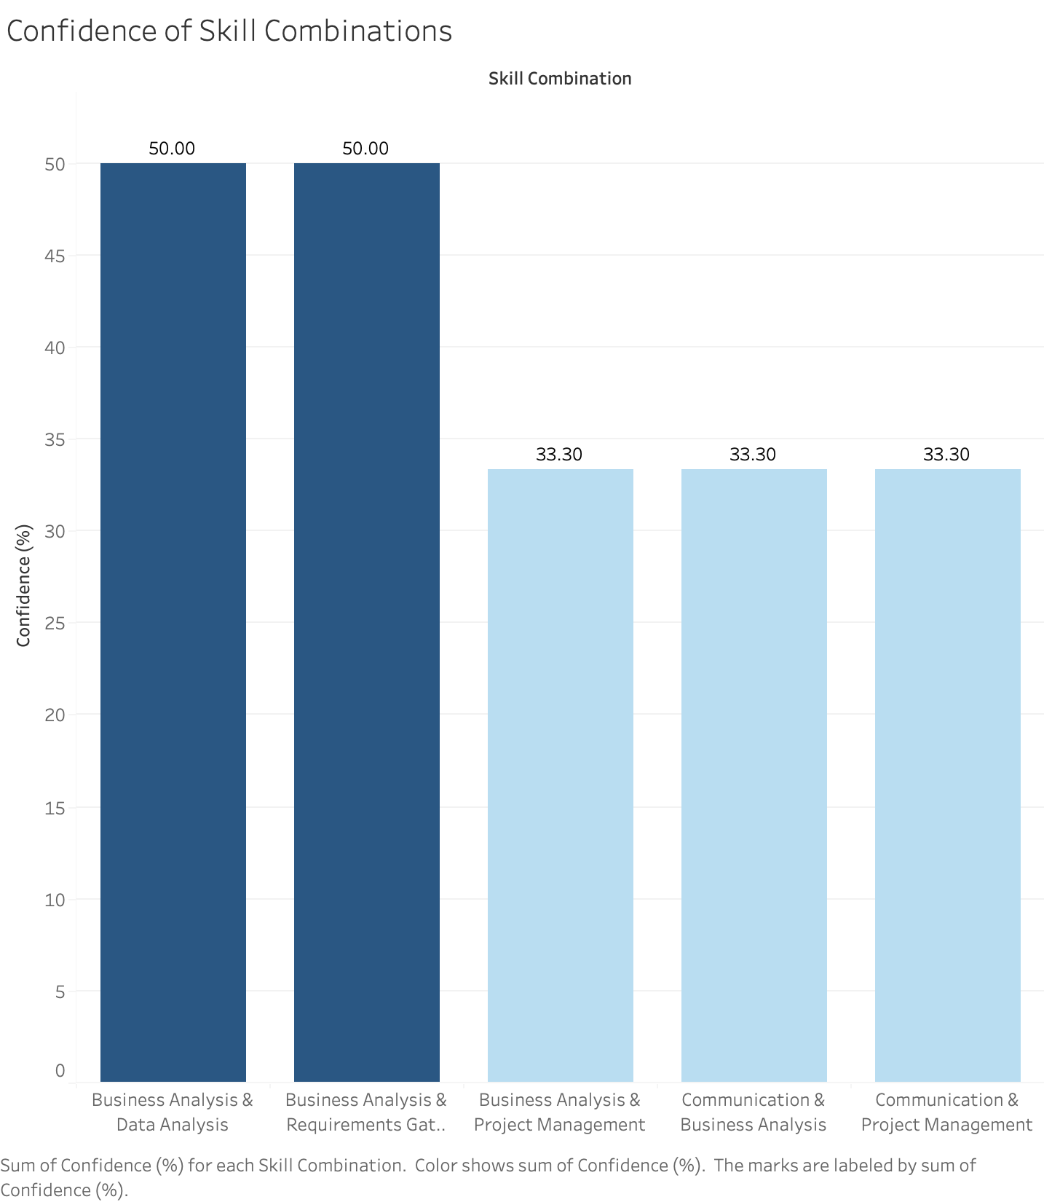

Figure 20 - Confidence Levels for Skill Combinations

Figure 20 - Confidence Levels for Skill Combinations gives us a good insight into the confidence levels derived from our results. High confidence levels depict the reliability of certain skill when the other skill in the combination is present. The top skill combinations present are :-

1. Business Analysis and Data Analysis
2. Business Analysis and Requirements Gatherings

Both these combinations have a confidence of 50% depicting that these skills are often found together in job listings. The following 3 skill combinations Business Analysis and Project Management, Communication and Business Analysis, and Communication and Project Management have 33.3% confidence that suggests they are also crucial to the given analysis but less consistently available.

### Lift for Skill Combinations

The chart below shown as Figure 21- Lift for Skill Combinations, tell us about the lifts associated with the top 5 skill combinations derived from the result of our analytical model.

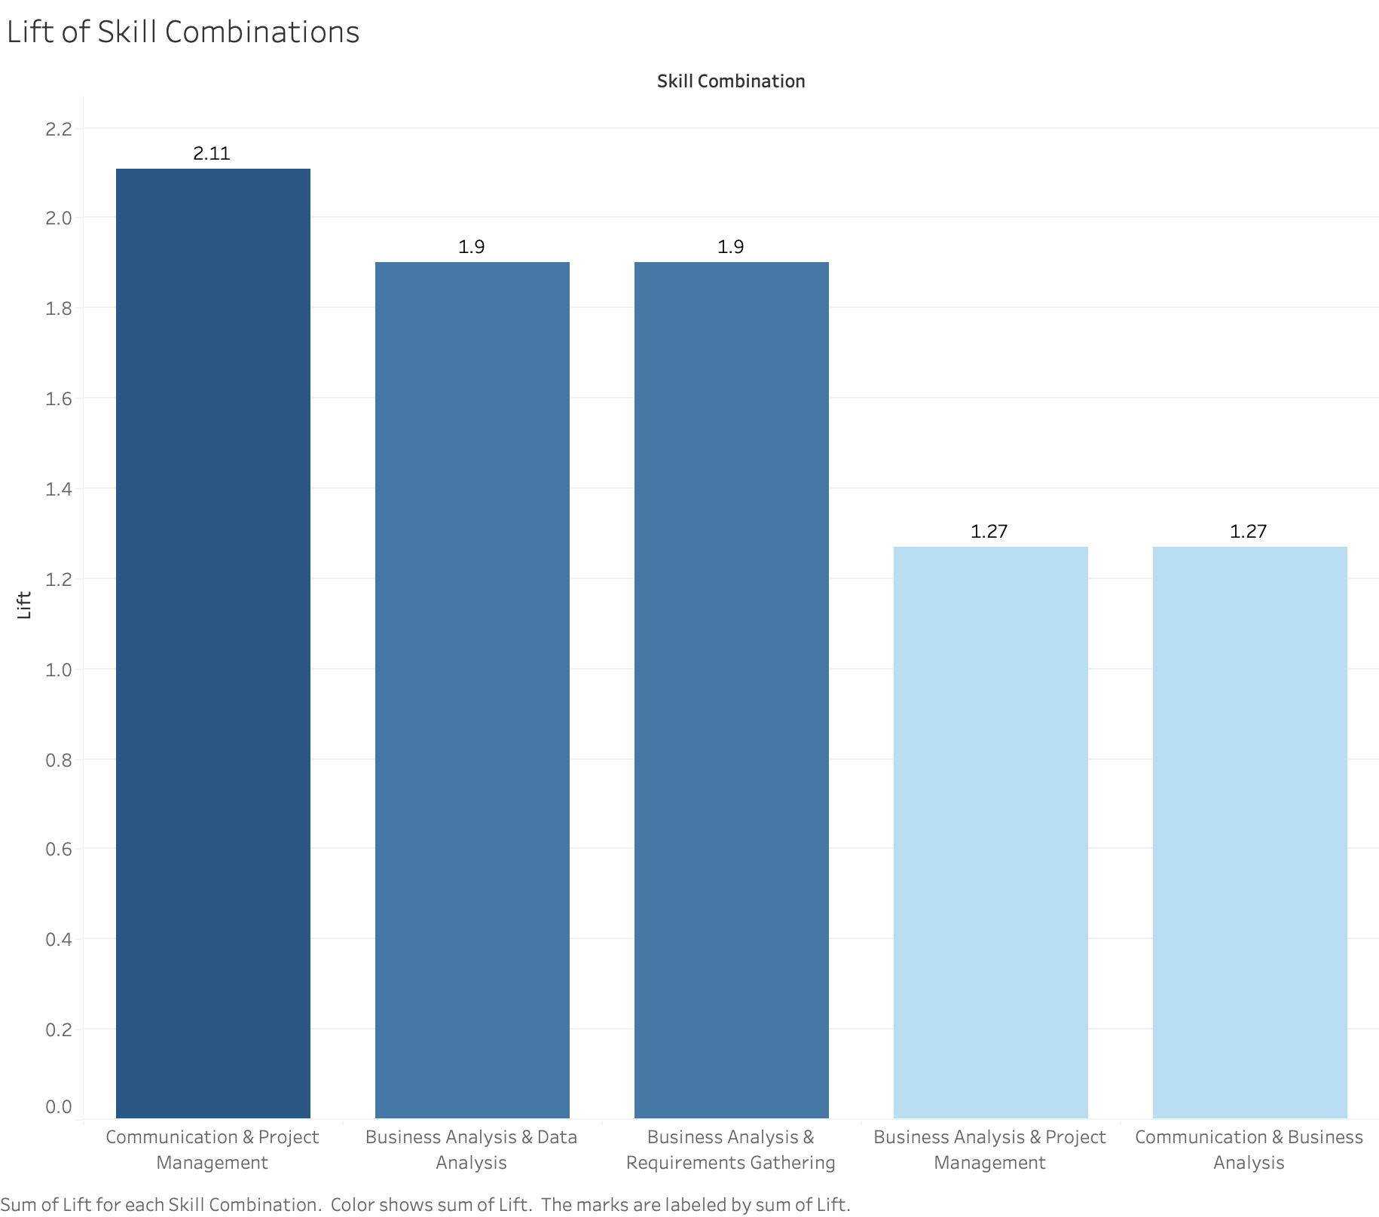

Figure 21- Lift for Skill Combinations

These lift values for each skill combination depict how much more often the skills appear together compared to their independent occurrence. The skill combination with the highest lift is Communication and Project Management with a lift value of 2.11 which depicts that communication and project management are present and required together. Other important skill pairs are Business Analysis and Data Analysis and Business Analysis and Requirements Gathering which have lift values of 1.90, further reinforcing their strong association.

### Conclusion of Findings

After analysing all the results, we found the top 5 skill combinations from to be:-

1. Business Analysis and Requirements Gatherings
   * Confidence – 50%
   * Lift – 1.90
2. Business Analysis and Data Analysis
   * Confidence – 50%
   * Lift – 1.90
3. Communication and Project Management
   * Confidence – 33.3%
   * Lift – 2.11
4. Business Analysis and Project Management
   * Confidence – 33.3%
   * Lift – 1.27
5. Communication and Business Analysis
   * Confidence – 33.3%
   * Lift – 1.27

### 

### Resulting Model

The resulting model used the Apriori Association Rule Mining and their relevant metrics to analyse and identify the top 5 skill combinations required for Business Analysts. The analysis focused on various skills present in our dataset extracted from LinkedIn. The following findings can be concluded from the results of our analytical model.

* **Core Skill** - Business Analysis was found at the core of all the skills and has been a part of majority of skills in the whole dataset as well as our results.
* **Technical Skills** – Technical skills which include Data Analysis, Requirements Gathering and Project Management were found to be important complementors of our core skill.
* **Soft Skills** – Communication which is a soft skill has also been considerably paired with the core and technical skills which shows the importance of soft skills.

## Presentation of findings | K- means Clustering

After all the refinement of the data, I found the k-means result and relevant result to analyse the skills distribution/ segmentation along using supporting metrics. The output table is given below showing the 3 model clusters.

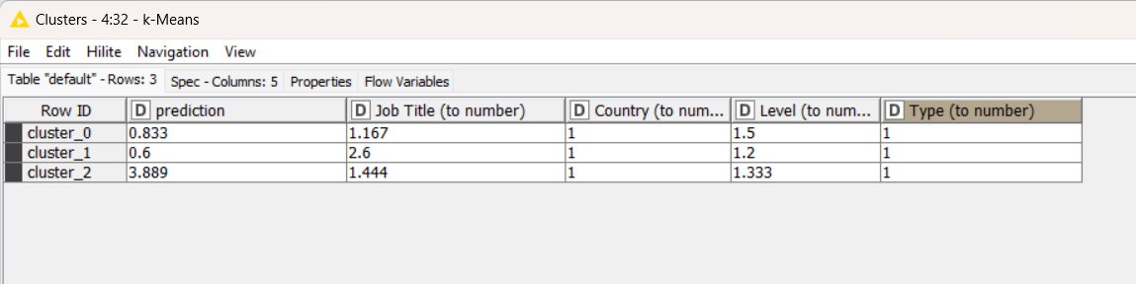

Figure 22 – K-means Results

**Cluster centroids**

The table displays the centroids for each cluster (cluster_0, cluster_1, cluster_2) based on attributes like Job Title, Country, Level, and Type based on predictive skills. For instance, cluster_0's Job Title and prediction skills value of 1.167 indicates potential association with specific job titles and cluster (o) category skills. Cluster 0 represents a mid-level hierarchy with uniform job titles and lower levels, suggesting senior or managerial roles. Cluster 1 includes broader roles with higher job titles and lower levels, possibly representing junior roles across diverse job functions. Cluster 2 displays a balance between job titles and level attributes, suggesting roles with moderate job functions and mid-level responsibilities.

## Labelled output

Figure-23: labelled input used for iterations.

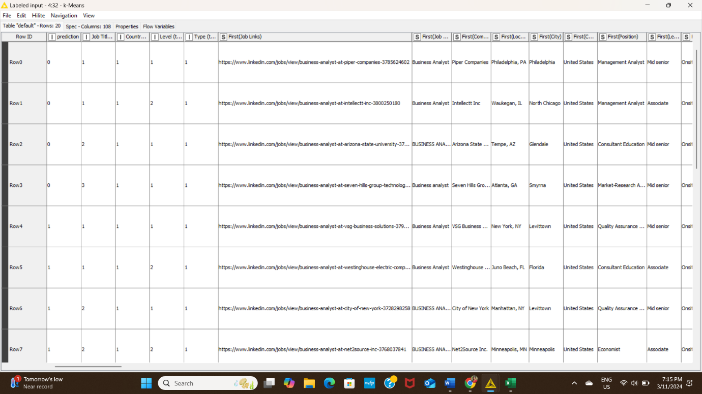

## Eludician Distance measurement

For this, analysis, I have measured distance which is showing greater than one (>1) means which means moderate distance (not so high/ not so low) exist between variable and centre value. The ideal Euclidean distance for clustering is based on the distance between clusters, with smaller distances indicating more cohesive clusters and larger distances indicating better separation. Our model results better separation.

Figure-24: Elucidian Measurement.

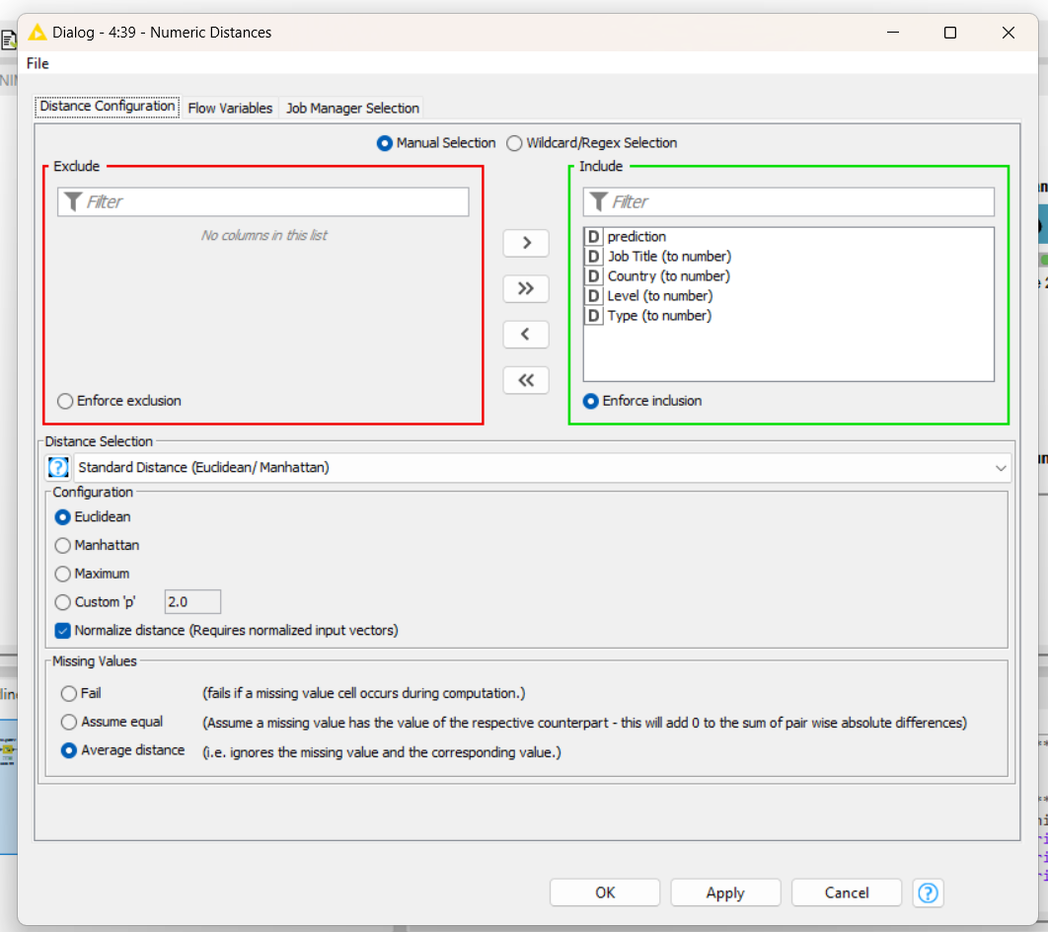

And the output table of distance measurement is showing

Figure-25: The distance matrix

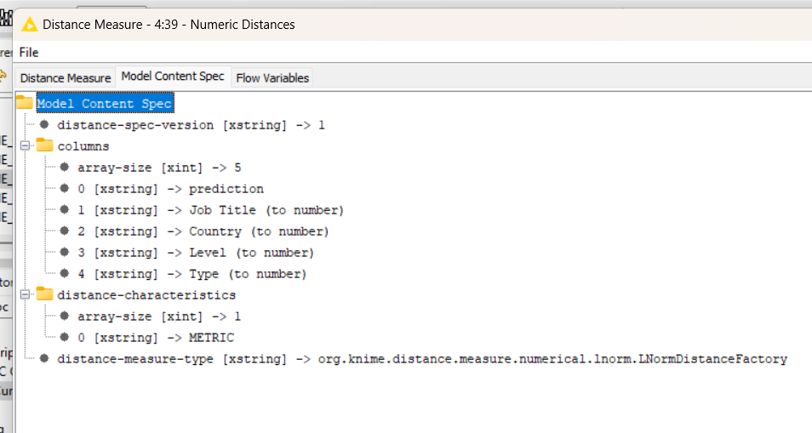

**Model Evaluation**

For model evaluation, I selected numeric scorers to explain the clusters, Cronbach alpha to understand the overall model reliability fitness and correlation analysis to understand the validity of the relationship between variables.

1. Cronbach Alpha for internal consistency check: Cronbach's Alpha measures the correlation between variables within a group, with higher values indicating better internal consistency. It ranges from 0 to 1, with values above 0.7 indicating good internal consistency and 0.618 indicating moderate consistency

Table: 5: Cronbach Alpha

|  |  |
| --- | --- |
| Cronbach Alpha | Value |
|  | 0.618 |

1. Numeric scores

Table: 6: Numeric Scores

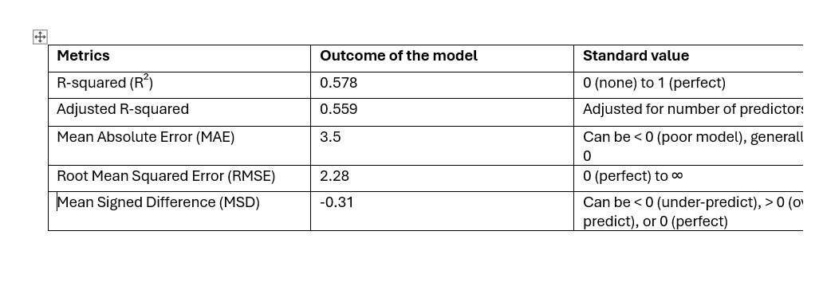

Form this numeric score, we can say the value of adjust r-square is 0.578, means this model explain 57.8% of the overall data and model moderately fit with its clustering value.

**Visual Models**

To visualize the model, we have selected the scatter plot to show the cluster of skill distribution to each category based on job title (Business Analyst). We know each cluster has their own skill category and showing the presence in the scatterplot as cluster 0 (Green dots), Cluster 1( red dots), cluster 2(orange dots) and the left dots are other skills categories which is not covered under analysis.

Figure-26: Scatter plot

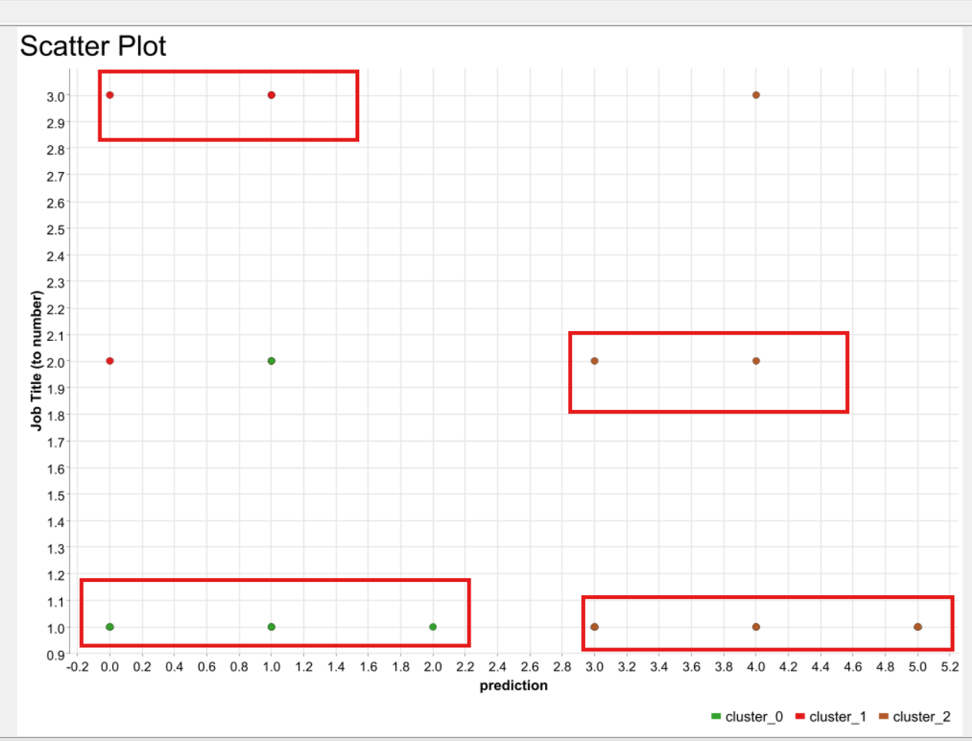

Sunburst Chart

If we consider figure 27&28, we can the variation of all the skills in the dataset is visualized in the sunburst chart which is complicated to understand, but in case we develop the cluster chart, we can see the specific skill sets are merged into different cluster category and showing strong presence in the 2nd diagram.

Figure-27: Sunburst Chart

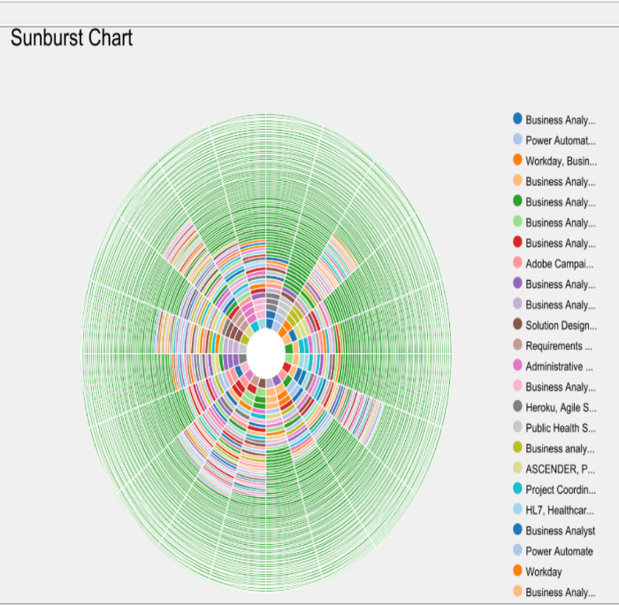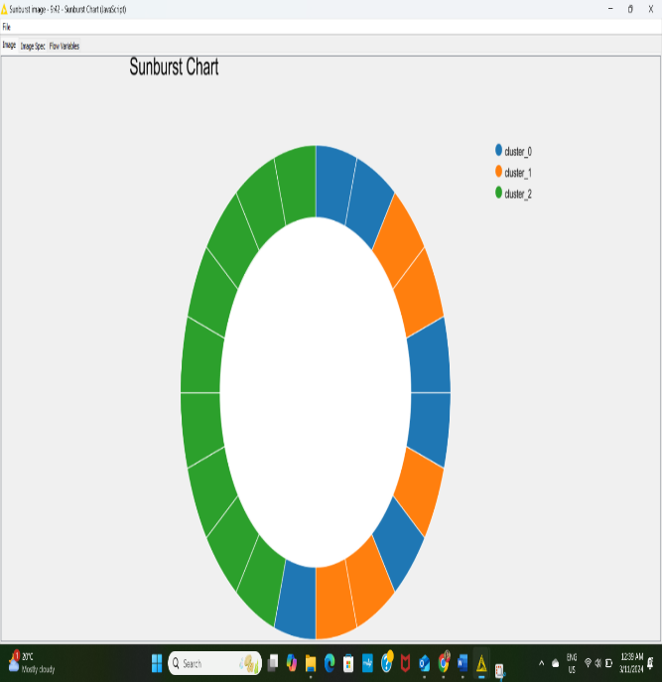

In cluster (2) = all the business analysis related skills which are mention in table -3 has the strong dominance in achieving business analyst position and then cluster (0) and then cluster (1). Go back to table 3 to read skills category.

**Histogram to check normalization**

In this diagram, to check the data normalization, we have developed histogram keeping consistent prediction skills (Blue bin) as a constant value in the x axis and in the y axis we made the trial of other variables (Job title, Job level, job type, country) comparing to predictive skills variables. Only 4th image is showing normal distribution and supports job title and job skills are closely related and three of skills category is highly relevant to business analyst role. In other image (1st ) job type and skills are related but not showing depends on seniority and juniority or onsite/ offsite or country focus. All other histograms are left skewed.

Figure-28: Histogram for Normalization

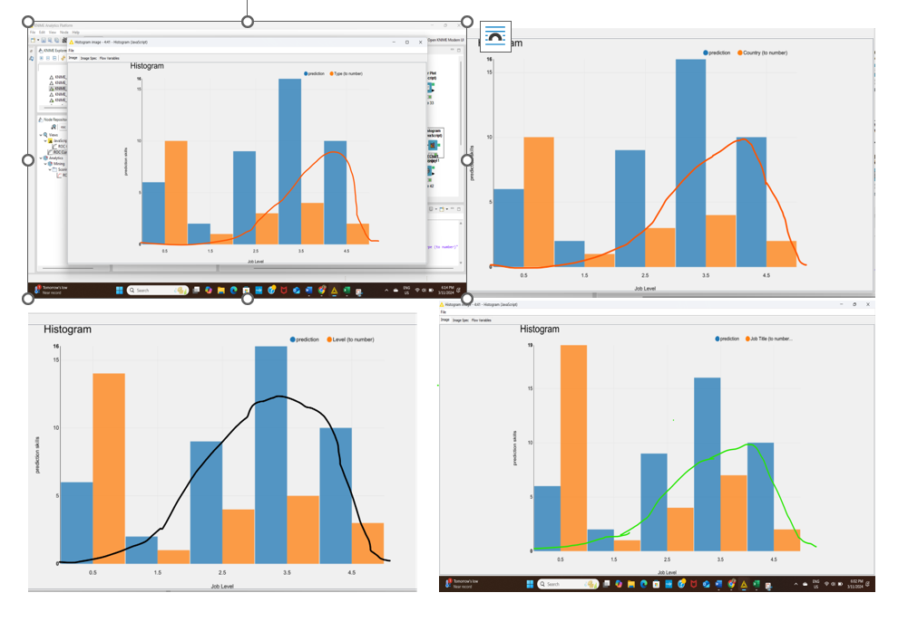

## Resulting Model

The resulting model used the K- means and their relevant metrics to analyse and identify the top three clusters based on the skills category for business analyst job. In conclusion, the following findings can be drawn from the overall analysis

* **Primary Skill - Business Analysis** related skills which is the most crucial for these types of job.
* **Supporting skills**: Requirements gather/ requirement engineering which supports the job, more subjective knowledge and expertise.
* **Human skills**: Communication skills category skills are really important to handle the job in any situation.

## Presentation of findings | Process mining

The most frequently listed skills for business analyst roles highlight a broad range of technical and functional competencies. These include business analysis, data analysis, data visualisation, and ERP Implementation. Such skills suggest a strong demand for professionals who can analyse business processes, draw insights from data, and implement enterprise resource planning (ERP) systems. The inclusion of skills like procurement and financial management also indicates that business analysts are being employed across diverse sectors, requiring a multifaceted understanding of both technology and business operations. This reflects the evolving nature of the role, which now spans operational, strategic, and technical areas.

The dataset shows that most business analyst job postings are in the United States, specifically in Tennessee. While the data might not reflect a broad global distribution, the high concentration in the U.S. points to a robust demand for business analysts in this region, particularly in states with thriving industries or large business hubs. This aligns with the widespread adoption of digital transformation strategies by U.S. businesses, which require skilled business analysts to bridge the gap between IT and business processes.

Most business analyst roles are categorised at the mid-senior level, indicating that companies are seeking candidates with substantial experience and advanced skills. Mid-senior level roles suggest that employers expect business analysts to manage complex projects, lead teams, and provide critical insights for strategic decision-making. This also implies that there are fewer entry-level positions available, due to the specialised nature of the tasks involved. Business analysts at this level are often required to work closely with senior management and other stakeholders to ensure the successful delivery of business outcomes.

The data shows a preference for onsite business analyst positions, with fewer remote or hybrid roles listed. This may be indicative of industries or organisations that require physical presence due to the collaborative or sensitive nature of the work. For instance, roles involving ERP implementation or procurement might necessitate onsite coordination with various departments. However, it is worth noting that the job market is evolving, and future trends may see more flexibility in work arrangements as remote work becomes more integrated into business operations.

The business analyst job market, as reflected in the dataset, shows a demand for highly skilled professionals who possess a wide range of technical and business expertise. The majority of roles are at the mid-senior level, indicating the need for experienced individuals capable of taking on leadership responsibilities. Additionally, the U.S. remains a key location for these roles, and while the majority are onsite positions, there may be future shifts towards more flexible working arrangements. These trends highlight the importance of adaptability and continuous skill development for business analysts as the role continues to expand in scope and influence across industries.

Below are the key findings from the dataset:

Top 10 Companies Hiring for Business Analyst Roles, Figure 3:

1. Tata Consultancy Services: 52 listings
2. Dice: 37 listings
3. NR Consulting: 25 listings
4. Stellent IT: 25 listings
5. Robert Half: 19 listings
6. Software Technology Inc.: 17 listings
7. TekIntegral: 13 listings
8. Intellectt Inc: 9 listings
9. Jobs for Humanity: 8 listings
10. CACI International Inc.: 8 listings

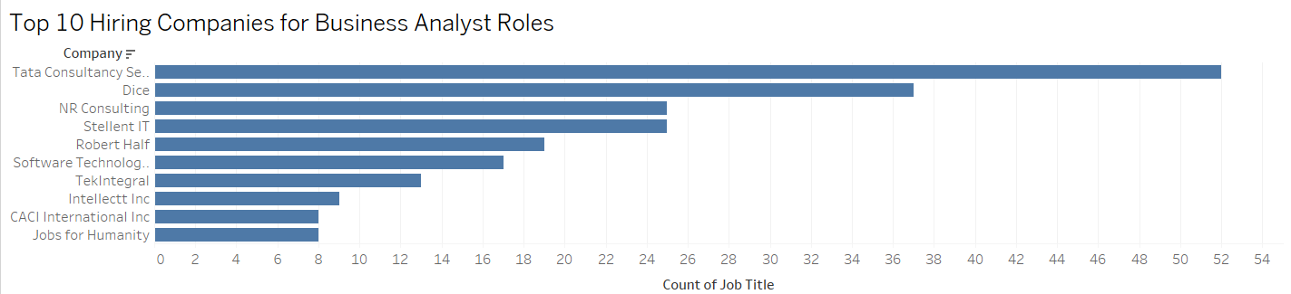

Figure 29: Top 10 Companies Hiring BA’s

Top 10 Job Positions Related to Business Analyst Roles, figure 4:

1. Management Analyst: 316 listings
2. Job Analyst: 131 listings
3. Economist: 88 listings
4. Consultant Education: 76 listings
5. Instructor Business Education: 65 listings
6. Quality Assurance Analyst: 35 listings
7. Market-Research Analyst I: 19 listings
8. Change Person: 10 listings
9. Charter: 4 listings
10. Designer: 2 listings

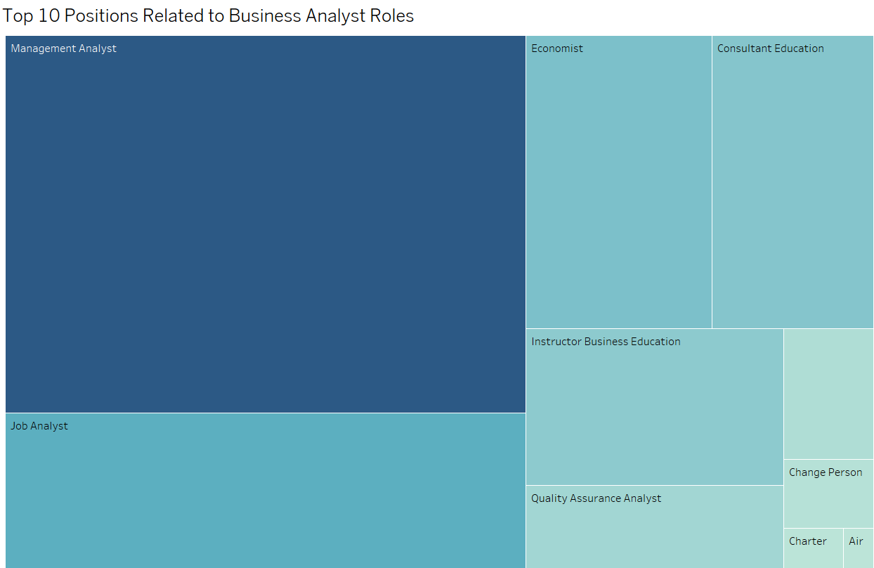

**Figure 30: Top 10 Job Positions Related to BA**

**Top 10 Skills Listed in Job Postings:**

* Business Analysis: 313 occurrences
* Communication: 221 occurrences
* Project Management: 197 occurrences
* Data Analysis: 170 occurrences
* SQL: 158 occurrences
* Business Analyst: 131 occurrences
* Requirements Gathering: 119 occurrences
* Problem Solving: 101 occurrences
* Agile: 92 occurrences
* Teamwork: 92 occurrences

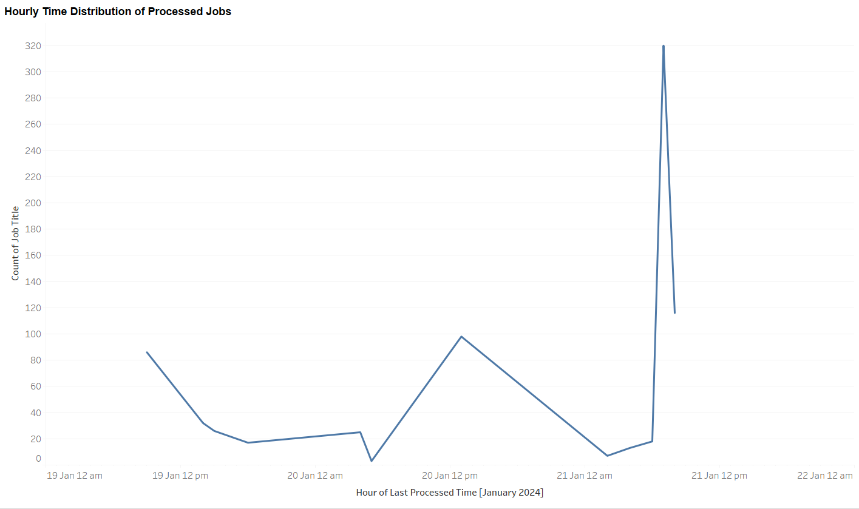

Figure 31: Hourly Time Distribution of Processed Jobs

Figure 31 presents a detailed view of processed business analyst (BA) job positions over a series of hours in January 2024. The y-axis labelled “# BA Positions,” indicates the volume of processed job entries, with values reaching up to 320, while the x-axis shows the hourly breakdown across a few specific dates in January.

The sharp peak on January 21 may signal a heavy data processing load within that hour, due to batch processing or a high influx of job postings. This level of variability could suggest scheduled data processing times or periods of high demand. These trends underscore potential bottlenecks that may require attention to manage processing loads more evenly. Additionally, if these peaks are part of regular patterns, resource adjustments could be made during peak hours to ensure efficient and timely processing.

Trends Observed:

* The data shows significant fluctuations in the processing times throughout the brief period.
* There is an initial high point on January 19, with processed time.
* After that, there is a drop, reaching a low point.
* A spike is observed again on January 20, followed by another peak, the highest in the chart, on January 21.

These findings highlight the companies most actively hiring for business analyst roles, the diverse positions associated with these roles, and the critical skills employers seek.

Based on the process mining analysis of the dataset, here are some key trends, patterns, and results derived from the job listings for Business Analyst roles on LinkedIn in 2024:

Employer Patterns:

* Top Employers: Large consulting and IT firms dominate the hiring landscape, with Tata Consultancy Services, Dice, and NR Consulting leading in job listings for business analyst roles. This trend suggests that consulting and tech companies are prioritizing business analysis skills, likely to support various client projects or internal business operations.
* Concentration of Job Listings: The top 10 companies alone account for a massive portion of the job listings, which may indicate limited competition among employers in certain regions or specific sectors, particularly in consulting and IT.

Job Position Patterns:

* Range of Positions: While "Business Analyst" remains a common title, other associated positions such as "Management Analyst," "Quality Assurance Analyst," and "Market-Research Analyst" are also prevalent. This shows that the business analysis skill set is valuable in various analytical and quality assurance roles.
* Seniority Level: Most roles identified are mid-level positions, aligning with the demand for experienced professionals capable of performing independent analysis and decision-making.

Skills Trends:

* Core Business Analyst Skills: Key skills frequently listed include Business Analysis, Project Management, Data Analysis, Requirements Gathering, and Problem Solving. These are foundational competencies for a business analyst role, reflecting a strong emphasis on both technical and analytical skills.
* Technical Skills: SQL and Agile methodologies are highly sought-after, suggesting that employers value business analysts who can work within data-driven and Agile environments.
* Soft Skills: Communication and teamwork are also frequently mentioned, indicating that business analysts are expected to collaborate effectively and communicate insights to various stakeholders.

Geographic Patterns:

* Location Concentration: Many of the listed job positions are located in major U.S. cities or tech hubs, such as New York, Virginia, and Minnesota. This pattern suggests that demand for business analysts is strong in regions with concentrated business and tech industries.
* Onsite Work Preference: A large number of these roles are designated as "Onsite," indicating that despite global shifts toward remote work, companies hiring business analysts may still prefer candidates to work from office locations, to facilitate teamwork and closer interaction with clients.

Process Mining Insights:

* Event Flows: The event log (job postings) flows from company listings to position offerings, and finally to skills required. This pattern allows for a high-level model showing:
  + Employer Demand: Filtering by company reveals hotspots for business analyst positions, identifying firms with frequent openings and potential areas for job seekers to target.
  + Skills Mapping: By decomposing the job skills, the process mining model helps map specific skills to roles, which shows that some skills like SQL and Agile are in high demand for certain titles (e.g., "Data Analyst" or "Quality Assurance Analyst") but less so for generalist roles.

The process mining analysis reveals strong demand from consulting and IT firms, with specific expectations around technical skills like SQL and Agile, coupled with essential business analysis competencies. The geographic clustering in major cities and preference for onsite roles suggests a competitive market, particularly for skilled analysts who can adapt to data-intensive environments and Agile workflows. The model demonstrates clear event pathways from company demand to skill requirements, providing a map that illustrates which qualifications are most critical for various job types.

## Interpretation of findings | Logistic Regression

Figure 3 is the result from logistic regression model showing that technical skills are not really required on the market. A business analyst is a bridge between the business side and the technical or data teams. They translate business ideas into actionable plans or insights that technical team can work on that, therefore, they are more like “interpreters” who make data and business needs understandable for everyone.

While technical skills in modelling are valuable, they are not the core requirement for a business analyst. The more important skills are analytical thinking, problem-solving, project management and strong communication skills.

Analytical thinking and problem-solving skills are mandatory for them to work with business and walk with them through their trouble to identify the root cause and define the proper solutions for technical teams to proceed.

Besides that, strong communication and project management are the major skills that most hiring managers looking for. Business analysts will work in different projects to support business and their company, or with different clients if they are service providers for business analysis. They must be ready to be members of project management team or know how-to work in the project within project timeframe to deliver the goals.

Furthermore, it is impossible to work well in business analysis area without effective communication. As a business analyst, they will interact with different people from different background and knowledge in projects, and any misleading from conversation will get bad results.



Figure 32- One hiring position requires Project management, analysis, and communication skill.

From one of hiring post on Seek platform, those skills are required by employer (Odoo, 2024)

Based on those findings, employers should focus on improve their employees in these skills by sending them to the training courses or focusing on these skills if they are hiring for business analyst staff.

## Interpretation of findings | Light Gradient Boosting Machine

In this case study, LightGBM demonstrated remarkable classification capability and high accuracy in large sample categories due to its use of a histogram algorithm for feature selection and split point determination, which effectively reduces computation time and improves prediction efficiency. In feature importance analysis, LightGBM is able to identify the skill features that contribute the most, which provides practical value for applications in human resource management, such as recruitment, skills inventory, and employee training. The model excels in handling large-scale datasets and maintains strong performance in high-dimensional feature scenarios. However, its classification performance in small sample categories is limited, primarily due to data imbalance and overlapping skills. Because skill features in this case are highly overlapping between the two job levels, the model struggles to clearly distinguish between different categories in multi-class scenarios, leading to an increased confusion rate. Therefore, in practical applications, further data balancing techniques or other model optimization strategies are required to enhance the model’s recognition ability for small samples.

**Model Performance Interpretations**

Advantages

* High accuracy: The model shows high accuracy in the classification of most positions, especially the “Mid-Senior” category, which indicates that the model has good performance in identifying large sample categories.
* Importance of core skills: Through feature importance analysis, the model is able to identify key skills across different positions, such as general skills like "Communication”, “Business Analysis” and “Data Analysis” which can assist HR in targeting core competencies in talent management.
* Suitable for HR management: Model results and analysis can be applied to many aspects of HR, including recruitment, skills inventory, and employee training, thereby improving overall HR efficiency.

Disadvantages

* Poor classification of small sample categories: In the classification of the “Associate” category, the model performs poorly, especially in the recall rate of binary classification and multi-category classification. This may be related to factors such as sample imbalance and high skill overlap rate.
* Difficulty in classification caused by overlapping skills: Due to the overlap of most skills across different roles, such as “Business Analysis” and “Data Analysis” the model struggles to learn clear distinctions among these skills, resulting in higher confusion rates in multi-class classification.
* Sensitivity to small samples: The model is easily affected by data set imbalance when processing small sample data, which will lead to the weakening of the recognition ability of certain categories such as “Associate” and the inability to effectively learn its features.

Final Thoughts

Overall, this research provides a valuable foundation for automated tools for human resource management. However, the analysis results only show high classification accuracy in large sample categories, indicating that practical applications require more data support and model optimization. Besides, as long as governments and organizations keep pushing for the preservation and open access of digital data, data science can help make even greater contributions to healthcare, education, and environmental protection. By fostering collaboration across different fields, human beings will be able to tackle complex social issues more effectively, enhance quality of life, and drive sustainable development.

## Interpretation of findings | Apriori Association Rule

After analysing the key skill combinations that employers value in Business Analysts today. In this section, we interpret these findings to understand their significance, assess the strengths and weaknesses of the model, and discuss what these insights mean for the US Consulting Company.

### Key Insights from the Analysis

#### Communication and Project Management

* + The combination of Communication and Project Management is a promising skill combination with a lift of 2.11, showing that employers really value professionals who can both manage projects and communicate effectively. It shows that businesses aren’t just looking for people who can keep a project on track but they need individuals who can also keep everyone informed and aligned with the project with their communication skills.

#### Business Analysis and Requirements Gathering

* + Business Analysis and Requirements Gathering came out with a confidence of 50%, which means that half of the job listings that require business analysis, gathering requirements is equally critical and sought after. This skill combination highlights the importance of understanding and documenting what various stakeholders might need. Employers are looking for Business Analysts who can lay a strong foundation of a project by ensuring they fully understand what’s required and plan accordingly with the ability to translate stakeholder needs into a clear and actionable plan.

#### Business Analysis and Data Analysis

* + The Business Analysis and Data Analysis combination, also with 50% confidence, highlights how important data has become in decision-making and particularly for Business Analyst roles. It’s no longer enough for Business Analysts to just understand business processes, they now need to analyse data to make informed recommendations to support any organisation. Employers want candidates who can dive into the data, find the key insights, and use those to drive strategic business decisions from which the business can benefit from or avoid any risks.

#### Business Analysis and Project Management

* + With a 33.3% confidence and 1.27 lift, the pairing of Business Analysis and Project Management indicates a growing expectation for Business Analysts to have project management skills in their portfolio of skills.
  + Employers are looking professionals who can do the analysis as well as manage the facilitation and delivery of projects. In many companies, Business Analysts are expected to be active participants in managing timelines and ensuring that project deliverables are met.

#### Communication and Business Analysis

* + The combination of Communication and Business Analysis, with a 33.3% confidence, emphasizes that technical know-how must go hand in hand with effective communication. With effective communication an employer is looking for a Business Analyst that is making sure everyone, from executives to frontline staff, understands the analysis. Employers are prioritizing candidates who can effectively bridge the gap between data and business strategy, ensuring everyone is on the same page and make business operations and decisions more streamlined.

### Strengths, Weaknesses and Improvements of Model

#### Strengths:

* Practical Insight - The model provides practical insights and associations that are highly relevant for both employers and job seekers. By identifying which skills are frequently required together, it gives a clear idea of the key competencies needed to succeed in the role. (Kantardzic, 2019)
* Skill Combinations - It also gives a in-depth view of skill requirements, emphasizing the importance of both technical and soft skills in accordance with the core skill. This balance is crucial for Business Analysts who need to excel in various aspects of their roles. (Pinheiro et al., 2023)

#### Weaknesses:

* Focus on Traditional Skills - One of the limitations is that the model focuses primarily on traditional skills. It may miss emerging competencies which can be on the rise and are not majorly sough after at the moment. (Mlakar et al., 2023)
* Reliance on Data - The model is also based on current job postings, meaning it may not fully capture future needs or industry changes. With technology and business environments evolving rapidly, the demand for skills could shift, hence no predictive insights can be provided. (Kantardzic, 2019)

### Possible Improvements:

* Single Sourced Data – LinkedIn is the single source for all of our data which does not have data of the companies that might not use LinkedIn as their recruitment platform, this can include smaller organisations as well as the leaders of the industry. Hence, exploring more datasets can be a viable improvement for the analysis. (Pinheiro et al., 2023)
* Integration with Additional Job Metrics - The model and findings can be further improved by further processing data into clusters of geographical buckets. We can particularly analyse skill combinations present in the top 5 cities to further analyse and support the findings of the model. (Kantardzic, 2019).
* Focus on Emerging Skills - An addition of time filter in the model can give us insight on the rise and decline in the demand of particular skill combinations, which can then suggest which skills stay in demand and what new skills are being requested more with time. The current dataset does not have relevant metrics to proceed with this analysis. The addition of time into the analysis can then provide insight about predictive future data as well as past trends. (Pinheiro et al., 2023)

### Final Thoughts

The analysis highlights that employers are looking for a mix of core business analysis skills, complemented by technical expertise and strong communication skills. This combination is key to thriving in a dynamic work environment where Business Analysts are expected to do more than just analyse. Rather they need to lead, communicate, and drive projects forward. As businesses adapt to the demands of modern challenges, they need versatile candidates who can bring together technical, managerial, and interpersonal skills to ensure success.

## Interpretation of findings | K-means Clustering

## After analysing the key skill categories based on the cluster (0) , cluster(1) and Cluster (2) valuable for business analyst job now a days. In this section, we interpret the major insights derived from the analysis.

## Key Insights from the Analysis

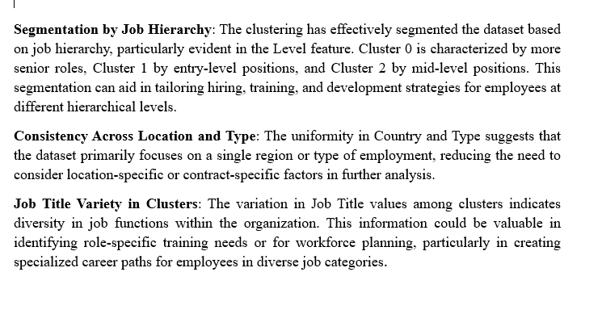

## Strengths, Weaknesses and Improvements of Model

### Strengths:

K-means is a simple, efficient, and fast clustering algorithm that is suitable for analyzing extensive job-related data. Its scalability allows it to handle large datasets, allowing for faster clustering. The algorithm's clear centroids make it easy to interpret results, and it can handle various types of numerical data and distance metrics, primarily using Euclidean distance.

### Weaknesses:

K-means is a clustering algorithm that has several limitations, including difficulty in defining the number of clusters (K), sensitivity to initialization, assumption of spherical clusters, sensitivity to outliers, and limitations with categorical data. Its effectiveness diminishes with nominal or ordinal categorical data without appropriate preprocessing, and its results may vary based on initial placement of centroids.

### Possible Improvements

To optimize K-means clustering, use techniques like elbow method, silhouette score, or cross-validation. Enhance initialization with K-means++ to reduce sensitivity. Standardize data for equal contribution to distance calculations. Handle outliers by detecting and removing them. Explore hybrid approaches like K-means with hierarchical clustering or density-based methods. Evaluate clustering quality using metrics like inertia, silhouette score, or Davies-Bouldin index. After initial clustering, analyze results and refine clusters based on domain knowledge or additional features for improved insights.

## 6.10. Interpretation of findings | Process mining

It is reasonable to assume that the demand for business analysts will continue to grow as organisations increasingly rely on data-driven decision-making. The ongoing digital transformation across various industries necessitates a greater focus on business intelligence and analytics. As companies collect vast amounts of data, the need for professionals who can analyse this data and derive actionable insights is expected to rise. The evolving landscape of business operations suggests that those with business analysis skills will be crucial for organisations aiming to remain competitive in a data-centric environment.

The necessity for technical skills, particularly in data analysis and proficiency in tools like SQL, will become even more pronounced. As organisations shift towards a more data-centric approach, the ability to work with data and utilise analytical tools will be essential for business analysts. Job postings are likely to increasingly require expertise in data visualisation software and programming languages. This shift reflects the growing expectations placed on business analysts to not only interpret data but also to manipulate and present it effectively.

Moreover, many organisations are likely to maintain a preference for onsite business analyst roles, especially within sectors where collaboration and immediate problem-solving are paramount. The analysis indicates that companies often require physical presence for roles involving complex implementations, such as ERP systems. This preference may persist as organisations recognise the value of face-to-face interactions and the facilitation of collaborative problem-solving that onsite roles provide.

Entry-level positions in business analysis will remain scarce, leading to increased competition among candidates seeking to enter the field. The concentration of mid-senior level roles suggests that organisations are primarily looking for candidates with substantial experience. Consequently, newcomers may need to pursue internships or related positions to build the necessary qualifications and practical experience required for mid-level roles. This situation may create challenges for those attempting to break into the field without prior experience.

It is likely that job opportunities for business analysts will continue to be concentrated in specific geographic regions, particularly in urban centres and areas with a strong business presence. The analysis highlights a high concentration of job postings in the United States, especially in states such as Tennessee. This trend suggests that urban areas with thriving industries will remain the primary employers of business analysts. As such, candidates may need to consider relocating or targeting their job searches towards these key markets.

Additionally, the roles and titles associated with business analysis are expected to evolve, reflecting the expanding scope of the profession. As organisations recognise the importance of business analysis across various functions, a broader array of job titles and responsibilities may emerge. This may include roles such as "Data Analyst," "Management Analyst," and "Quality Assurance Analyst," indicating the growing applicability of business analysis skills across different contexts.

In addition to technical expertise, it is reasonable to assume that soft skills, particularly communication and teamwork, will become increasingly important for business analysts. Given the collaborative nature of the role, professionals in this field must effectively engage with stakeholders and convey insights. Consequently, employers are likely to prioritise candidates who demonstrate strong interpersonal abilities alongside technical competencies.

# **Recommendations**

Based on the holistic and comprehensive analysis of the US Job Market for Business Analyst roles, we pose strategic recommendations for the US Consulting firm. The final recommendations have been curated and divides into the contexts of **Job Seekers** and **Employers**, which will provide better and categorial insight to the US Consulting Company. By analysing and combining all the results, findings and interpretations from all the various models - Logistic Regression, Light Gradient Boosting Machine, Apriori Association Rule Mining, and Process Mining we have come up with the following recommendations: -

## Implications for Job Seekers

1. **Develop Comprehensive Skill Sets -**  Job seekers should focus on acquiring both technical as well as soft skills. Core technical skills like Business Analysis, Data Analysis, and Requirements Gathering are essential for the US Market (Han, Pei, & Yin, 2000). However, pairing these with communication and project management skills can significantly enhance employability which has been observed from the results of the Apriori Association Rule Mining Model (Ramakrishnan, 2024). The analysis highlighted that skill combinations such as Business Analysis with Communication and Project Management are in high demand, providing job seekers with a competitive edge and hence can result in higher employability.
2. **Emphasize Key Skill Combinations** - Findings from the Apriori Association Rule Mining suggest that job seekers should prioritize developing combinations such as Business Analysis and Data Analysis and Communication and Project Management (Agrawal & Srikant, 1994). These combinations were frequently found in job listings, indicating their value to employers and the overall US job market.
3. **Adapt to Industry Trends** - ased on findings from the **Light Gradient Boosting Machine (LightGBM)** model, job seekers should enhance their skills in data analysis tools and languages, such as **Python** and **SQL**. The high-dimensional feature analysis of LightGBM indicated that job roles increasingly require candidates to have a comprehensive understanding of data-driven decision-making processes (Liu et al., 2021).
4. **Target Mid-Senior Level Roles** - Given that most Business Analyst positions are mid-senior level, job seekers should gain relevant experience and build a strong portfolio that demonstrates project leadership, analytical skills, and problem-solving capabilities (Kaushik et al., 2023).

## Implications for Employers

1. **Skill-Based Hiring with Emphasis on Key** **Combinations** - The Apriori model showed that combinations like Business Analysis and Requirements Gathering and Communication and Project Management are highly valued in the US job market. Employers should reflect these combinations in job postings to attract candidates who possess the most relevant skill sets and can contribute to their organisation’s success. (Agrawal & Srikant, 1994).
2. **Integrate Data Analytics into Hiring** Practices - Insights from process mining suggest that employers should use analytics to streamline hiring processes and identify recruitment bottlenecks. This can enhance the candidate experience and improve hiring efficiency, allowing for better workforce alignment (Badakhshan et al., 2022).
3. **Emphasize Multi-Skilled Candidate Profiles** - Findings from the LightGBM analysis pointed out that successful candidates often possess a combination of technical and managerial skills. Employers should target candidates who bring a mix of technical expertise and project management capabilities to effectively support complex projects (Liu et al., 2021).
4. **Invest in Employee Development Programs** - The Logistic Regression model underscored the importance of soft skills such as communication and collaboration. Employers should invest in training programs that build these competencies, helping employees become more effective team members and leaders (Tan, Steinbach, & Kumar, 2005).

In conclusion, this analytic plan provides a comprehensive analysis of Business Analyst job trends in the U.S. based on LinkedIn data. Key findings include the distribution of job offerings, top cities, leading employers, and prevalent job levels. Visuals illustrate significant patterns, revealing a concentration of mid-senior roles and the dominance of certain cities and companies in the job market.

# **References**

1. Abdullah, D., Susilo, S., Ahmar, A. S., Rusli, R., & Hidayat, R. (2021). The application of K-means clustering for province clustering in Indonesia of the risk of the COVID-19 pandemic based on COVID-19 data. *Quality & Quantity*. <https://doi.org/10.1007/s11135-021-01176-w>
2. Govender, P., & Sivakumar, V. (2020). Application of k-means and hierarchical clustering techniques for analysis of air pollution: A review (1980–2019). *Atmospheric Pollution Research*, *11*(1), 40–56. <https://doi.org/10.1016/j.apr.2019.09.009>
3. Ikotun, A. M., Ezugwu, A. E., Abualigah, L., Abuhaija, B., & Heming, J. (2022). K-means Clustering Algorithms: a Comprehensive Review, Variants Analysis, and Advances in the Era of Big Data. *Information Sciences*, *622*(622). <https://doi.org/10.1016/j.ins.2022.11.139>
4. Pu, G., Wang, L., Shen, J., & Dong, F. (2021). A hybrid unsupervised clustering-based anomaly detection method. *Tsinghua Science and Technology*, *26*(2), 146–153. <https://doi.org/10.26599/tst.2019.9010051>
5. Song, X.-F., Zhang, Y., Gong, D.-W., & Gao, X.-Z. (2022). A Fast Hybrid Feature Selection Based on Correlation-Guided Clustering and Particle Swarm Optimization for High-Dimensional Data. *IEEE Transactions on Cybernetics*, *52*(9), 9573–9586. <https://doi.org/10.1109/TCYB.2021.3061152>
6. Vijay Kumar Trivedi, Piyush Kumar Shukla, & Pandey, A. (2022). Automatic segmentation of plant leaves disease using min-max hue histogram and k-mean clustering. *Multimedia Tools and Applications*, *81*(14), 20201–20228. <https://doi.org/10.1007/s11042-022-12518-7>
7. Andreswari, R., Fauzi, R., Valensia, L., & Chanifah, S. (2022). Conformance Analysis of Student Activities to Evaluate Implementation of Outcome-Based Education in Early of Pandemic using Process Mining. *SHS Web of Conferences*, *139*, 3018-. <https://doi.org/10.1051/shsconf/202213903018>
8. Badakhshan, P., Wurm, B., Grisold, T., Geyer-Klingeberg, J., Mendling, J., & vom Brocke, J. (2022). Creating business value with process mining. The Journal of Strategic Information Systems, 31(4), 101745-. https://doi.org/10.1016/j.jsis.2022.101745
9. M. Bozkaya, J. Gabriels and J. M. van der Werf, "*Process Diagnostics: A Method Based on Process Mining*" 2009 International Conference on Information, Process, and Knowledge Management, Cancun, Mexico, 2009, pp. 22-27, doi: 10.1109/eKNOW.2009.29.

1. Pal, A. (2021). Logistic regression: A simple primer. Cancer Research, Statistics, and Treatment, 4(3), 551–554. https://doi.org/10.4103/crst.crst_164_21
2. Van Eck, M.L., Lu, X., Leemans, S.J.J., van der Aalst, W.M.P. (2015). PM2: A Process Mining

Project Methodology. In: Zdravkovic, J., Kirikova, M., Johannesson, P. (eds) Advanced Information Systems Engineering. CAiSE 2015. Lecture Notes in Computer Science(), vol 9097. Springer, Cham. https://doi.org/10.1007/978-3-319-19069-3_19

1. Van der Aalst, W. M., de Leoni, M., & ter Hofstede, A. H. (2011). Process mining and visual

analytics: Breathing life into business process models. *BPM Center Report BPM-11-15, BPMcenter. org*, *17*, 699-730.

1. Cheng-Fa Tsai, Yi-Chau Lin, & Chi-Pin Chen. (n.d.). A new fast algorithms for mining association rules in large databases. IEEE International Conference on Systems, Man and Cybernetics, vol.7, 6. <https://doi.org/10.1109/icsmc.2002.1175703>
2. An improved Apriori algorithm for association rule mining in employability analysis. (2023). Tehnicki vjesnik - Technical Gazette, 30(5). <https://doi.org/10.17559/tv-20230327000481>
3. Ragozini, G., & Vitale, M. P. (2019). Challenges in social network research: Methods and applications. Springer Nature.
4. Tan, P., Steinbach, M., Karpatne, A., & Kumar, V. (2018). Introduction to data mining.
5. Agrawal, R., & Srikant, R. (1994). Fast algorithms for mining association rules in large databases. Proceedings of the 20th International Conference on Very Large Data Bases (VLDB), 487-499.
6. Badakhshan, P., Wurm, B., Grisold, T., Geyer-Klingeberg, J., Mendling, J., & vom Brocke, J. (2022). Creating business value with process mining. The Journal of Strategic Information Systems, 31(4), 101745.
7. Bao, F., Mao, L., Zhu, Y., Xiao, C., & Xu, C. (2022). An improved evaluation methodology for

mining association rules. Axioms, 11(1), 17.

1. Borgelt, C. (2005). An implementation of the FP-growth algorithm. Proceedings of the 1st

International Workshop on Open Source Data Mining: Frequent Pattern Mining Implementations, 1-5.

1. Cambria, F., Invernici, F., Bernasconi, A., & Ceri, S. (2024). MINE GRAPH RULE: A new Cypher-like operator for mining association rules on property graphs.
2. Han, J., Pei, J., & Yin, Y. (2000). Mining frequent patterns without candidate generation.

Proceedings of the 2000 ACM SIGMOD International Conference on Management of Data, 1-12.

1. Kaushik, M., Sharma, R., Fister Jr., I., & Draheim, D. (2023). Numerical association rule mining: A systematic literature review.
2. Liu, J., Wang, S., & Zhou, X. (2021). Application of LightGBM algorithm in high-dimensional

feature classification problems. Journal of Machine Learning and Data Mining, 9(3), 456-472.

1. Ramakrishnan, S. (2024). Comprehensive overview of logistic regression and its applications in

business intelligence. International Journal of Business Analytics, 11(1), 34-50.

1. Tan, P.-N., Steinbach, M., & Kumar, V. (2005). Introduction to data mining. Boston: Addison-

Wesley.

1. Van der Aalst, W. M., de Leoni, M., & ter Hofstede, A. H. (2011). Process mining and visual

analytics: Breathing life into business process models. BPM Center Report BPM-11-15, BPMcenter.org, 17, 699-730.

1. Bao, F., Mao, L., Zhu, Y., Xiao, C., & Xu, C. (2021). An improved evaluation methodology for

mining association rules. Axioms, 11(1), 17. <https://doi.org/10.3390/axioms11010017>

1. Kantardzic, M. (2019). Data mining: Concepts, models, methods, and algorithms. John Wiley &

Sons.

1. Mlakar, U., Fister, I., & Fister, I. (2023). Variable-length differential evolution for numerical and discrete association rule mining. <https://doi.org/10.21203/rs.3.rs-3373966/v1>
2. Pinheiro, C., Guerreiro, S., & Mamede, H. S. (2023). A survey on association rule mining for

enterprise architecture model discovery. Business & Information Systems Engineering. https://doi.org/10.1007/s12599-023-00844-5

1. Logistic Regression: Fundamentals, Applications, and Benefits. (2024, May 10). Resonio. https://www.resonio.com/market-research/logistic-regression/
2. Ramakrishnan, M. (2022, November 30). Python For Analytics. Emeritus Online Courses; National University of Singapore Business School. https://emeritus.org/blog/data-analytics-what-is-logistic-regression/

# Appendices

## APPENDIX A

This project will mainly use the dataset from the source: <https://www.kaggle.com/datasets/asaniczka/1-3m-linkedin-jobs-and-skills-2024?select=linkedin_job_postings.csv> The data was collected from the LinkedIn platform by Asaniczka in 2024.

The initial dataset contains the first three csv files as per below, and we performed cleaning and preparing the data before merging them into the final dataset or dataset 4 in the list.

**Dataset 1: job_skills.csv**

This dataset provides variables such as job_link where the hiring job is available and job_skills to present the required skills for the opening position.

**Dataset 2: job_summary.csv**

This document contains same value job_link as the above dataset, along with job_summary to show the contents of the job.

**Dataset 3: linkedin_job_postings.csv**

This dataset provides more information about the hiring positions in the martket from job_title, job_location, company, and job_link. It also includes the parameters that the author of dataset used to pull off the data from LinkedIn platform.

**Dataset 4: cleaned and merged from the above three datasets.**

## APPENDIX B | Task Allocation

To ensure efficient completion of our Advanced Business Intelligence and Analytics group assessment, a clear and structured task allocation table has been developed. This table outlines each task required for the project, the respective team member responsible, and the key deliverables. By assigning accountability to individual members, the group aimed to enhance collaboration, meet deadlines effectively, and maintain consistent progress.

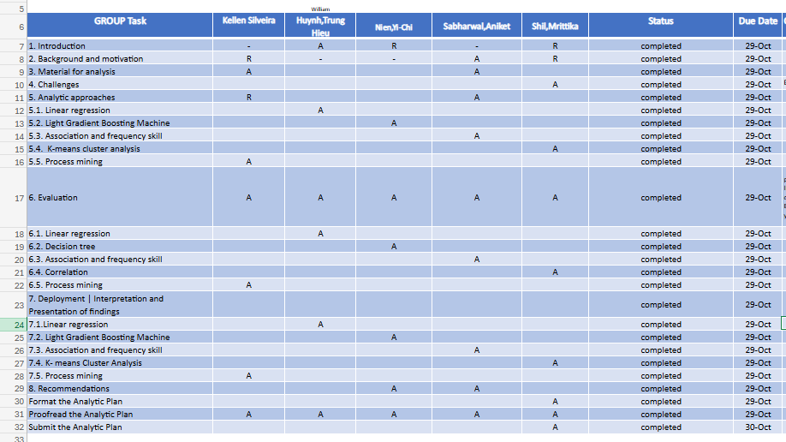

## APPENDIX C | Data Dictionary

The data dictionary serves as a reference guide, ensuring consistency and clarity in how the data is interpreted and utilized throughout the analytic plan.

|  |  |
| --- | --- |
| Job Link | |
| Definitions | A URL link to a detailed and specific job posting on LinkedIn. |
| Justifications | Provides direct access to the job listing for further details and verification. |
| Guidelines of Use | Verify that the link is active and correctly directs to the intended job posting. Periodically check for link validity as job postings may expire. |
| Data Type | String (URL) |
| Scope | Unique for each job listing, providing a direct reference to the original post. |
| Source | Data is derived from job postings such as those available on LinkedIn and collected datasets like [Kaggle - 1.3M LinkedIn Jobs and Skills 2024](https://www.kaggle.com/datasets/asaniczka/1-3m-linkedin-jobs-and-skills-2024). |

|  |  |
| --- | --- |
| Job Title | |
| Definitions | The title of the job position being advertised. |
| Justifications | Identifies the role being offered and is crucial for classification and categorisation in analysis, and for job seekers looking for specific titles. |
| Guidelines of Use | Use the exact job title as provided by the employer to ensure accuracy and consistency. Standardize common roles to avoid duplicates with different naming conventions. |
| Data Type | String (Text) - though standardization may be applied. |
| Scope | Specific to each job listing. |
| Source | Data is derived from job postings such as those available on LinkedIn and collected datasets like [Kaggle - 1.3M LinkedIn Jobs and Skills 2024](https://www.kaggle.com/datasets/asaniczka/1-3m-linkedin-jobs-and-skills-2024). |

|  |  |
| --- | --- |
| Company | |
| Definitions | The name of the company that is hiring for the job position. |
| Justifications | Identifies the employer, which is essential for company-specific analysis and understanding industry trends. Also, allowing job seekers to search for opportunities by company name. |
| Guidelines of Use | Ensure the company name is recorded accurately and consistently. Avoid abbreviations unless commonly recognized. |
| Data Type | String (Text) |
| Scope | Unique to each job listing, representing the hiring company. |
| Source | Data is derived from job postings such as those available on LinkedIn and collected datasets like [Kaggle - 1.3M LinkedIn Jobs and Skills 2024](https://www.kaggle.com/datasets/asaniczka/1-3m-linkedin-jobs-and-skills-2024). |

|  |  |
| --- | --- |
| Job Location | |
| Definitions | The physical location of the job, including the city and state. |
| Justifications | Indicates where the job is based, which is important for geographical analysis and understanding the distribution of job opportunities. Also, helps job seekers filter opportunities by geographic location. |
| Guidelines of Use | Ensure the location is recorded in a standard format (e.g., "City, State"). |
| Data Type | Standardized geographic locations/addresses. |
| Scope | Location-specific to each job posting. |
| Source | Data is derived from job postings such as those available on LinkedIn and collected datasets like [Kaggle - 1.3M LinkedIn Jobs and Skills 2024](https://www.kaggle.com/datasets/asaniczka/1-3m-linkedin-jobs-and-skills-2024). |

|  |  |
| --- | --- |
| Job City | |
| Definitions | The city where the job search is focused or where the job is located. |
| Justifications | Used for filtering and analysing job opportunities by city, providing insights into local job markets. |
| Guidelines of Use | Record the city name accurately. If the job is remote or flexible, indicate this clearly. |
| Data Type | String (Text) - though standardization may be applied. |
| Scope | Specific to each job listing. |
| Source | Data is derived from job postings such as those available on LinkedIn and collected datasets like [Kaggle - 1.3M LinkedIn Jobs and Skills 2024](https://www.kaggle.com/datasets/asaniczka/1-3m-linkedin-jobs-and-skills-2024). |

|  |  |
| --- | --- |
| Job Country | |
| Definitions | The country where the job is located or where the job search is focused. |
| Justifications | Essential for geographical analysis and understanding the distribution of job opportunities across different countries. |
| Guidelines of Use | Ensure the country is accurately recorded. Use the full country name rather than abbreviations. |
| Data Type | String (Text) - though standardization may be applied. |
| Scope | Specific to each job listing. |
| Source | Data is derived from job postings such as those available on LinkedIn and collected datasets like [Kaggle - 1.3M LinkedIn Jobs and Skills 2024](https://www.kaggle.com/datasets/asaniczka/1-3m-linkedin-jobs-and-skills-2024). |

|  |  |
| --- | --- |
| Job Position | |
| Definitions | The general position or category of the job, often aligned with the job title. |
| Justifications | Helps in categorising jobs into broader roles or functions for analysis. |
| Guidelines of Use | Ensure the position is clearly defined and matches the job title. Use consistent terminology across entries. |
| Data Type | String (Text) |
| Scope | Broad categorisation of the job role. |
| Source | Data is derived from job postings such as those available on LinkedIn and collected datasets like [Kaggle - 1.3M LinkedIn Jobs and Skills 2024](https://www.kaggle.com/datasets/asaniczka/1-3m-linkedin-jobs-and-skills-2024). |

|  |  |
| --- | --- |
| Job Level | |
| Definitions | The seniority level of the job position. |
| Justifications | Identifies the experience level required, which is crucial for candidates and for market segmentation. |
| Guidelines of Use | Use the job level as specified by the employer. Standardise the terminology where possible (e.g., Associate, Mid Senior) |
| Data Type | Picklist (Associate, Mid Senior) |
| Scope | Represents the required seniority for the job role. |
| Source | Data is derived from job postings such as those available on LinkedIn and collected datasets like [Kaggle - 1.3M LinkedIn Jobs and Skills 2024](https://www.kaggle.com/datasets/asaniczka/1-3m-linkedin-jobs-and-skills-2024). |

|  |  |
| --- | --- |
| Job Type | |
| Definitions | The nature of the job in terms of work arrangement (e.g., Onsite, Remote). |
| Justifications | Indicates the work environment, which is crucial for candidates with specific preferences or requirements. |
| Guidelines of Use | Record the job type exactly as specified by the employer. If the job type is hybrid, indicate the proportion of onsite versus remote work if available. |
| Data Type | Picklist (Hybrid, Onsite, Remote) |
| Scope | Specific to each job listing. |
| Source | Data is derived from job postings such as those available on LinkedIn and collected datasets like [Kaggle - 1.3M LinkedIn Jobs and Skills 2024](https://www.kaggle.com/datasets/asaniczka/1-3m-linkedin-jobs-and-skills-2024). |

|  |  |
| --- | --- |
| Job Skills | |
| Definitions | Specific abilities, competencies, and qualifications required to perform tasks effectively in various job roles, including both hard skills (technical, specialized knowledge) and soft skills (communication, leadership, etc.). |
| Justifications | Critical for identifying and categorizing positions across different industries. Helps job seekers understand requirements and employers specify expectations. Supports filtering and analysis of job listings, aiding market research and career planning. |
| Guidelines of Use | Use the exact job skills as listed by employers to ensure data accuracy. |
| Standardize common skill terms to avoid duplicates (e.g., "Project Management" vs. "Project Planning"). |
| Categorize skills into relevant groups (e.g., technical, managerial, healthcare-specific) to facilitate analysis and reporting. |
| Data Type | String (Text) - though standardization may be applied. |
| Scope | Specific to each job listing. Skills cover a wide range of sectors (e.g., healthcare, IT, construction, sales, manufacturing). Must be updated and expanded to reflect industry trends and demands. |
| Source | Data is derived from job postings such as those available on LinkedIn and collected datasets like [Kaggle - 1.3M LinkedIn Jobs and Skills 2024](https://www.kaggle.com/datasets/asaniczka/1-3m-linkedin-jobs-and-skills-2024). |

|  |  |
| --- | --- |
| Job Summary | |
| Definitions | A description of the job role, outlining key responsibilities, tasks, and expectations. |
| Justifications | Provides a summary of the job's core duties and required expertise, useful for quickly assessing the role's requirements. |
| Guidelines of Use | Ensure the summary is a concise reflection of the full job description. It should cover the main aspects of the role without extraneous details. |
| Data Type | String (Long Text) |
| Scope | Summarises the responsibilities and duties associated with the job role. |
| Source | Data is derived from job postings such as those available on LinkedIn and collected datasets like [Kaggle - 1.3M LinkedIn Jobs and Skills 2024](https://www.kaggle.com/datasets/asaniczka/1-3m-linkedin-jobs-and-skills-2024). |

|  |  |
| --- | --- |
| First Time Seen | |
| Definitions | The timestamp indicating the first instance a record or item was observed by an applicant. This field captures the initial occurrence for tracking purposes. |
| Justifications | This field is critical for understanding the lifecycle of items or records within the system, facilitating analysis on trends, usage patterns, and historical reference. It helps in identifying new entries and assessing their impact over time. |
| Guidelines of Use | Avoid modifying this field after initial entry, as it is intended to reflect the original observation date. |
| Data Type | Date (YYYY-MM-DD) |
| Scope | Applicable to all records or items requiring tracking of their initial observation. This field is relevant in record management, analytics, and reporting contexts. |
| Source | Data is derived from job postings such as those available on LinkedIn and collected datasets like [Kaggle - 1.3M LinkedIn Jobs and Skills 2024](https://www.kaggle.com/datasets/asaniczka/1-3m-linkedin-jobs-and-skills-2024). |

|  |  |
| --- | --- |
| Last Processed Time | |
| Definitions | The date and time indicating the most recent instance when a record or item was processed within the system. This field captures the last update or action taken on the item. |
| Justifications | This field is crucial for tracking the status and lifecycle of items or records, allowing for monitoring and management of workflows. It aids in determining the freshness of data and ensuring timely processing. |
| Guidelines of Use | Populate this field each time a record is processed or updated.  Ensure that the field is automatically updated by the system to reflect the latest processing time. |
| Data Type | Date (YYYY-MM-DDTHH:MM) |
| Scope | Applicable to all records or items that require tracking of their processing status. This field is important for data management, analytics, and reporting processes. |
| Source | Data is derived from job postings such as those available on LinkedIn and collected datasets like [Kaggle - 1.3M LinkedIn Jobs and Skills 2024](https://www.kaggle.com/datasets/asaniczka/1-3m-linkedin-jobs-and-skills-2024). |

## APPENDIX D | Kellen V. H. Silveira – HERKY010

### Appendix D.1 | Process Mining - Analysis

Accordantly to Bozkaya et al.(2009), process mining analyses event logs to offer insights into how processes are carried out. It helps organisations understand the actual process flow, identify bottlenecks, check if logs conform to specifications, and explore collaboration patterns. Key areas include performance metrics, process discovery, conformance checking, and social networks. These insights assist organisations in assessing their control over processes and ensuring it accurately reflect business operations (Van Eck et at., 2015).

Figure 1 illustrates a process mining workflow, starting with events, which are refined through filtering. These filtered events are then used in process mining to generate a discovered model, while a manual model can be developed alongside. Both models are compared in a map step. The process includes data visualisation, which draws from the events and feeds into a combined map/data visualisation. The workflow integrates steps of filtering, mining, modelling, and visualising to analyse and map event data (Van der Aalst et al., 2011).



Figure 1: High-level visual of process mining

Process mining involves various techniques for extracting, visualising, and analysing process information from event data recorded in event logs. Its focus is on analysing end-to-end business processes. By using data collected during process execution, it generates models that depict how these processes are carried out and monitors their ongoing performance. This method provides organisations with ‘behavioural visibility’, allowing analysts to identify specific actions and individuals that may require further investigation, especially when a process does not perform as expected (Badakhshan et al., 2022).

There are three core components in process mining (Andreswari et al., 2022):

* Process Discovery: using event logs to generate a visual model of the process.
* Conformance Checking: comparing the discovered process model to a pre-defined model to detect deviations.
* Performance Analysis: identifying bottlenecks, throughput times, and inefficiencies within the process.

In the context of the US consulting firm seeks insights into the U.S. job market for Business Analyst roles case study, process mining helped understand the entire journey of job seekers or how companies recruit candidates. It also allowed to analyse patterns and identify how numerous factors such as employers, skills, and locations interact with each other in the job market for Business Analyst qualifications.

The dataset ([Kaggle - 1.3M LinkedIn Jobs and Skills 2024](https://www.kaggle.com/datasets/asaniczka/1-3m-linkedin-jobs-and-skills-2024)) focuses on job postings for Business Analyst positions, providing valuable insights into key trends and patterns across required skills, job locations, seniority levels, job types, first time seen and last processed time. By analysing these elements, it was possible to understand the job market demand for Business Analysts and the expectations companies have for this role.

The dataset contains job postings and associated skills. While it is not a traditional process mining event log, process mining principles were applied to extract insights related to recruitment flows, such as:

* Company Hiring Patterns: identify which companies post more jobs, for which positions, and the associated skills.
* Skills Sets Analysis: analyse which skills are most in demand and the companies that prefer specific skill sets.
* First Time Seen: identify when an applicant first saw the positions. This insight can highlight the initial interest in a job and how quickly applicants engage with new listings.
* Last Processed Time: indicate the most recent date and time when a jon position was updated.

Process mining is an emerging technique that leverages data analytics and process management principles to examine the flow of activities within a dataset. This technique provides insights into how processes are carried out, revealing common patterns, deviations, and inefficiencies. In the context of analysing job postings, process mining allowed to explore recruitment patterns, identifying what employers seek in Business Analyst candidates, the types of positions they offer, and the skills they prioritise.

To apply process mining to a dataset of job postings, each job listing was treated as an individual case or process instance. Each attribute within the dataset, such as the job title, company, location, skills, job level, job type first time seen and last processed time, were viewed as a stage or component of the recruitment process for filling Business Analyst-related roles. By deploying process mining techniques, it was mapped out common themes and variations in the recruitment practices across different employers.



Figure 2: Job Posting Process

Figure 2 represents the process discovery, process mining core element, it refers to the construction of a visual representation of the recruitment process specifically for Business Analyst roles. In this visualisation, we can trace the lifecycle of job postings, from the moment a position is opened to the skills and location, among others specified.

Additionally, process discovery allowed to delve into the skills most commonly associated with Business Analyst positions. By examining the dataset, it was possible to determine the skills, such as SQL, data analysis, or project management, are frequently listed alongside "Business Analyst" in job postings. Process discovery thus uncovers recruitment patterns that are consistent across different employers, industries, and locations, while also revealing variations in attributes such as job level or skill requirements.

Conformance checking is a process mining technique that compares actual recruitment practices to an expected or idealised model. In this case, conformance checking was used to assess whether companies adhere to a standardised approach when recruiting for Business Analyst roles.

One aspect of conformance checking involves examining the consistency in required qualifications. By scrutinising the dataset, it was possible to determine if different employers follow similar criteria when specifying required skills for Business Analyst candidates. This comparison revealed whether certain qualifications, certifications, or experiences are universally valued in the industry, or if there are considerable differences between companies.

Performance analysis focused on identifying inefficiencies, bottlenecks, or delays in the recruitment process. The "First Time Seen" variable served as a pivotal timestamp within the job positions dataset, specifically indicating when an applicant first encountered a particular job listing. This detail played an essential role in analysing applicant behaviour and the lifecycle of job postings.

The "Last Processed Time" variable was a vital timestamp within the job positions dataset that records the most recent date and time when a specific job listing was updated or reviewed.

Process mining provided a comprehensive method for analysing job postings data, enabling an in-depth understanding of recruitment patterns for Business Analyst roles. By applying process discovery, conformance checking, and performance analysis to the dataset valuable insights were provided into employer preferences, skill requirements, and job location trends. Key metrics such as employer patterns, geographical trends, and skill decomposition further enhance the analysis, offering a structured approach for identifying significant trends.

### Appendix D.2 | Process Mining - Result of analysis

The most frequently listed skills for business analyst roles highlight a broad range of technical and functional competencies. These include business analysis, data analysis, data visualisation, and ERP Implementation. Such skills suggest a strong demand for professionals who can analyse business processes, draw insights from data, and implement enterprise resource planning (ERP) systems. The inclusion of skills like procurement and financial management also indicates that business analysts are being employed across diverse sectors, requiring a multifaceted understanding of both technology and business operations. This reflects the evolving nature of the role, which now spans operational, strategic, and technical areas.

The dataset shows that the majority of business analyst job postings are located in the United States, specifically in Tennessee. While the data might not reflect a broad global distribution, the high concentration in the U.S. points to a robust demand for business analysts in this region, particularly in states with thriving industries or large business hubs. This aligns with the widespread adoption of digital transformation strategies by U.S. businesses, which require skilled business analysts to bridge the gap between IT and business processes.

The majority of business analyst roles are categorised at the mid-senior level, indicating that companies are seeking candidates with substantial experience and advanced skills. Mid-senior level roles suggest that employers expect business analysts to manage complex projects, lead teams, and provide critical insights for strategic decision-making. This also implies that there are fewer entry-level positions available, due to the specialised nature of the tasks involved. Business analysts at this level are often required to work closely with senior management and other stakeholders to ensure the successful delivery of business outcomes.

The data shows a preference for onsite business analyst positions, with fewer remote or hybrid roles listed. This may be indicative of industries or organisations that require physical presence due to the collaborative or sensitive nature of the work. For instance, roles involving ERP implementation or procurement might necessitate onsite coordination with various departments. However, it is worth noting that the job market is evolving, and future trends may see more flexibility in work arrangements as remote work becomes more integrated into business operations.

The business analyst job market, as reflected in the dataset, shows a demand for highly skilled professionals who possess a wide range of technical and business expertise. The majority of roles are at the mid-senior level, indicating the need for experienced individuals capable of taking on leadership responsibilities. Additionally, the U.S. remains a key location for these roles, and while the majority are onsite positions, there may be future shifts towards more flexible working arrangements. These trends highlight the importance of adaptability and continuous skill development for business analysts as the role continues to expand in scope and influence across industries.

Below are the key findings from the dataset:

Top 10 Companies Hiring for Business Analyst Roles, Figure 3:

* Tata Consultancy Services: 52 listings
* Dice: 37 listings
* NR Consulting: 25 listings
* Stellent IT: 25 listings
* Robert Half: 19 listings
* Software Technology Inc.: 17 listings
* TekIntegral: 13 listings
* Intellectt Inc: 9 listings
* Jobs for Humanity: 8 listings
* CACI International Inc.: 8 listings



Figure 3: Top 10 Companies Hiring BA’s

Top 10 Job Positions Related to Business Analyst Roles, figure 4:

* Management Analyst: 316 listings
* Job Analyst: 131 listings
* Economist: 88 listings
* Consultant Education: 76 listings
* Instructor Business Education: 65 listings
* Quality Assurance Analyst: 35 listings
* Market-Research Analyst I: 19 listings
* Change Person: 10 listings
* Charter: 4 listings
* Designer: 2 listings



Figure 4: Top 10 Job Positions Related to BA

Top 10 Skills Listed in Job Postings:

* Business Analysis: 313 occurrences
* Communication: 221 occurrences
* Project Management: 197 occurrences
* Data Analysis: 170 occurrences
* SQL: 158 occurrences
* Business Analyst: 131 occurrences
* Requirements Gathering: 119 occurrences
* Problem Solving: 101 occurrences
* Agile: 92 occurrences
* Teamwork: 92 occurrences



Figure 5: Hourly Time Distribution of Processed Jobs

Figure 5 presents a detailed view of processed business analyst (BA) job positions over a series of hours in January 2024. The y-axis labelled “# BA Positions,” indicates the volume of processed job entries, with values reaching up to 320, while the x-axis shows the hourly breakdown across a few specific dates in January.

The sharp peak on January 21 may signal a heavy data processing load within that hour, due to batch processing or a high influx of job postings. This level of variability could suggest scheduled data processing times or periods of high demand. These trends underscore potential bottlenecks that may require attention to manage processing loads more evenly. Additionally, if these peaks are part of regular patterns, resource adjustments could be made during peak hours to ensure efficient and timely processing.

Trends Observed:

* The data shows significant fluctuations in the processing times throughout the brief period.
* There is an initial high point on January 19, with processed time.
* After that, there is a drop, reaching a low point.
* A spike is observed again on January 20, followed by another peak, the highest in the chart, on January 21.

These findings highlight the companies most actively hiring for business analyst roles, the diverse positions associated with these roles, and the critical skills employers seek.

Based on the process mining analysis of the dataset, here are some key trends, patterns, and results derived from the job listings for Business Analyst roles on LinkedIn in 2024:

Employer Patterns:

* Top Employers: Large consulting and IT firms dominate the hiring landscape, with Tata Consultancy Services, Dice, and NR Consulting leading in job listings for business analyst roles. This trend suggests that consulting and tech companies are prioritizing business analysis skills, likely to support various client projects or internal business operations.
* Concentration of Job Listings: The top 10 companies alone account for a massive portion of the job listings, which may indicate limited competition among employers in certain regions or specific sectors, particularly in consulting and IT.

Job Position Patterns:

* Range of Positions: While "Business Analyst" remains a common title, other associated positions such as "Management Analyst," "Quality Assurance Analyst," and "Market-Research Analyst" are also prevalent. This shows that the business analysis skill set is valuable in various analytical and quality assurance roles.
* Seniority Level: Most roles identified are mid-level positions, aligning with the demand for experienced professionals capable of performing independent analysis and decision-making.

Skills Trends:

* Core Business Analyst Skills: Key skills frequently listed include Business Analysis, Project Management, Data Analysis, Requirements Gathering, and Problem Solving. These are foundational competencies for a business analyst role, reflecting a strong emphasis on both technical and analytical skills.
* Technical Skills: SQL and Agile methodologies are highly sought-after, suggesting that employers value business analysts who can work within data-driven and Agile environments.
* Soft Skills: Communication and teamwork are also frequently mentioned, indicating that business analysts are expected to collaborate effectively and communicate insights to various stakeholders.

Geographic Patterns:

* Location Concentration: Many of the listed job positions are located in major U.S. cities or tech hubs, such as New York, Virginia, and Minnesota. This pattern suggests that demand for business analysts is strong in regions with concentrated business and tech industries.
* Onsite Work Preference: A large number of these roles are designated as "Onsite," indicating that despite global shifts toward remote work, companies hiring business analysts may still prefer candidates to work from office locations, to facilitate teamwork and closer interaction with clients.

Process Mining Insights:

* Event Flows: The event log (job postings) flows from company listings to position offerings, and finally to skills required. This pattern allows for a high-level model showing:
  + Employer Demand: Filtering by company reveals hotspots for business analyst positions, identifying firms with frequent openings and potential areas for job seekers to target.
  + Skills Mapping: By decomposing the job skills, the process mining model helps map specific skills to roles, which shows that some skills like SQL and Agile are in high demand for certain titles (e.g., "Data Analyst" or "Quality Assurance Analyst") but less so for generalist roles.

The process mining analysis reveals strong demand from consulting and IT firms, with specific expectations around technical skills like SQL and Agile, coupled with essential business analysis competencies. The geographic clustering in major cities and preference for onsite roles suggests a competitive market, particularly for skilled analysts who can adapt to data-intensive environments and Agile workflows. The model demonstrates clear event pathways from company demand to skill requirements, providing a map that illustrates which qualifications are most critical for various job types.

### Appendix D.3 | Process Mining - Interpretation of your findings

It is reasonable to assume that the demand for business analysts will continue to grow as organisations increasingly rely on data-driven decision-making. The ongoing digital transformation across various industries necessitates a greater focus on business intelligence and analytics. As companies collect vast amounts of data, the need for professionals who can analyse this data and derive actionable insights is expected to rise. The evolving landscape of business operations suggests that those with business analysis skills will be crucial for organisations aiming to remain competitive in a data-centric environment.

The necessity for technical skills, particularly in data analysis and proficiency in tools like SQL, will become even more pronounced. As organisations shift towards a more data-centric approach, the ability to work with data and utilise analytical tools will be essential for business analysts. Job postings are likely to increasingly require expertise in data visualisation software and programming languages. This shift reflects the growing expectations placed on business analysts to not only interpret data but also to manipulate and present it effectively.

Moreover, many organisations are likely to maintain a preference for onsite business analyst roles, especially within sectors where collaboration and immediate problem-solving are paramount. The analysis indicates that companies often require physical presence for roles involving complex implementations, such as ERP systems. This preference may persist as organisations recognise the value of face-to-face interactions and the facilitation of collaborative problem-solving that onsite roles provide.

Entry-level positions in business analysis will remain scarce, leading to increased competition among candidates seeking to enter the field. The concentration of mid-senior level roles suggests that organisations are primarily looking for candidates with substantial experience. Consequently, newcomers may need to pursue internships or related positions to build the necessary qualifications and practical experience required for mid-level roles. This situation may create challenges for those attempting to break into the field without prior experience.

It is likely that job opportunities for business analysts will continue to be concentrated in specific geographic regions, particularly in urban centres and areas with a strong business presence. The analysis highlights a high concentration of job postings in the United States, especially in states such as Tennessee. This trend suggests that urban areas with thriving industries will remain the primary employers of business analysts. As such, candidates may need to consider relocating or targeting their job searches towards these key markets.

Additionally, the roles and titles associated with business analysis are expected to evolve, reflecting the expanding scope of the profession. As organisations recognise the importance of business analysis across various functions, a broader array of job titles and responsibilities may emerge. This may include roles such as "Data Analyst," "Management Analyst," and "Quality Assurance Analyst," indicating the growing applicability of business analysis skills across different contexts.

In addition to technical expertise, it is reasonable to assume that soft skills, particularly communication and teamwork, will become increasingly important for business analysts. Given the collaborative nature of the role, professionals in this field must effectively engage with stakeholders and convey insights. Consequently, employers are likely to prioritise candidates who demonstrate strong interpersonal abilities alongside technical competencies.

## APPENDIX E | Aniket Sabharwal, Sabay023

### APPENDIX E.1 | Background and Motivation

The US consulting firm seeks insights into the U.S. job market for Business Analyst roles with the primary goal to analyse job postings from LinkedIn to uncover key trends, such as the most in-demand skills, top hiring companies, and geographic distribution of job listings in the United States. This analysis particularly emphasizes on identifying the frequent skill combinations using Apriori Association Rule Mining to provide a deeper understanding of the ideal skill sets for Business Analyst positions in the United States market as well the trends of these associated skills. By understanding these skill combinations and their relevant metrics, the US Consulting firm can then tailor their strategy to match the industry requirements.

### APPENDIX E.2 | Material for Analysis

#### Data Description

The dataset used for this analysis consists of job listings extracted from LinkedIn, specifically targeting Business Analyst roles in the United States. The key columns include job links, job title, company, location, skills, and job levels. The Job Skills field was particularly important for Association Rule Mingling as it listed multiple skills in a comma-separated format, which was processed for association analysis, as this will help us build a relationship amongst the various skills and their occurrence by converting the skills into a list and binary entities

#### Data Dictionary

The data used for this analysis focuses on various aspects of job postings that have been extracted from LinkedIn. The scope of our analysis was to analyse the job postings from United States particularly with respect to Business Analyst role. We saw that there are some key columns that will help us refine the dataset for our analysis.

From our understanding of the data Country, Job Title, Job Links and Job Skills are some very crucial aspects to justify our analysis and come up with the desired analytical metrics and co-relations.

Country – The country was an initial determinant in the scope. Our scope includes analysing the United States job listings and the country variable will help us refine the data.

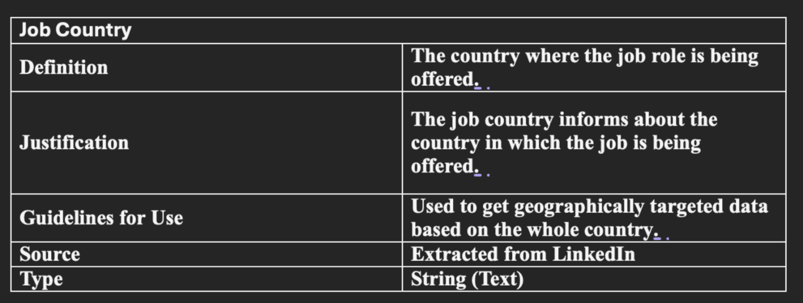

Job Title – The job title will help us refine the job listing to just that of Business Analyst roles to work on the exact data.

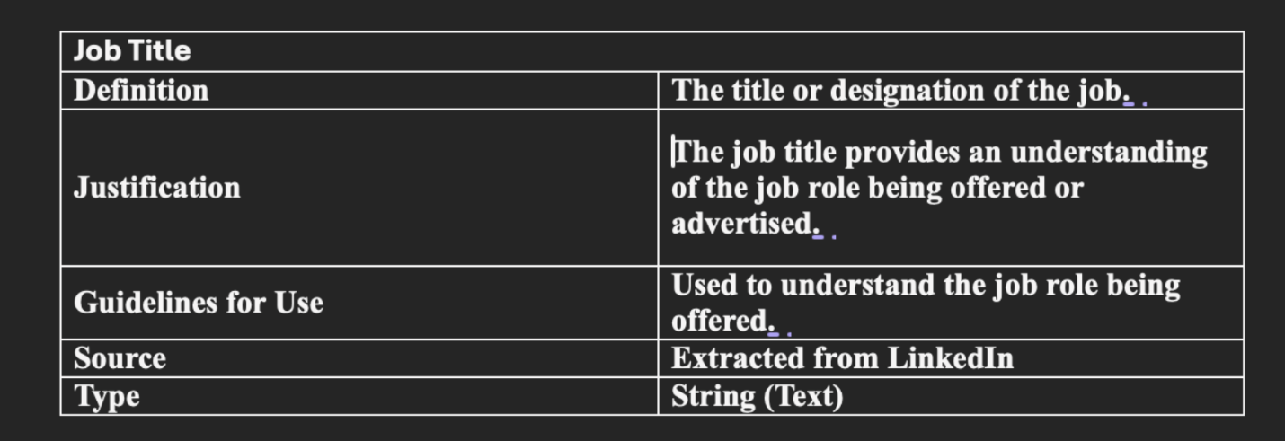

Job Links – The job links is the only variable that is present in all the datasets and will act as a joining metric for joining the datasets.

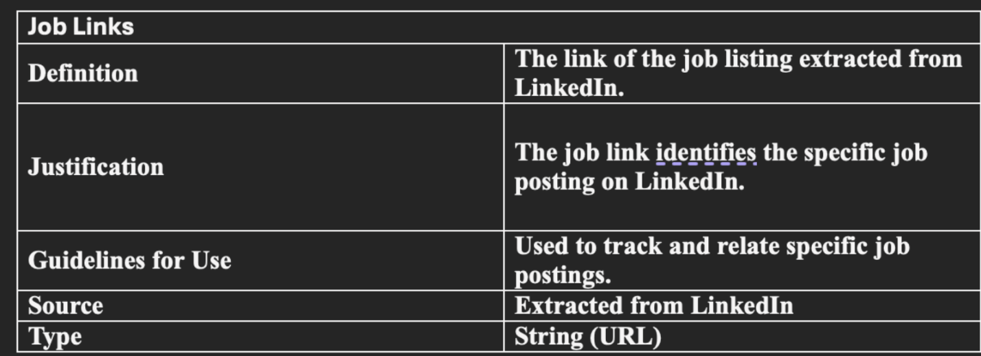

Job Skills – The job skills will help us analyse the various skills required for different types and positions of job listings.

### APPENDIX E.3 | Analytical Approach

I have used the Apriori Association Rule Mining model for my contribution of the analysis.

#### Data Preparation

The data extracted from LinkedIn needed to be cleaned and filtered in accordance with the Apriori Association Model. All the refinement of the data was done using Knime. The data was first cleaned by removing all the redundant columns and joined using the Job Links which can be seen in Figure 9 - Data before cleaning. The data after cleaning was filtered in accordance with our scope, which gave us data on Business Analyst roles in the United States.

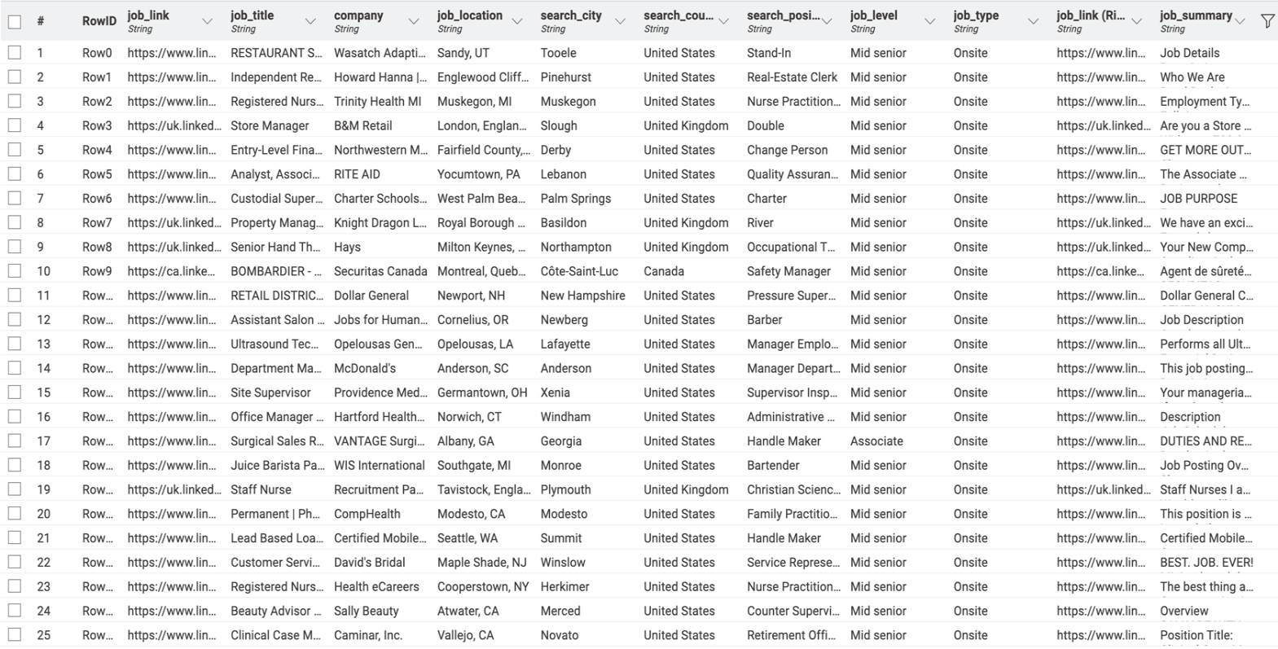

Figure 9 - Data before cleaning

Now that the data was cleaned and filtered which can be seen in Figure 10 - Data after Refinement, the data was modified in accordance with the Apriori Association Model which required the job skills to be interpreted as a single transaction, but the current dataset has skills mentioned as ‘string’. We split the skills as converted the output as a list which could now be used for the association model. (Kantardzic, 2019)

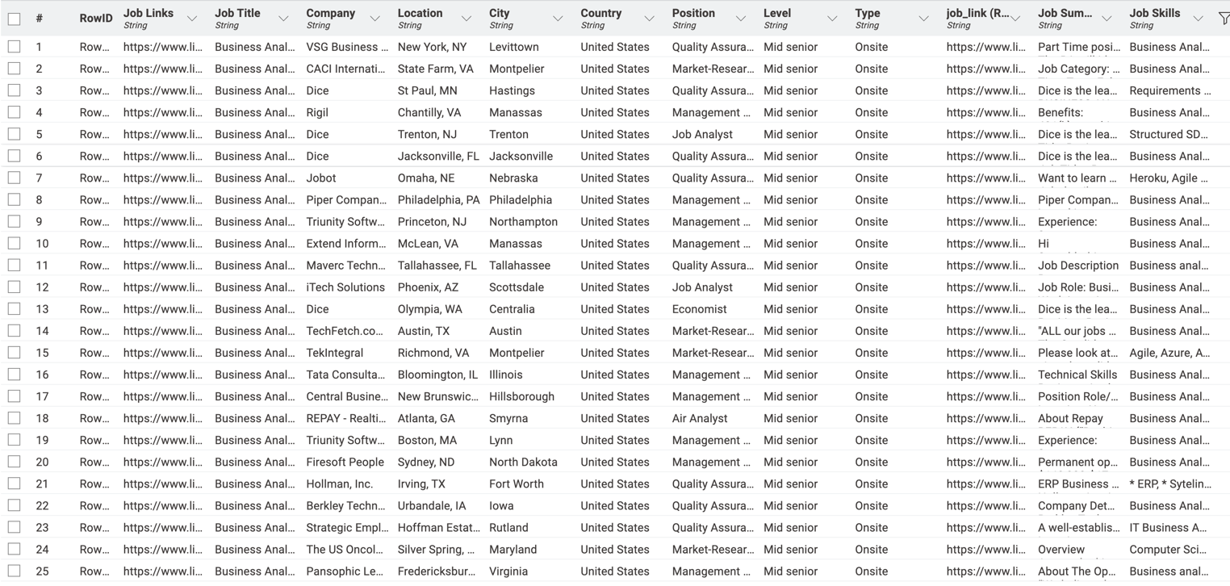

Figure 10 - Data after Refinement

The output could now be used to identify the item set based on the Apriori Algorithm. Once we have the output from the item set finder based on the Apriori Algorithm, we can use it to fabricate results based on our scenario by setting the relevant controls.

#### Association Rule Mining

We applied the Apriori Association Rule Mining to identify frequent skill combinations with respect to our scope of Business Analyst Role in the United States. The Apriori Association Rule calculates the following metrics:-

**Support:** The support tells us how often a certain combination of skills appear in the processed dataset. (Kantardzic, 2019)

**Confidence:** The confidence represent how likely is the presence of the identified combination of skill. It will help us to analyse the probability of various skills being associated with the presence of another skill. (Kantardzic, 2019)

**Lift:** Lift will tell us about the likelihood of any of the combinations occurring compared to the independent occurrences. (Kantardzic, 2019)

#### Model Specific Controls

To get the desired results from our model, we need to set specific controls which would give us accurate and relevant data.(Bao et al., 2021) The first control particular to Apriori Association Rule Mining was set in the Item Set Finder where we restricted the set size to a maximum and minimum of 2 indicating we need a set of 2 skills with a minimum support of 10% which will only give us sets that are present in at least 10% in the given data. Similar limits and controls were set in the Association Rule Learner with a Minimum Rule Confidence of 10%, all these can be observed in Figure 11- Table Set Finder and Figure 12- Association Rule Learner.



Figure 11- Table Set Finder



Figure 12- Association Rule Learner

#### Adjustments to Plan

In our initial plan, we were just planning to work on the induvial occurrence of skills and the relevant areas of analysis. We have now refined our analysis to various models to best utilise the strengths of various models to find the most accurate data and in turn provide the best possible recommendations to the US Consulting Company.

### APPENDIX E.4 | Results and Findings

After all the refinement of the data in accordance with the Apriori Association with all the relevant controls, we got the desired results. We got all the relevant metrics to analyse the top skill combinations along with their supporting metrics. The output table from Knime has been shown below showing the top 5 skill combinations.



Figure 13 - Knime Results

#### Confidence of Skill Combinations

The bar chart shown below depicts the visual representation of the results of the model in accordance with the top 5 skill combinations.



Figure 14 - Confidence Levels for Skill Combinations

Figure 7 gives us a good insight into the confidence levels derived from our results. High confidence levels depict the reliability of certain skill when the other skill in the combination is present. The top skill combinations present are :-

1. Business Analysis and Data Analysis
2. Business Analysis and Requirements Gatherings

Both these combinations have a confidence of 50% depicting that these skills are often found together in job listings. The following 3 skill combinations Business Analysis and Project Management, Communication and Business Analysis, and Communication and Project Management have 33.3% confidence that suggests they are also crucial to the given analysis but less consistently available.

#### Lift for Skill Combinations

The chart below shows the lifts associated with the top 5 skill combinations derived from the result of our analytical model.



Figure 15 - Lift for Skill Combinations

Figure 8 tells us that these lift values for each skill combination depict how much more often the skills appear together compared to their independent occurrence. The skill combination with the highest lift is Communication and Project Management with a lift value of 2.11 which depicts that communication and project management are present and required together. Other important skill pairs are Business Analysis and Data Analysis and Business Analysis and Requirements Gathering which have lift values of 1.90, further reinforcing their strong association.

#### Conclusion of Findings

After analysing all the results, we found the top 5 skill combinations to be:-

1. Business Analysis and Requirements Gatherings
   * Confidence – 50%
   * Lift – 1.90
2. Business Analysis and Data Analysis
   * Confidence – 50%
   * Lift – 1.90
3. Communication and Project Management
   * Confidence – 33.3%
   * Lift – 2.11
4. Business Analysis and Project Management
   * Confidence – 33.3%
   * Lift – 1.27
5. Communication and Business Analysis
   * Confidence – 33.3%
   * Lift – 1.27

#### Resulting Model

The resulting model used the Apriori Association Rule Mining and their relevant metrics to analyse and identify the top 5 skill combinations required for Business Analysts. The analysis focused on various skills present in our dataset extracted from LinkedIn. The following findings can be concluded from the results of our analytical model.

* Core Skill - Business Analysis was found at the core of all the skills and has been a part of majority of skills in the whole dataset as well as our results.
* Technical Skills – Technical skills which include Data Analysis, Requirements Gathering and Project Management were found to be important complementors of our core skill.
* Soft Skills – Communication which is a soft skill has also been considerably paired with the core and technical skills which shows the importance of soft skills.

### APPENDIX E.5 | Interpretations

After analysing the key skill combinations that employers value in Business Analysts today. In this section, we interpret these findings to understand their significance, assess the strengths and weaknesses of the model, and discuss what these insights mean for the US Consulting Company.

#### Key Insights from the Analysis

##### Communication and Project Management

* + The combination of Communication and Project Management is a promising skill combination with a lift of 2.11, showing that employers really value professionals who can both manage projects and communicate effectively. It shows that businesses aren’t just looking for people who can keep a project on track but they need individuals who can also keep everyone informed and aligned with the project with their communication skills.

##### Business Analysis and Requirements Gathering

* + Business Analysis and Requirements Gathering came out with a confidence of 50%, which means that half of the job listings that require business analysis, gathering requirements is equally critical and sought after. This skill combination highlights the importance of understanding and documenting what various stakeholders might need. Employers are looking for Business Analysts who can lay a strong foundation of a project by ensuring they fully understand what’s required and plan accordingly with the ability to translate stakeholder needs into a clear and actionable plan.

##### Business Analysis and Data Analysis

* + The Business Analysis and Data Analysis combination, also with 50% confidence, highlights how important data has become in decision-making and particularly for Business Analyst roles. It’s no longer enough for Business Analysts to just understand business processes, they now need to analyse data to make informed recommendations to support any organisation. Employers want candidates who can dive into the data, find the key insights, and use those to drive strategic business decisions from which the business can benefit from or avoid any risks.

##### Business Analysis and Project Management

* + With a 33.3% confidence and 1.27 lift, the pairing of Business Analysis and Project Management indicates a growing expectation for Business Analysts to have project management skills in their portfolio of skills.
  + Employers are looking professionals who can do the analysis as well as manage the facilitation and delivery of projects. In many companies, Business Analysts are expected to be active participants in managing timelines and ensuring that project deliverables are met.

##### Communication and Business Analysis

* + The combination of Communication and Business Analysis, with a 33.3% confidence, emphasizes that technical know-how must go hand in hand with effective communication. With effective communication an employer is looking for a Business Analyst that is making sure everyone, from executives to frontline staff, understands the analysis. Employers are prioritizing candidates who can effectively bridge the gap between data and business strategy, ensuring everyone is on the same page and make business operations and decisions more streamlined.

### APPENDIX E.6 | Strengths, Weaknesses and Improvements of Model

#### Strengths:

* Practical Insight - The model provides practical insights and associations that are highly relevant for both employers and job seekers. By identifying which skills are frequently required together, it gives a clear idea of the key competencies needed to succeed in the role. (Kantardzic, 2019)
* Skill Combinations - It also gives a in-depth view  of skill requirements, emphasizing the importance of both technical and soft skills in accordance with the core skill. This balance is crucial for Business Analysts who need to excel in various aspects of their roles. (Pinheiro et al., 2023)

#### Weaknesses:

* Focus on Traditional Skills - One of the limitations is that the model focuses primarily on traditional skills. It may miss emerging competencies which can be on the rise and are not majorly sough after at the moment.(Mlakar et al., 2023)
* Reliance on Data - The model is also based on current job postings, meaning it may not fully capture future needs or industry changes. With technology and business environments evolving rapidly, the demand for skills could shift, hence no predictive insights can be provided. (Kantardzic, 2019)

#### Possible Improvements:

* Single Sourced Data – LinkedIn is the single source for all of our data which does not have data of the companies that might not use LinkedIn as their recruitment platform, this can include smaller organisations as well as the leaders of the industry. Hence, exploring more datasets can be a viable improvement for the analysis. (Pinheiro et al., 2023)
* Integration with Additional Job Metrics - The model and findings can be further improved by further processing data into clusters of geographical buckets. We can particularly analyse skill combinations present in the top 5 cities to further analyse and support the findings of the model. (Kantardzic, 2019)
* Focus on Emerging Skills - An addition of time filter in the model can give us insight on the rise and decline in the demand of particular skill combinations, which can then suggest which skills stay in demand and what new skills are being requested more with time. The current dataset does not have relevant metrics to proceed with this analysis. The addition of time into the analysis can then provide insight about predictive future data as well as past trends. (Pinheiro et al., 2023)

### APPENDIX E.7 Recommendations

Based on the in-depth analysis of the U.S. job market for Business Analyst roles, strategic recommendations are outlined to assist both job seekers and employers in optimizing their approaches. The analysis highlights the importance of skill combinations and employer expectations that shape the hiring landscape. By leveraging these insights, job seekers can align their career development with market demands, and employers can enhance their recruitment processes to attract top talent.

#### Implications for Job Seekers

Job seekers should not only acquire individual skills but also ensure they develop the right combinations of skills. For example, combining technical skills like Business Analysis and soft skills like communication will significantly enhance their employability and overall efficiency of their workforce.

#### Implications for Employers

Employers should focus their recruitment efforts on candidates who have mastered technical, managerial and soft skills. The combination of Business Analysis and Project Management is especially important as demonstrated by the analysis.

Skill-Based Hiring: Companies should consider adjusting their job postings to reflect the importance of skill combinations rather than isolated technical competencies. This could improve the match between job seekers' qualifications and company expectations, especially in competitive markets.

### APPENDIX E.8 | Final Thoughts

The analysis highlights that employers are looking for a mix of core business analysis skills, complemented by technical expertise and strong communication skills. This combination is key to thriving in a dynamic work environment where Business Analysts are expected to do more than just analyse. Rather they need to lead, communicate, and drive projects forward. As businesses adapt to the demands of modern challenges, they need versatile candidates who can bring together technical, managerial, and interpersonal skills to ensure success.

## APPENDIX F | Ethan Nien - nieyy007

### Appendix F.1 | Background and motivation

This analytic research aims to provide career planning guidance for human resources agencies and job seekers seeking business analyst positions in the United States. The U.S. job is diverse, covering a wide range of regions, cities, job types, levels, and required skills. Therefore, how to provide specific and useful advice to job seekers in such a diverse environment is the main goal of this research.

The analysis of this report is based on the LinkedIn Jobs & Skills 2024 dataset on the Kaggle platform, which comes from the latest job information on LinkedIn and contains multiple fields such as job title, company name, location, and skill fields. Through detailed analysis of this data, the research aims to identify the key skill sets required at different job levels, such as associate and mid- to senior-level, which will help companies design more targeted recruitment strategies to ensure job descriptions include the most valuable skills for specific roles. It also provides some suggestions for job seekers to adjust their skills development plans and enhance their competitiveness in the job market.

Overall, the results of this research will not only help companies improve recruitment efficiency but also help job seekers to better understand market demands and plan a more targeted career development path accordingly. In addition, the research findings also have important reference value for fresh graduates and business analysts seeking promotion to higher positions. They can prepare job-required skill sets early based on the skills trends revealed to gain better career development opportunities.

### Appendix F.2 | Data Description

The dataset used in this analytic report comes from the 2024 Kaggle platform and contains the latest global job postings from LinkedIn in 2024. It consists of three files: job_summary.csv, job_skills.csv, and linkedin_job_postings.csv. These files all include a common field, job_link for job posting links, which plays a crucial role in joining these data sources.

The linkedin_job_postings.csv is the core data source for this research. It not only contains the URL for each job posting but also provides additional recruitment details such as job title, company name, job location, job level, and job type.

The job_skills.csv file further provides a list of required skills for each job. The skills are presented as comma-separated fields, listing multiple skill items that form the fundamental basis for the skill analysis in this research.

job_summary.csv contains summary information for each entry, including expectations and notes. However, due to the disorganized nature of the job_summary data in this file and its lack of consistent logical structure, it could not be effectively integrated with the other data. Therefore, it will be excluded from the analysis in the following action.

### Appendix F.3 | Data Preparation

#### Appendix F.3.1 | Data Clean

During the data preparation stage, this analysis report uses KNIME to join and clean the datasets. The entire KNIME workflow is shown in Figure a, which includes reading the initial dataset, transforming data formats, joining tables, applying filters to exclude irrelevant data columns such as job link, country/region, and first seen, etc., and finally outputting the cleaned dataset for modeling.

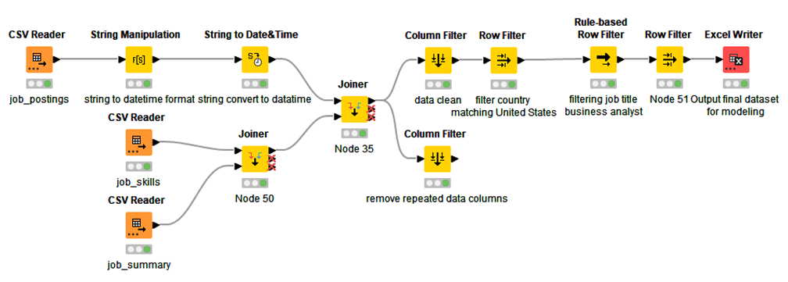Figure a: KNIME workflow overview

Since the columns got_summary, job_link, last_processed_time, got_ner, is_being_worked, first_seen and job_summary are irrelevant to our research goals, these columns cannot provide useful information for the prediction model. The data before cleaning is shown in Figure b. Hence, these unnecessary fields will be filtered and cleared using KNIME so that subsequent analysis can focus more on the core information required for this report.

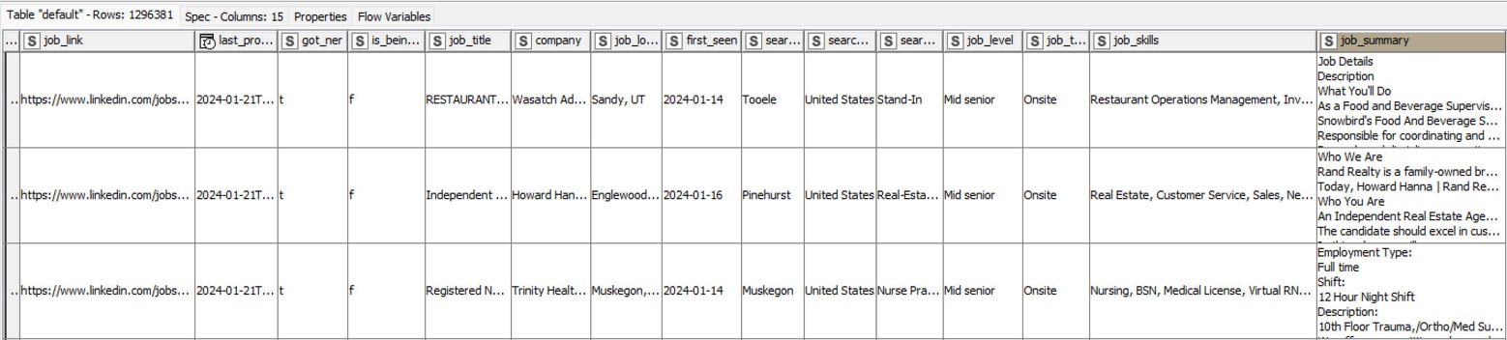Figure b: Original joint dataset

For example, the search_country field is filtered to only include job postings located in the United States, ensuring that the analysis remains focused on the U.S. job market, as shown in Figure c. The job_title field was also filtered to select only posts containing the text "Business Analyst" or "business analyst," narrowing it down to jobs that are particularly relevant to our analysis goals.

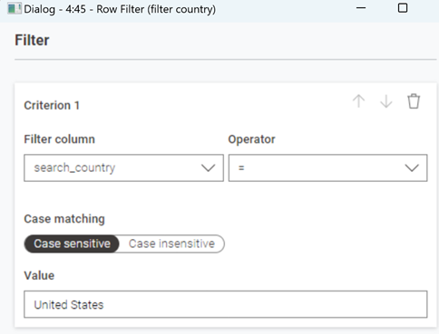

Figure c: Country filter (United States only)

The below Figure d presents the final state of the cleaned dataset which will be used for subsequent analytical actions.

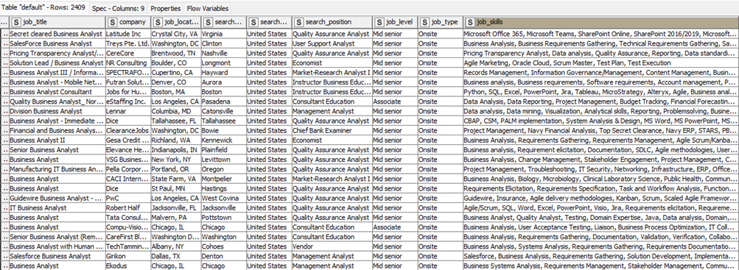Figure d: Dataset after cleaning

#### Appendix F.3.2 | Data Dictionary

In order to better understand the meaning and purpose of each field in the dataset, the following is a detailed description of the main fields:

|  |  |
| --- | --- |
|  | job_title |
| Definition | The title of the job position being advertised. |
| Justification | To categorize the nature of the job position. |
| Guidelines for Use | Use to categorize job postings by title for analysis or sorting. |
| Type | String (Text) |
| Source | linkedin_job_postings.csv |

job_title: This field represents the job title and displays the title of each recruitment position. In this analysis, use this field to filter for jobs related to Business Analyst to ensure that the analysis is focused on this job type.

|  |  |
| --- | --- |
|  | company |
| Definition | Name of the company offering the job. |
| Justification | To identify the employer for the job posting. |
| Guidelines for Use | Use to group or filter job postings by company. |
| Type | String (Text) |
| Source | linkedin_job_postings.csv |

company: The company name corresponds to each job position. Although this field is not used as a main feature in this analysis, it reflects the source of the data and the distribution of positions.

|  |  |
| --- | --- |
|  | job_location |
| Definition | The actual location of the job including state and city. |
| Justification | To display the job location for users to review. |
| Guidelines for Use | Use to filter or analyze job listings by location. |
| Type | String (Text) |
| Source | linkedin_job_postings.csv |

|  |  |
| --- | --- |
|  | search_city |
| Definition | The city where the job is searching for. |
| Justification | To specify the city of the job search is important for candidates who are looking for narrow-range location roles. |
| Guidelines for Use | Use to filter or analyze job postings based on search city. |
| Type | String (Text) |
| Source | linkedin_job_postings.csv |

|  |  |
| --- | --- |
|  | search_country |
| Definition | The country where the job is searching for. |
| Justification | To specify the country of the job search is important for candidates who are looking for jobs based on nations. |
| Guidelines for Use | Use to filter or analyze job postings based on search country. |
| Type | String (Text) |
| Source | linkedin_job_postings.csv |

job_location, search_city, search_country: These fields represent the specific location, city and country where the job is located, providing geographical information background. In this analysis, geographical variables were not directly used for model characterization but could serve as potential variables for further analyses.

|  |  |
| --- | --- |
|  | search_position |
| Definition | Unified job titles on Linkedin that companies are searching for. |
| Justification | Assist in grouping positions for further analysis. |
| Guidelines for Use | Use to categorize search results by job position. |
| Type | String (Text) |
| Source | linkedin_job_postings.csv |

|  |  |
| --- | --- |
|  | job_level |
| Definition | The level of the job position. |
| Justification | Use to filter or analyze jobs by level. |
| Guidelines for Use | To understand the experience or career level required for the job. |
| Type | String (Text) |
| Source | linkedin_job_postings.csv |

job_level: This field describes the level of the job and is one of the target variables of this research. Different job levels such as Associate, and Mid-Senior, represent the high and low levels of the position, and the prediction results of the model mainly revolve around this variable.

|  |  |
| --- | --- |
|  | job_type |
| Definition | Type of the job. |
| Justification | Classify the work style for the job. |
| Guidelines for Use | Use to filter or analyze jobs by type. |
| Type | String (Text) |
| Source | linkedin_job_postings.csv |

job_type: This field indicates the type of job, such as Onsite, Remote, and Hybrid. Although it is not included in the model feature in this analysis, it provides additional information about the nature of the position.

|  |  |
| --- | --- |
|  | job_skills |
| Definition | The skill required for the job. |
| Justification | To outline the competence needed for the job. |
| Guidelines for Use | Analyze the required skills and qualifications for the candidate. |
| Type | String (Text) |
| Source | job_skills.csv |

job_skills: This field contains a comma-separated list of skills required for each position. This field is the core feature of this analysis. After cleaning and coding, it is converted into the input feature of the model and used to predict the job score.

### Appendix F.4 | Model Building

LightGBM (Light Gradient Boosting Machine) is a decision tree-based boosting algorithm known for its efficiency in processing large-scale data sets and high-dimensional features. Unlike a single decision tree, LightGBM improves prediction accuracy by integrating multiple decision trees while maintaining strong interpretability of features. Research by Liu et al. (2021) indicates that LightGBM adopts the histogram algorithm in the feature selection of the decision tree and the determination of the segmentation point. This approach bins the original continuous feature values and uses these bins to construct the model, which significantly reduces the time consumption of split point selection and improves both training and prediction efficiency. Due to these advantages, this analysis uses Python and LightGBM as the primary tools for predicting job levels based on skill dataset. The below screenshot as Figure e shows the process of conducting research using a Python script.

Figure e: Using Python for Data Processing, Modelling, and Evaluation

#### Appendix F.4.1 | Feature Engineering

Since the skill field is a text data type, in the feature engineering stage, this method needs to encode it and build features so that the model can better understand and predict the impact of different skill combinations on job levels.

#### Appendix F.4.2 | Top 10 skills

To streamline the analysis and emphasize the most relevant skills, this approach identifies the top 10 skills based on their frequency within the dataset. By prioritizing these high-frequency skills, the analysis aims to handle class imbalance, reduce noise, select meaningful features, and ultimately enhance model performance. These top 10 skills will also be used to compare with the model for all skills, with the top 10 skills selected and their respective frequencies as follows (see Table 1):

|  |  |
| --- | --- |
| Skill | Count |
| Business Analysis | 855 |
| Communication | 705 |
| Project Management | 663 |
| SQL | 622 |
| Data Analysis | 553 |
| Agile | 328 |
| Requirements Gathering | 324 |
| Problem Solving | 323 |
| Teamwork | 302 |
| Business Analyst | 289 |

Table 1: Frequency-based Top 10 skills for Business Analyst at all job levels

Through LightGBM's feature importance analysis, this modeling approach is able to identify the most influential skills, providing valuable references for companies to formulate recruitment strategies and optimize job seekers' skills improvement.

#### Appendix F.4.3 | Model selection and training

This model aims to predict the job skills required at different job levels using both binary and multi-class classification models with the parameter 'objective'. The binary classification models focus on distinguishing a specific job grade from other grades to identify key characteristics that best reflect the skill requirements of the position. In contrast, the multi-class classification model predicts all job levels simultaneously, offering a comprehensive view of the hierarchical distribution of job levels and their associated skill characteristics.

Both classification methods divide the data set into training and test sets in a ratio of 80:20 to ensure that the class distribution of the two data sets is balanced.

#### Appendix F.4.4 | Key Parameters Selection

The following parameters, listed in Table 2, are used in this method to ensure the model's adaptability to different classification tasks:

|  |  |  |
| --- | --- | --- |
| Parameter | Definition | Usage |
| objective | Specifies the type of learning task. | 'binary': For binary classification. |
| 'multiclass': For multi-class classification  (predicting multiple job levels simultaneously). |
| num_class | Indicates the number of the target class. | The value is to match the dataset's unique job levels. |
| random_state | Controls the randomness for reproducibility. | Set 42 to ensure consistent results across multiple runs. |

Table 2: Classification model parameters

The following screenshots f-1 and f-2 show the actual parameter settings used for training the model in the Python script:



Figure f-1: Parameter settings of training model for Binary classification



Figure f-2: Parameter settings of training model for Multiple classification

### Appendix F.5 | Analysis Results and Findings

The analysis results used the LightGBM model to split the dataset into 80% for training and 20% for testing and validating the model's prediction accuracy. In addition, job_skills are used as feature sets and two different classification models are used: binary classification and multi-class classification to evaluate different feature sets and predict job_level.

According to the results in Table 3 below, the accuracy of all models is above 85%, which shows that whether the top 10 skills or all skills are used for classification, the model performs quite well in predicting job level.

|  |  |  |  |
| --- | --- | --- | --- |
| Model Type | Skill Set | Job Level | Accuracy (%) |
| Binary Classification | Top_10_Skills | Associate | 86.1 |
| Binary Classification | Top_10_Skills | Mid-Senior | 86.31 |
| Multi-Class Classification | Top_10_Skills | All Levels | 86.31 |
| Binary Classification | All_Skills | Associate | 85.48 |
| Binary Classification | All_Skills | Mid-Senior | 85.68 |
| Multi-Class Classification | All_Skills | All Levels | 85.68 |

Table 3: Model Accuracy for different job levels and skill sets

#### Appendix F.5.1 | Binary Classification - Associate (Top 10 Skills)

According to the confusion matrix results in Figure g below, the model clearly lacks discrimination in classifying the associate job level. Although it achieved extremely high accuracy (99.76%) for the classification of the “Not Associate” category, the recognition of the “Associate” category almost completely failed, and all “Associate” category were incorrectly classified as “Not Associate”. Such a result may be mainly affected by the following two factors: First, the number of “Associate” is relatively small, making it difficult for the model to learn enough characteristics of “Associate” during the training process. Secondly, the skill requirements of different positions are highly overlapping, making it difficult for the model to distinguish “Associate” from other positions at the feature level, further exacerbating the difficulty of classification.



Figure g: Confusion matrix for Associate level in Binary classification

To further confirm the above hypothesis, this report analyzes the importance of skills at different job levels, as shown in Figures h-1 and h-2 below. The results show that there is a significant overlap in the feature importance of the top ten skills for each position, which to some extent confirms the impact of skill overlap on the model's classification ability. This finding not only provides insight into model performance but also points to room for improvement in dataset sampling strategies.



Figure h-1: Feature importance analysis: Top 10 skills



Figure h-2: Multi-class classification results

#### Appendix F.5.2 | Importance of Feature for Top 10 Skill Requirements

It can be clearly observed from the feature importance chart that there is a high overlap in feature importance in skills for “Mid-Senior” and “Associate”. Specifically, Business Analysis, Data Analysis, and Communication show high rankings in both roles and contribute similarly at over 12%. This overlap in skills not only makes it difficult for models to distinguish between different positions but may also be one of the main reasons for misclassification in previous confusion matrices. In particular, general skills with universal applicability, such as Business Analysis and Data Analysis, contribute to a certain extent in all positions, which weakens the discriminative power of the model and makes it impossible to classify specific positions accurately.

In the analysis of the importance of features for “Associate”, Communication and Data Analysis showed the highest contribution, accounting for more than 14% each. This further supports the model’s reliance on general skills when predicting “Associate”. However, this dependence also limits the model’s performance in identifying “Associate”. In order to improve the recognition effect of “Associate”, future improvement directions should focus on adding skills that are more characteristic of “Associate”, such as the introduction of some basic skills or specific task characteristics that are closely related to “Associate”. Such improvements not only help reduce the model's over-reliance on general skills but also enhance its discriminative power in classifying “Associate”, further improving the prediction accuracy of the overall model.

#### Appendix F.5.3 | Multi-Class classification (all skills):

In the result of multi-class classification, which is shown in Figure i below, the model showed obvious confusion when processing the classification of “Associate” and “Mid-senior”. Although the identification of “Mid-senior” has relatively high accuracy (97.84%), in the “Associate” category, the model only successfully identifies a very small number of samples, and only about 9.09% of the actual “Associate” category was correctly identified. Most of the “Associate” category was incorrectly classified as “Mid-Senior”, which illustrates the model's serious deficiencies in discriminating between these two positions. Judging from the distribution of feature importance, many core skills have similar proportions between “Associate” and “Mid-Senior”. A similar situation occurs again, where there is a certain ratio between general skills such as Business Analysis and Data Analysis, which may lead to misclassification. In addition, the model's classification of categories may be affected by the dominance of larger categories in the dataset, thus weakening the ability to identify “correlation” between categories in small samples.



Figure i: Multi-Class Classification

### Appendix F.6 | Model Performance Interpretations

In this case study, LightGBM demonstrated remarkable classification capability and high accuracy in large sample categories due to its use of a histogram algorithm for feature selection and split point determination, which effectively reduces computation time and improves prediction efficiency. In feature importance analysis, LightGBM is able to identify the skill features that contribute the most, which provides practical value for applications in human resource management, such as recruitment, skills inventory, and employee training. The model excels in handling large-scale datasets and maintains strong performance in high-dimensional feature scenarios. However, its classification performance in small sample categories is limited, primarily due to data imbalance and overlapping skills. Because skill features in this case are highly overlapping between the two job levels, the model struggles to clearly distinguish between different categories in multi-class scenarios, leading to an increased confusion rate. Therefore, in practical applications, further data balancing techniques or other model optimization strategies are required to enhance the model’s recognition ability for small samples.

#### Appendix F.6.1 | Advantages

* High accuracy: The model shows high accuracy in the classification of most positions, especially the “Mid-Senior” category, which indicates that the model has good performance in identifying large sample categories.
* Importance of core skills: Through feature importance analysis, the model is able to identify key skills across different positions, such as general skills like "Communication”, “Business Analysis” and “Data Analysis” which can assist HR in targeting core competencies in talent management.
* Suitable for HR management: Model results and analysis can be applied to many aspects of HR, including recruitment, skills inventory, and employee training, thereby improving overall HR efficiency.

#### Appendix F.6.2 | Disadvantages

* Poor classification of small sample categories: In the classification of the “Associate” category, the model performs poorly, especially in the recall rate of binary classification and multi-category classification. This may be related to factors such as sample imbalance and high skill overlap rate.
* Difficulty in classification caused by overlapping skills: Due to the overlap of most skills across different roles, such as “Business Analysis” and “Data Analysis” the model struggles to learn clear distinctions among these skills, resulting in higher confusion rates in multi-class classification.
* Sensitivity to small samples: The model is easily affected by data set imbalance when processing small sample data, which will lead to the weakening of the recognition ability of certain categories such as “Associate” and the inability to effectively learn its features.

### Appendix F.7 | Final Thoughts

Overall, this research provides a valuable foundation for automated tools for human resource management. However, the analysis results only show high classification accuracy in large sample categories, indicating that practical applications require more data support and model optimization. Besides, as long as governments and organizations keep pushing for the preservation and open access of digital data, data science can help make even greater contributions to healthcare, education, and environmental protection. By fostering collaboration across different fields, human beings will be able to tackle complex social issues more effectively, enhance quality of life, and drive sustainable development.

### Appendix F.8 | Recommendations

First of all, it is recommended to refer to other open-source datasets to increase the accuracy of model training and effectively reduce the incidence of classification errors. Secondly, future research work can consider adjusting the objectives of analysis to avoid classifying predictions for data fields that are prone to high overlap. In contrast, shifting the analysis target to the potential work regions, company characteristics, or salary ranges of different job openings may be more helpful in improving the prediction performance of the model. Meanwhile, it can also provide HR and job seekers with more practical analysis results.

#### Appendix F.8.1 | Implications for Human Resource (HR)

The results of this analysis can significantly improve the recruitment efficiency of the HR department. Through the model results, HR can more quickly screen out qualified candidates. Especially when facing large-scale recruitment, the model can quickly identify applicants with core skills, thereby improving the accuracy of recruitment decisions. At the same time, HR can also optimize skills inventory and employee training plans based on the key skills identified by the model, ensuring that resources are focused on developing skills that are most valuable to the organization. In addition, the application of the model is not limited to recruitment but can also be used to support internal promotion and employee deployment. By identifying employees suitable for promotion, especially in promotion plans for mid-level positions, HR can effectively improve the skill level within the organization without increasing labor costs, thereby achieving more accurate resource allocation and human resource management.

#### Appendix F.8.2 | Implications for Job Seekers (fresh graduates)

For recent graduates, the results of this analysis can serve as valuable guidance for career development. Graduates can identify the development direction of core skills based on the model results, and in particular, specific suggestions are provided when selecting skills that should be prioritized for improvement. For example, skills like "Communication" "Data Analysis" and "Business Analysis" are highly important in multiple positions. Even international graduates can realize the importance of communication skills and improve their English skills as early as possible to enhance their job competitiveness. In addition, the model can provide graduates with targeted self-improvement and preparation for the skill requirements of different positions. These analysis results can also help graduates prepare for interviews and write resumes in a targeted manner, highlight their skills that meet the requirements of specific positions, and increase the likelihood of admission. In the long run, graduates can develop a vertical or horizontal skill development plan based on the model's analysis of skill overlaps across different positions. For instance, they may start with roles that have broader skill requirements and gradually progress to higher-level positions, thereby achieving continuous career development.

## APPENDIX G | Mrittika Shil , Shimy033- K means Clustering

### APPENDIX G.1 | Background and Motivation

The U.S consulting firm analyses the perception of job market for Business Analyst role to uncover the job trends, major skills required, to hiring companies, geographical job listing in U.S and the main data source is LinkedIn data. In this project, the primary focus is to find a suitable model and evaluation on U.S job market emphasizing job skills and job title or Job skills and job level using cluster analysis to understand the skill sets and geographical listings of the job market. For this project, I applied K-means cluster analysis to understand the difference from mean. By understanding cluster of skills which has the combined association of job level, job type, job positions and other metrics to have the business analyst role in the U.S consulting industry.

**Scope of this analysis**

This project uses k-means clustering in KNIME for U.S. job market analysis, segmenting job data, identifying high-demand skill sets, and analysing geographical distributions and also conducts career level analysis to identify typical responsibilities and skills required at different stages which can be used for employees. Outliers are detected to identify emerging roles or industry changes. Pattern recognition can be used for workforce planning, training programs, and employment policies, ensuring meaningful segments and reliable insights by the employers

**Limitations of this analysis**:

The limitations of K-means clustering are:

* k-means clustering has many limitations, including its optimization for numerical data not appropriate for nominal data and requires conversion, implementation issues, sensitivity to outliers, and its assumption of spherical clusters (Ikotun et al., 2022).
* It also struggles with high-dimensionality job data, leading to poorly defined clusters (Song et al., 2022).
* Interpreting and translating these clusters into actionable business insights can be challenging due to the complex nature of job roles and skill requirements.

**APPENDIX G.2 | Material for Analysis**

## Data Description

For starting this analysis, we have three datasets extracted from LinkedIn consisting of job links, job title, company, location, skills and job levels mainly focusing on Business Analysts role. To analyse, I have decided the metrics and developed some hypothesis understanding the relationship among the variables. For analysis, I have combined three datasets as required and created some variables to apply the modelling technique to find out results. The key column includes job links, job title, company, location, job skills, job levels, job position and others. Initially all the variables are in nominal value.

The variable job skills are particularly important for K—means clustering as this column includes multiple skills in a comma- separated format, which was converted into a quantitative variable into a list and input dummy variables to build cluster and renamed as a prediction skill. The other four variable also converted which are job level, job title, country, job type.

## Data Dictionary

The extracted data from LinkedIn went through rigorous cleaning procedure. The primary motive is to analyse the correlation between the variables and finding possible relationships between them and how they influence one another. I have observed some key columns that assisted me to understand the pattern of variables and metrics of analysis. The major data columns are Job title, Job links, job skills, country and others. These four columns are the major influencing data of the datasets.

Table-1: Job title

|  |  |
| --- | --- |
| Job Title | |
| Definition | The job title listed by the employer, such as Business Analyst or Data Scientist, is the official description of the position. |
| Justification | The tool identifies specific job roles for trend analysis, salary benchmarking, and filtering search results by title. |
| Guidelines for use | The text should be entered as a string and the original title listed by the employer should be retained for consistency. |
| source | Website |
| type | String |

Table-2: Country

|  |  |
| --- | --- |
| Country | |
| Definition | The job location, such as the United States or Australia, is a crucial factor to consider. |
| Justification | The requirement is for a comprehensive analysis of geographical areas, regional job trends, and country-specific salary comparisons. |
| Guidelines for use | To enter a country name, use ISO 3166 and avoid abbreviations, such as "United States" instead of "USA". |
| source | Job listing website |
| type | URL |

Table-3: Job Link

|  |  |
| --- | --- |
| Job link | |
| Definition | The URL link leads to the full job listing on the job posting platform. |
| Justification | The link offers a swift method to access comprehensive job information, enabling access to data not included in the dataset. |
| Guidelines for use | The link should be in a valid URL format, use HTTPS if available, and be direct and not require further searching. |
| source | Job listing website |
| type | Link |

Table-4: Job skills

|  |  |
| --- | --- |
| Job skills | |
| Definition | The job requires specific capabilities or competencies such as Python, Project Management, and Communication. |
| Justification | This is crucial for identifying skill requirements, facilitating gap analysis, and aiding in job matching. |
| Guidelines for use | List skills as individual items separated by commas, using standard names and avoiding abbreviations, such as "Project Management" instead of "PM". |
| source | The job listing description is provided for your reference. |
| type | String |

Table-5: Job position

|  |  |
| --- | --- |
| Job position | |
| Definition | The position's functional area includes IT, Marketing, and Sales. |
| Justification | This is crucial for analysing job function trends and categorizing openings based on expertise. |
| Guidelines for use | The job should align with predefined functional areas such as IT, Marketing, and Finance. |
| source | Job Listing or Company HR System |
| type | String |

Table-6: Job level

|  |  |
| --- | --- |
| Job level | |
| Definition | The job's seniority level, such as Entry, Mid, Senior, or Executive, is a crucial factor to consider. |
| Justification | This tool facilitates career segmentation, enabling the analysis of entry-level vs. senior job market dynamics. |
| Guidelines for use | Acceptable values include "Entry", "Mid", "Senior", and "Executive". If unspecified, classify based on required experience. |
| source | Job listing website |
| type | string |

### APPENDIX G.3 | Analytics Approach

## Data Preparation

**Figure-1:Data Cleaning Process**

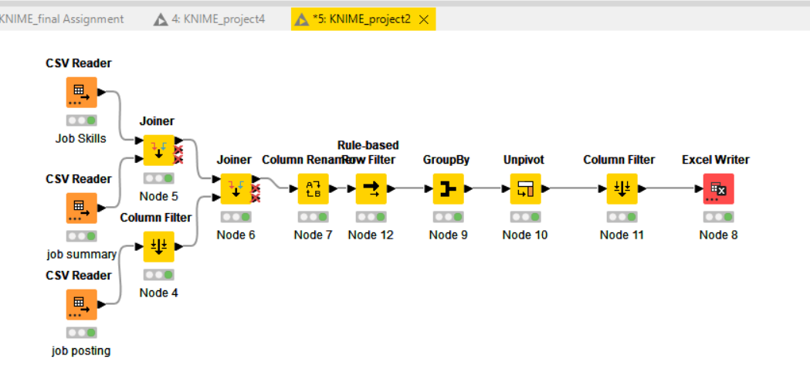

**Step-1: Combining – Joiner node**

Initially I uploaded three datasets which are Job skills, Job summary and job posting and for first two data set I used joiner to combine the datasets. Here is the join result.

Figure-2: Data integration

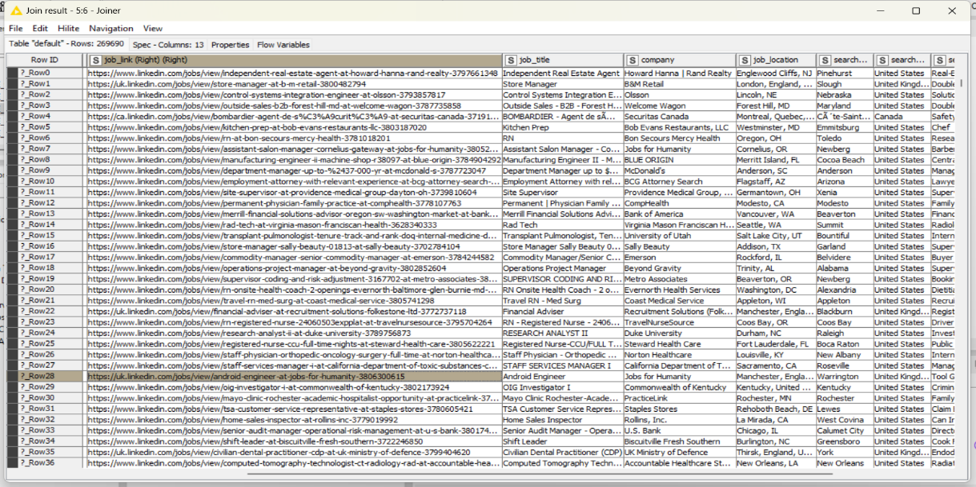

**Step-2: Column Filter for redundancy**:

For third dataset (Job posting). I used column filter to reduce the unnecessary columns.

Figure-3: Column filter

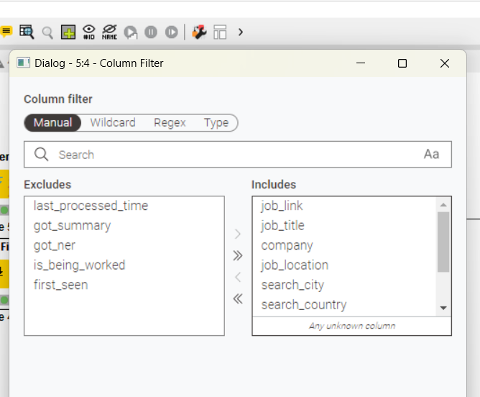

**Step-3: Column Rename to replace the column name**

The Column Rename node standardizes column names across a dataset, ensuring clarity, consistency, and alignment with analysis goals, thereby simplifying downstream processes and enhancing data interpretation. For example: I renamed some of the variable’s job_title to “Job Title”, job_link to “Job Link”, Job_ Skills to “Job Skills” and others.

Figure-4: Column rename

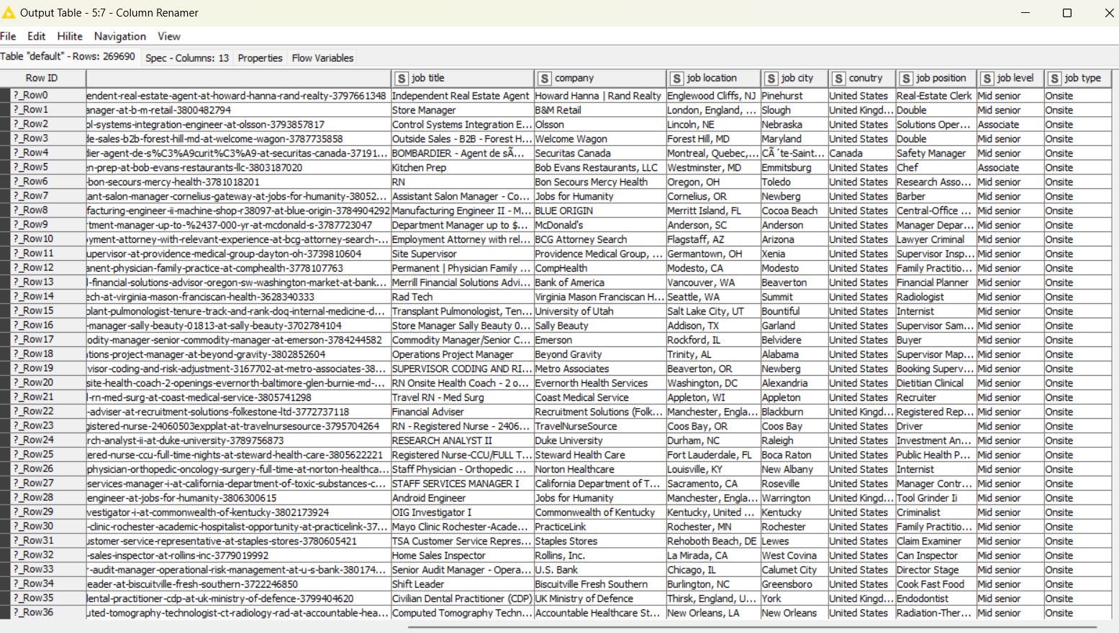

**Step-4: Rule based filter**:

I used Rule-Based Filter node to filter out unwanted rows based on specific rules, excluding irrelevant ones for analysis. It allows for specific criteria, like job listings from a specific country or level. I applied my own criteria and wanted to filter data set in which having business analyst job title.

Figure-5: Rule based filter

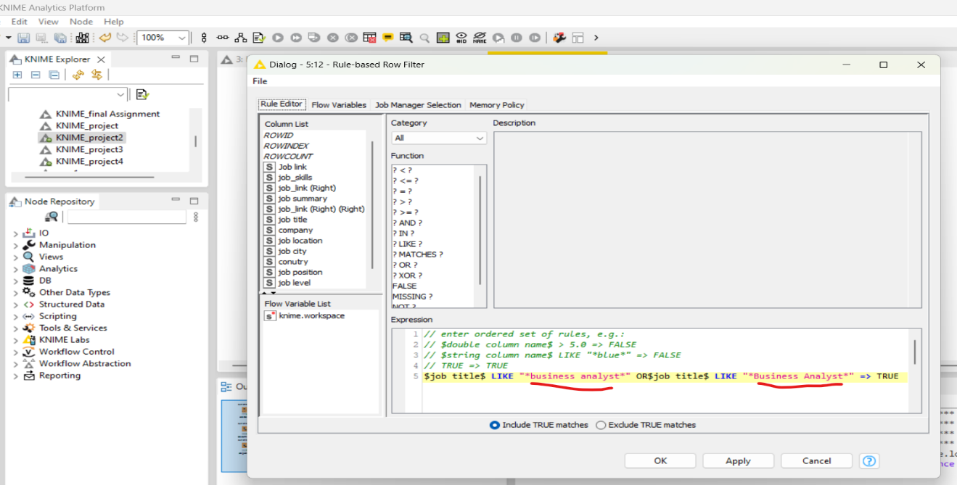

**Step-5- Group By, Unpivot and column filter**

Then, I used Group By node to aggregate data based on specific columns, reducing redundancy and duplicate records, and creating summaries for metrics like job title or country listings.

The Unpivot node converted columns into rows, aiding in data restructuring and analysis. It's useful for rearranging multiple attributes in separate columns, like skill distributions in a job skills dataset.

**Final data set**

After filtration, the dataset is completely clean to work on modelling. Here is the final outlook of the data set

Figure-6: Final dataset

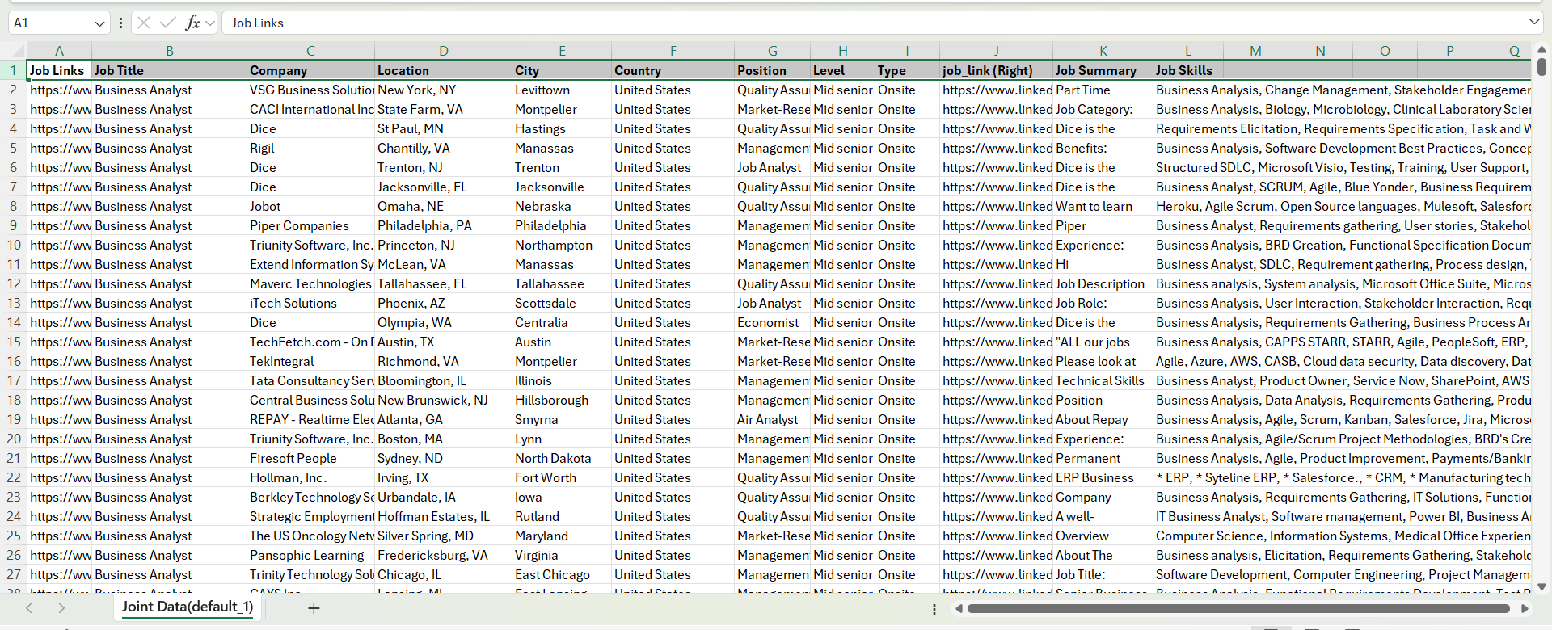

**Model Build Up**

**Model Selection**

For this project, I chose K-means clustering because this tool that can identify hidden patterns (Govender & Sivakumar, 2020), segment data (Vijay Kumar Trivedi et al., 2022), grouping (Abdullah et al., 2021), detect anomalies (Pu et al., 2021), and improve feature relevance (Pu et al., 2021). It helps identify common job market trends, segment data into meaningful groups, detect outliers, and ensures consistency within clusters. It also minimizes within-cluster variance, highlighting the most relevant attributes each job cluster. This comprehensive analysis provides actionable insights into skills, locations, and job types that shape the employment landscape.

**Metric selection**

For this project, I have decided my scope of analysis. The main job market is United States and Job title is Business Analyst and jobs skills are the major areas to play with modelling techniques. Metrics are to explore from this analysis are given below

* Clustering of related skills/ skills segmentation based on priori algorithm
* Find out relationship between Job skills and other variables (Job level, types)

**Tools for Analysis**

For Analysis, I have tried three different tools (stata, spss, smart pls) which has some restriction on nominal dataset and conversion and finally fit the model using KNIME Analytics platform for finalization which is easier than other tools to use and convert the data set.

**Data Conversion & Model Fit**

For applying this modelling technique (K-Means), I need to convert the data from nominal value to numeric. I applied some techniques such as cell splitter for job skills variable which a complete nominal data and only separated by comma in a row which was not useful for this modelling. With the help of *cell splitter*, I spited all the skills into column and in total I got 79 separate columns and used column rename node to name them as skill1, skill 2 and skill79. Then I wanted to count the frequency of repeated skills such as business analysis/ Business Analysis counting as same skills. I set the *rule engine* node to count and applied numbers to each of common skills sets. After applying rule engine, I found “predictive skills” column to analyse.

My dummy numbers applied to rule engine:

Table-7: Cluster category based on Skillset

|  |  |  |
| --- | --- | --- |
| Skills | Name of Skills | Dummy number |
| Skill-1= Cluster-0 | Business Analysis/ business analysis related skills | 1 |
| Skill-2: Cluster 1 | Requirement Gathering/ requirement gathering/ requirement specification/requirement engineering and related and Data analysis/ data visualization/data presentation/data tools/ data techniques and other data related skills | 2 |
| Skills-3= Cluster-2 | Communication/ presentation/ contacting stakeholders/ client engagement/ customer call/ customer facing and others, Project Management/ project management/ agile/ scrum/ ITIL and related skills | 3 |

For converting other variables such as Country [1 for U.S AND 2= other country], level [Associate=2,Mid senior=1],job type [1= onsite, 2=others] I applied category to number nodes and converted them into numerical value. Here is the output table

Figure-7: Output table



The next challenge is having missing values because for applying rule engines, many of the columns showing question mark (?) because of non-identification of skills which was not mentioned in the rule engine algorithm and detecting missing value. K-means clustering unable to generate output if any missing columns are there. Then I applied *group by node, missing value node and column filter* to replace the missing value with dummy zero (0), so that every missing column replaced with 0 as a string value. In total, 20 rows have some sort of missing value and replaced with dummy zero. Here is the out put table.

Figure -8: Missing Value replacement



Now, dataset is completely ready for K-means clustering. Then I applied *K means node, color manager, shape manager and some model evaluating techniques (Numeric scorers, Cronbach alpha, Numeric distance and simple correlation)* to understand the how strong association exists in the cluster and applied some visualization techniques (scatter plot, histogram, sunburst diagram) to see the cluster. Here is the overall Knime workflow I work with to fit modelling techniques.

Figure-9: Model Building



**Model Visualization**

To visualize the model, I have selected the scatter plot to show the cluster of skill distribution to each category based on job title (Business Analyst). We know each cluster has their own skill category and showing the presence in the scatterplot as cluster 0 (Green dots), Cluster 1( red dots), cluster 2(orange dots) and the left dots are other skills categories which is not covered under analysis.

Figure-10: Scatter plot



Sunburst Chart

If we consider diagram 5 &6, we can the variation of all the skills in the dataset is visualized in the sunburst chart which is complicated to understand, but in case we develop the cluster chart, we can see the specific skill sets are merged into different cluster category and showing strong presence in the 2nd diagram.

Figure-11: Sunburst Chart



In cluster (2) = all the business analysis related skills which are mention in table -3 has the strong dominance in achieving business analyst position and then cluster (0) and then cluster (1). Go back to table 3 to read skills category.

**Histogram to check normalization**

In this diagram, to check the data normalization, I have developed histogram keeping consistent prediction skills (Blue bin) as a constant value in the x axis and in the y axis I made the trial of other variables (Job title, Job level, job type, country) comparing to predictive skills variables. Only 4th image is showing normal distribution and supports job title and job skills are closely related and three of skills category is highly relevant to business analyst role. In other image (1st ) job type and skills are related but not showing depends on seniority and juniority or onsite/ offsite or country focus. All other histograms are left skewed.

Figure-12: Histogram



.

**Model Specification**

## K -means Clustering Model Specification

We applied k means clustering which is also a Apriori algorithm to identify frequent skill weight with respect to our scope of Business Analyst Role in the United States. The k means calculates the following metrics:-

**Cluster centroids**: K-means clustering uses a centroid as the center of each cluster, representing the average position of all points within the cluster across all dimensions.

**Inertia:** Inertia measures cluster compactness by calculating squared distances between data points and their cluster's centroid. Lower inertia indicates more compact clusters, while k-means algorithm aims to minimize inertia to enhance clustering quality.

**Distance/ numeric scores**: Euclidean distance, a measure of the straight-line distance between two points in multi-dimensional space, is frequently utilized in k-means clustering to determine the distance between each point and the cluster centroids.

## Model Specific Controls

To get the expected outcome of the k-means, I set specific controls to get specific response from application. I set 3 clusters based on five specific skill categories, hillite mapping and random initialization and number of iteration 20.

Figure-12: Model Specific controls



Figure 1- Table K-means specification

In case of adjustment, I have the plan to change the number of iterations and check how cluster changes and adjusting as per model specification.

### APPENDIX G.4 | Results and Findings

After all the refinement of the data, I found the k-means result and relevant result to analyse the skills distribution/ segmentation along using supporting metrics. The output table is given below showing the 3 model clusters.

Figure-13: K-means Cluster



Figure 3 – K-means Results

**Cluster centroids**

The table displays the centroids for each cluster (cluster_0, cluster_1, cluster_2) based on attributes like Job Title, Country, Level, and Type based on predictive skills. For instance, cluster_0's Job Title and prediction skills value of 1.167 indicates potential association with specific job titles and cluster (o) category skills. Cluster 0 represents a mid-level hierarchy with uniform job titles and lower levels, suggesting senior or managerial roles. Cluster 1 includes broader roles with higher job titles and lower levels, possibly representing junior roles across diverse job functions. Cluster 2 displays a balance between job titles and level attributes, suggesting roles with moderate job functions and mid-level responsibilities.

## Labelled output

Figure-14: labelled input used for iterations.



## Eludician Distance measurement

For this, analysis, I have measured distance which is showing greater than one (>1) means which means moderate distance (not so high/ not so low) exist between variable and centre value. The ideal Euclidean distance for clustering is based on the distance between clusters, with smaller distances indicating more cohesive clusters and larger distances indicating better separation. Our model results better separation.

Figure-15: Elucidian distance measurements



And the output table of distance measurement



Model Evaluation

For model evaluation, I selected numeric scorers to explain the clusters, Cronbach alpha to understand the overall model reliability fitness and correlation analysis to understand the validity of the relationship between variables.

1. Cronbach Alpha for internal consistency check: Cronbach's Alpha measures the correlation between variables within a group, with higher values indicating better internal consistency. It ranges from 0 to 1, with values above 0.7 indicating good internal consistency and 0.618 indicating moderate consiststency

Table-9: Cronbach Alpha

|  |  |
| --- | --- |
| Cronbach Alpha | Value |
|  | 0.618 |

1. Numeric score

Table-11: Numeric Scores



Form this numeric score, we can say the value of adjust r-square is 0.578, means this model explain 57.8% of the overall data and model moderately fit with its clustering value.

## Resulting Model

The resulting model used the K- means and their relevant metrics to analyse and identify the top three clusters based on the skills category for business analyst job. In conclusion, the following findings can be drawn from the overall analysis

* **Primary Skill - Business Analysis** related skills which is the most crucial for these types of job.
* **Supporting skills**: Requirements gather/ requirement engineering which supports the job, more subjective knowledge and expertise.
* **Human skills**: Communication skills category skills are really important to handle the job in any situation.

### APPENDIX G.5 | Interpretations

## After analysing the key skill categories based on the cluster (0) , cluster(1) and Cluster (2) valuable for business analyst job now a days. In these section, we interpret the major insights derived from the analysis.

## Key Insights from the Analysis

**Segmentation by Job Hierarchy**: The clustering has effectively segmented the dataset based on job hierarchy, particularly evident in the Level feature. Cluster 0 is characterized by more senior roles, Cluster 1 by entry-level positions, and Cluster 2 by mid-level positions. This segmentation can aid in tailoring hiring, training, and development strategies for employees at different hierarchical levels.

**Consistency Across Location and Type**: The uniformity in Country and Type suggests that the dataset primarily focuses on a single region or type of employment, reducing the need to consider location-specific or contract-specific factors in further analysis.

**Job Title Variety in Clusters**: The variation in Job Title values among clusters indicates diversity in job functions within the organization. This information could be valuable in identifying role-specific training needs or for workforce planning, particularly in creating specialized career paths for employees in diverse job categories.

### APPENDIX G.6 | Strengths, Weaknesses and Improvements of Model

## Strengths, Weaknesses and Improvements of Model

### Strengths:

K-means is a simple, efficient, and fast clustering algorithm that is suitable for analyzing extensive job-related data. Its scalability allows it to handle large datasets, allowing for faster clustering. The algorithm's clear centroids make it easy to interpret results, and it can handle various types of numerical data and distance metrics, primarily using Euclidean distance.

### Weaknesses:

K-means is a clustering algorithm that has several limitations, including difficulty in defining the number of clusters (K), sensitivity to initialization, assumption of spherical clusters, sensitivity to outliers, and limitations with categorical data. Its effectiveness diminishes with nominal or ordinal categorical data without appropriate preprocessing, and its results may vary based on initial placement of centroids.

### Possible Improvements

To optimize K-means clustering, use techniques like elbow method, silhouette score, or cross-validation. Enhance initialization with K-means++ to reduce sensitivity. Standardize data for equal contribution to distance calculations. Handle outliers by detecting and removing them. Explore hybrid approaches like K-means with hierarchical clustering or density-based methods. Evaluate clustering quality using metrics like inertia, silhouette score, or Davies-Bouldin index. After initial clustering, analyze results and refine clusters based on domain knowledge or additional features for improved insights.

### APPENDIX G.7 Recommendations

## Implications for Job Seekers

Prospective job applicants/ seekers can focus on developing specific set of skills and combining the skills such as business analysis and requirement gathering or project management and business analysis. Last not least communication skills are common in case of achieving job goal.

## Implications for Employers

Employers should prioritize candidates with technical, managerial, and soft skills, focusing on Business Analysis and Project Management. Skill-based hiring can improve the match between job seekers' qualifications and company expectations, especially in competitive markets, by adjusting job postings.

### APPENDIX G.8 | Final Thoughts

My analysis highlights that employers seek a blend of core business analysis skills, subjective expertise (requirement gathering), and strong communication for Business Analysts. They must lead, communicate, and drive projects forward in a dynamic work environment. As businesses adapt to modern challenges, versatile candidates with technical, managerial, and interpersonal skills are essential for success.

## APPENDIX H | Trung Hieu Huynh

### Appendix H.1 | Analysis – Logistic regression

Data Collection and Preparation

Before conducting the analysis report, I reviewed the three datasets downloaded from Kaggle website and found that there were numerous columns that needed to be removed in dataset “linkedin_job_postings.csv”.

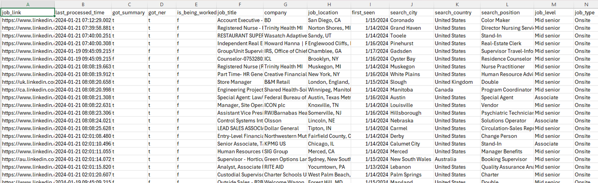

Figure 1 - The original data from linkedin_job_postings.csv

Therefore, I performed data cleaning immediately with Excel application to have a tidy dataset as per below.

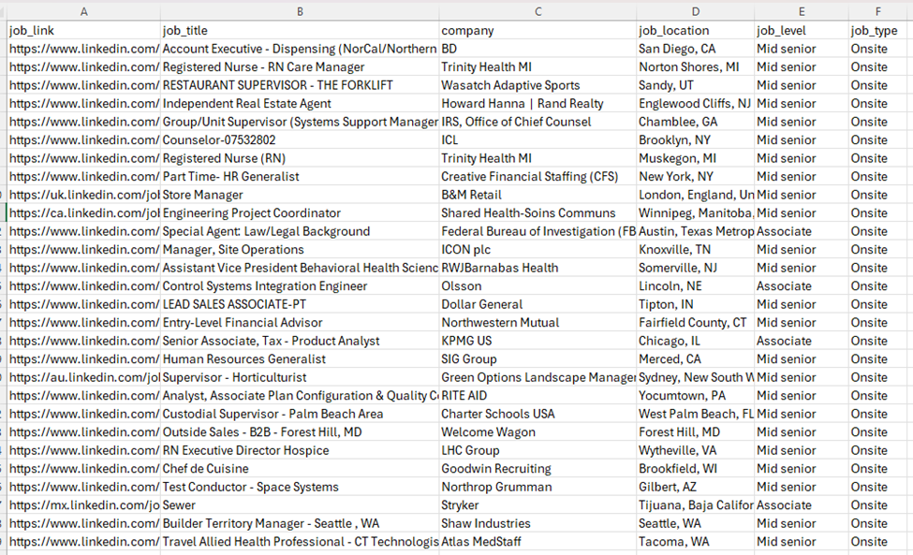

Figure 2 - Dataset "linkedin_job_postings.csv" after removing redundant columns.

The next step is merging three datasets into one dataset to analyze that information efficiently, it was done by using Knime application. The primary key to merging three datasets was the “Job_link” column, which is the destination webpage for the hiring job.

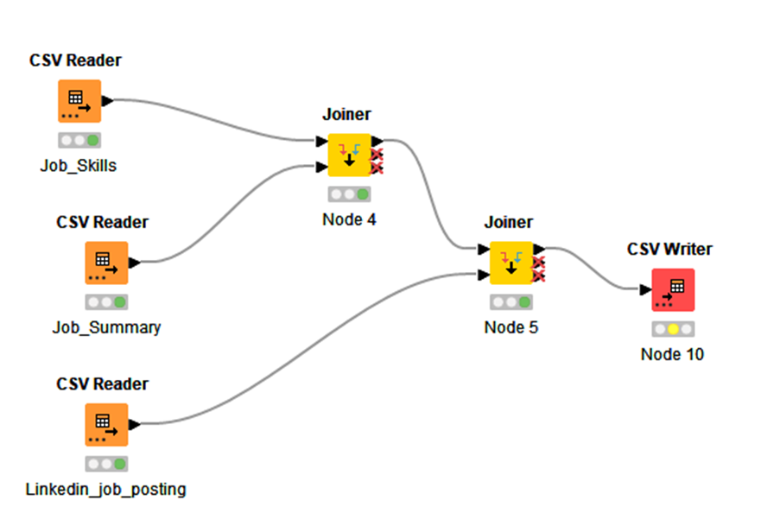

Figure 3 – Workflow in Knime showing three datasets is merged into one final dataset.

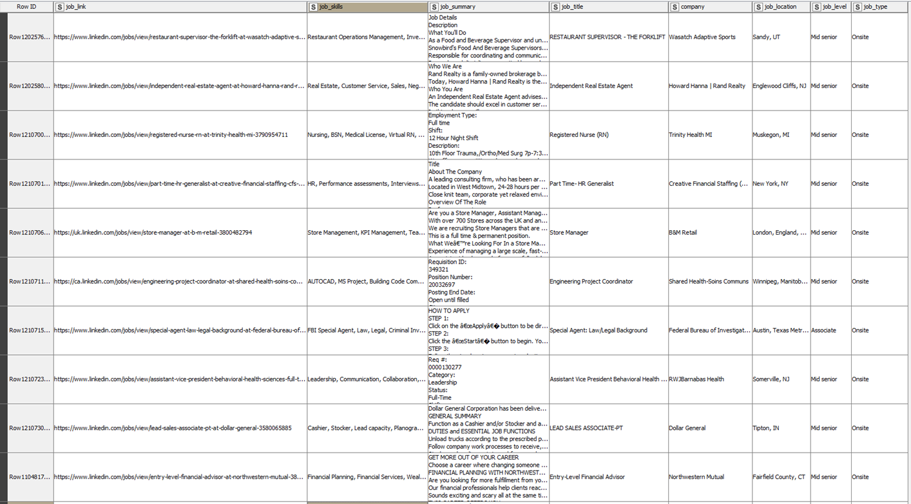

Figure 4 - The columns of the merged dataset in Knime

Since the merged dataset contains no statistics, I find that it will be suitable for working with classification model instead of other models. And I prefer to use logistic regression for my task to find which skills require for business analyst job.

**Building logistic regression with Python**

From now on, the merged dataset will be processed by Python application to build logistic model. Initially as per figure, the dataset contains 1013010 rows and 8 columns which is huge and unnecessary for building models.

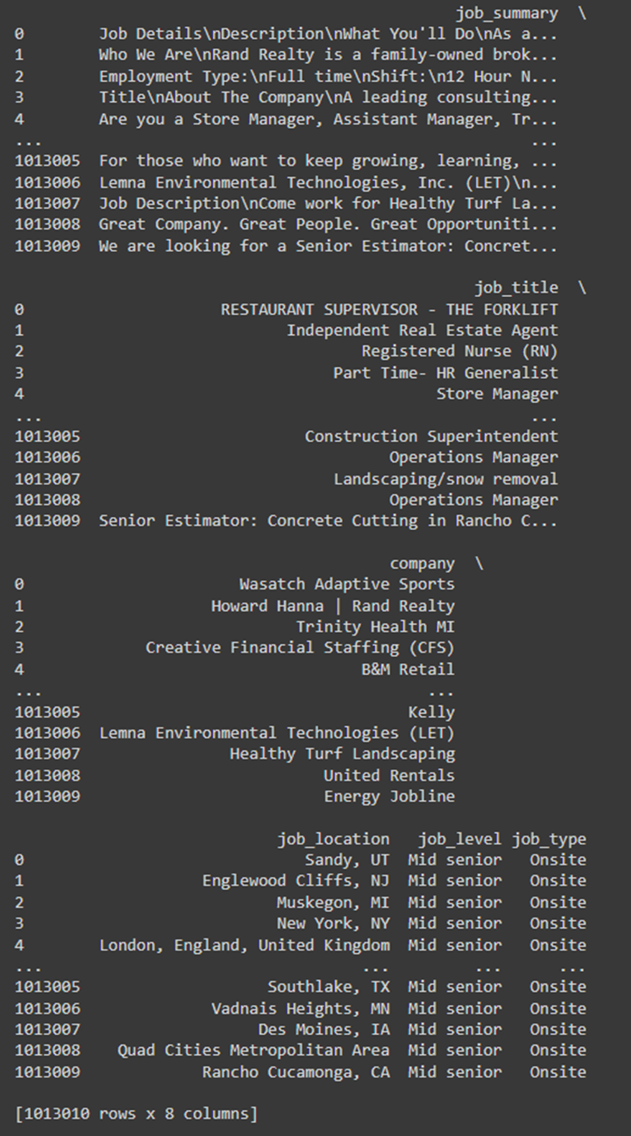

Figure 5 - the total rows of merged dataset in Python environment.

**Engineered features**

I have created a new column named “is_BA” and identify it as a binary target variable to check the value of “Job_title” column. If there is “business” or “analyst” in a cell of “Job_title” column, it will be marked as “1” in same row in “is_BA” column or else it will be marked as “0”.

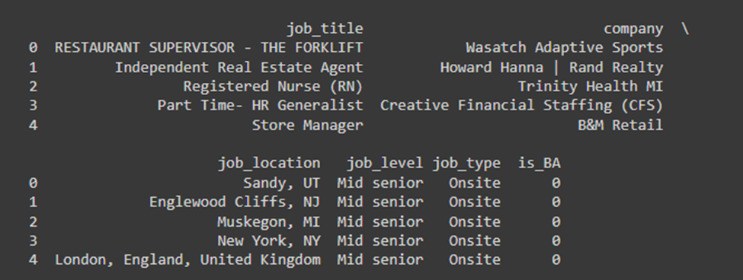

Figure 6 - the first five rows showing the result of Is_BA column

The next step is counting the total number of each category “Is_BA” to see how many “1” or “0” is in the dataset. And the result is 974721 records for 0 while it is 38289 records for 1.

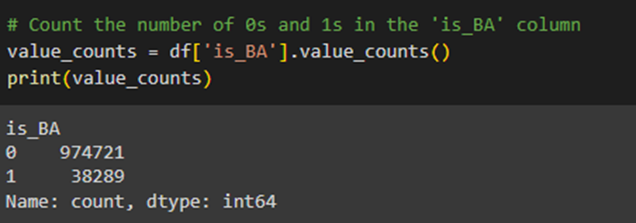

Figure 7 - The result of checking dataset for Is_BA column

The majority cell of “Job_title” is categorized as “0” and they will affect the result of modelling if we use them to run logistic regression, therefore, I removed them from the dataset and only kept around 30000 records.

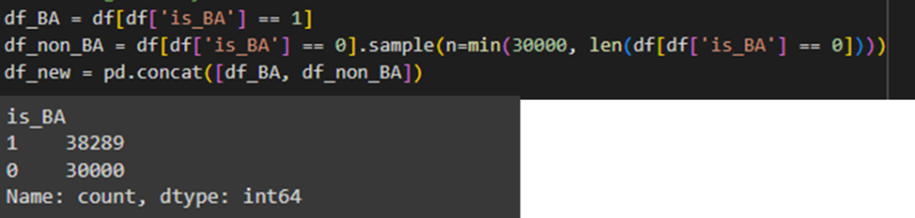

Figure 8 - After removing irrelevant rows, dataset has 38289 rows related to "business" or "analyst" in Job_title and 30000 rows not related to "business analyst" in Job_title.

Based on preliminary exploration from the previous report, we knew the top required skills for business analyst job, therefore, I created seven columns for skills such as “communication, analytical, management, teamwork, leadership, visualization, SQL, and Python”. Then I will extract and count how many times the employers require in their hiring posts.

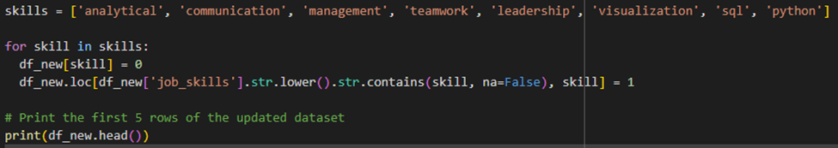

Figure 9 - Creating new seven columns for skills

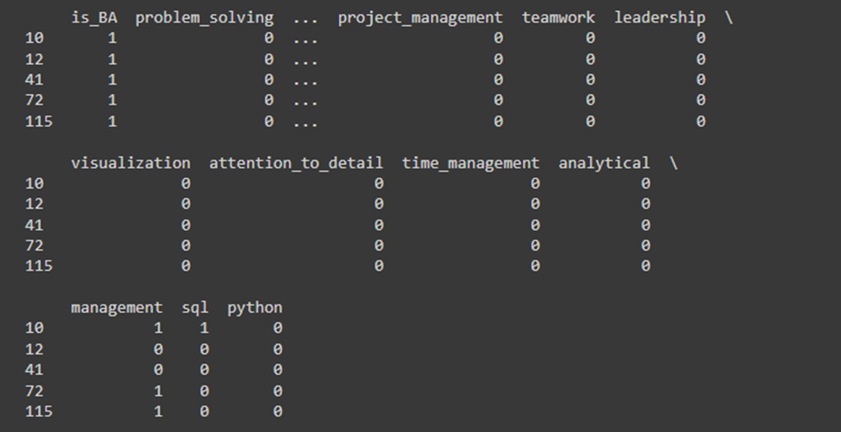

Figure 10 - The outlook of dataset with additional columns.

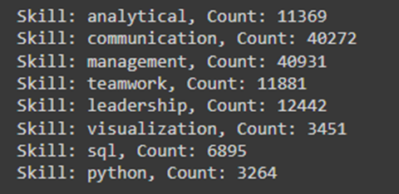

Figure 11 - After counting the skills required for each hiring job.

Now we have enough information required to run logistic regression model to get insights from the dataset, and the dataset will be divided into eighty percent for training and twenty percent for testing.

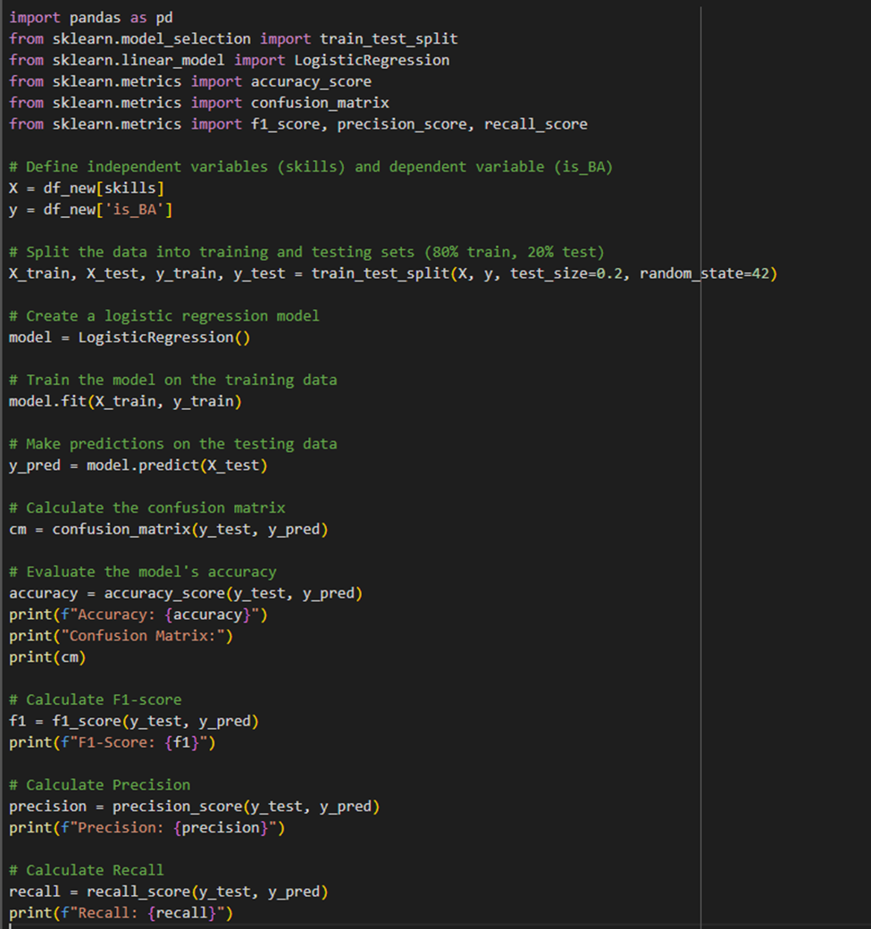

Logistic Regression (or Logit Model) is a popular used statistical for binary classification tasks, where the goal is to predict one of two possible outcomes (e.g., yes/no, true/false) (Easter H and Hemming K, 2021). It is also a strong technique for measuring the relative relevance of factors that influence outcome (Pal, 2021). Logistic regression can help do a quite range of mission such as analyzing customer data to identify factors that influence purchasing decisions, weather forecasting for special events, and identifying the risk in financial services like loan defaults or fraudulent transactions (Resonio, n.d)

Logistic regression is different from linear regression as the latter utilizes continuous variables for its targets, while logistics regression focuses on a binary value or categories. And there are three types of logistic regression: binary, multinomial, and ordinal (Ramakrishnan, 2024).

Binary: Predicts the relationship between a binary dependent variable (e.g., success/failure, yes/no) and an independent variable.

Multinomial: Analyzes a dependent variable with two or more discrete outcomes (e.g., predicting the most popular transport type: train, bus, car, bike).

Ordinal: Examines a dependent variable with a meaningful order and two or more categories (e.g., shirt size: S/M/L/XL or poll options: Agree/Disagree/Neutral).

Logistic regression will determine the job title, whether a business analyst is or not, based on the required skills in hiring advertisements.

### Appendix H.2 | Evaluation metrics

The result of logistic regression modelling achieved a prominent statistic.

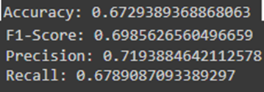

Figure 16 - The result after building up logistic regression model to predict job title is business analyst or not.

Accuracy: 0.6729389368868063 – This indicates that the model predicted correctly around 67.3% of hiring jobs are “business analyst” based on the skills.

F1-Score: 0.6985626560496659 - The F1-Score represents the harmonic average of precision and recall. A score of 0.699 suggests an appropriate mix of precision and recall. However, it also suggests that the model has some trade-offs between precision and recall.

Precision: 0.7193884642112578 - Precision indicates that several of the positive predictions were correct. A precision of 71.94% shows that about 72% of all predictions made by the model that the job title included "Business" or "Analyst" were right. This demonstrates that the model is quite good at minimizing false positives.

Recall: 0.6789087093389297 - Recall measures the proportion of true positive predictions among all actual positives. A recall of 0.679 means that 67.9% of the jobs that actually have “Business” or “Analyst” in the title were correctly identified by the model.

True Negatives: 4015 – It explains that jobs are predicted correctly not to have “Business” or “Analyst” in the title.

False Negatives: 2448 – Some jobs included “business” or “analyst” in the title, but the model failed to predict them.

True Positives: 5176 – These are positions for which the model accurately identified the appearance of "Business" or "Analyst" in the title.

False Positives: 2019 - These are cases where the model erroneously identified the inclusion of "Business" or "Analyst" in the title when it was absent.

Visualizations

Confusion matrix heatmap

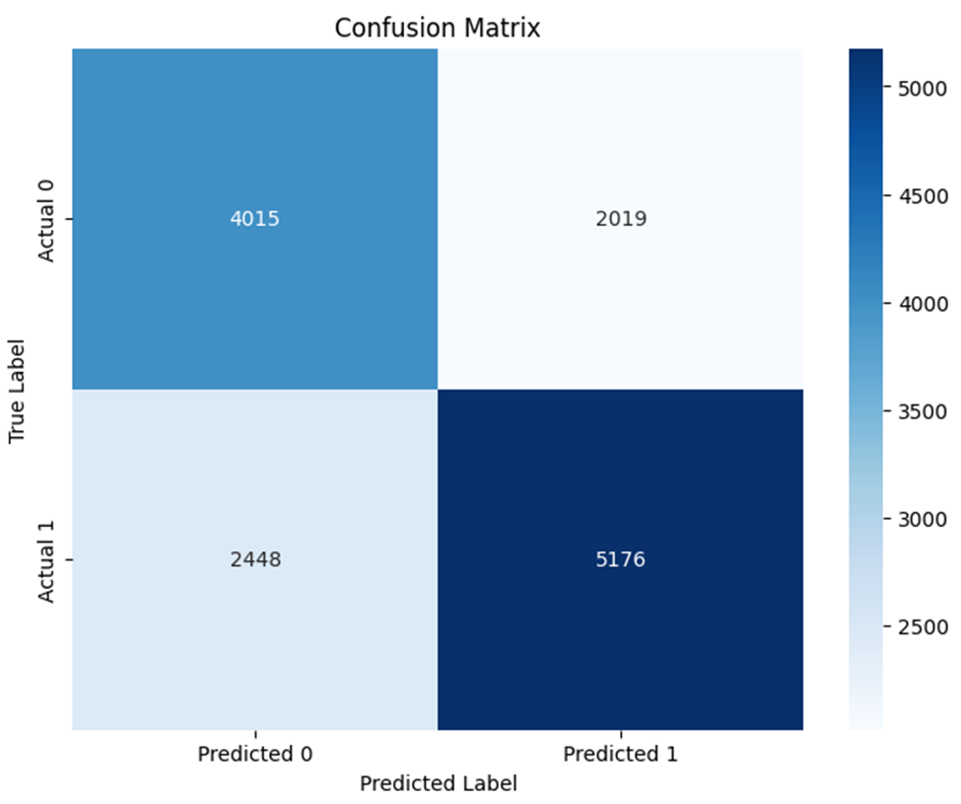

Figure 17 - Confusion matrix reveals notable false positives (2019) and false negatives (2448).

Model performance metrics

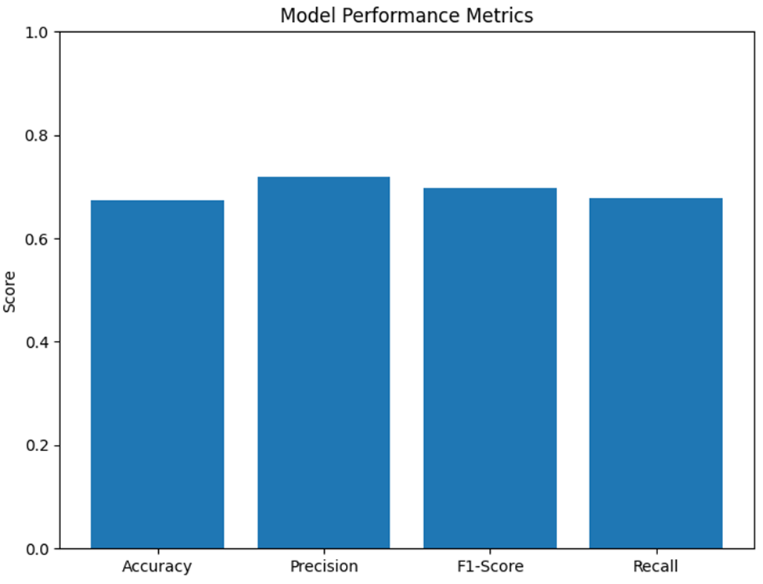

Figure 18 - The logistic regression model demonstrates moderate performance for predicting business analyst roles.

Precision-recall curve

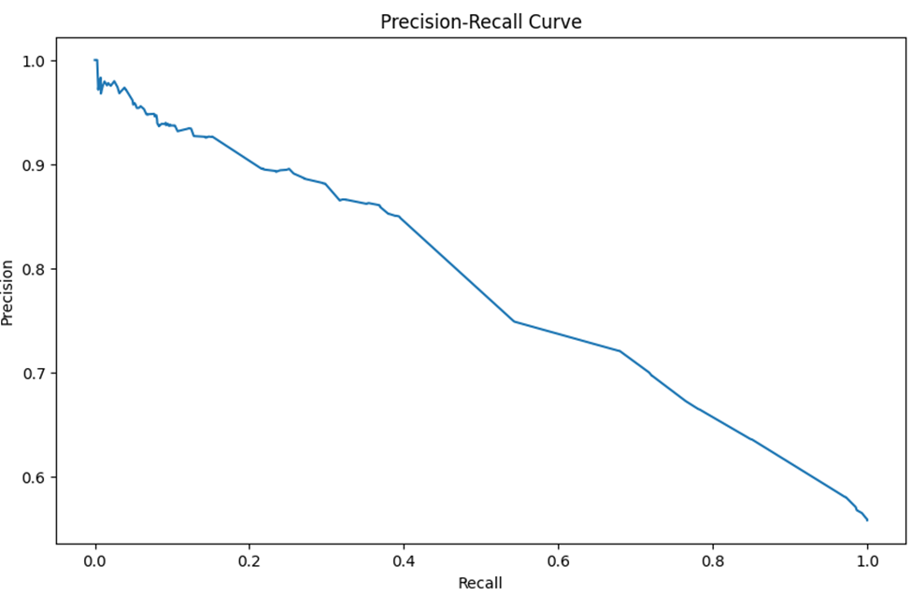

Figure 19 - The graph demonstrates precision-recall outcomes for predicting business analyst job titles.

Skills distribution



Figure 20 - The most demanded skills for hiring business analyst.

### Appendix H.3 | Interpretation of your findings

Summary of findings

The logistic regression model used to predict whether a job title is related to “Business analyst” achieved an accuracy of 67.29%. The F1-score of 69.86% indicates that a balanced performance between precision and recall, through there is room for improvement. The model’s precision of 71.94% shows that, out of the jobs it predicted as related to “Business Analyst”, about 72% were correctly identified. The recall of 67.89% presents that the model captured approximately 68% of the actual business analyst jobs but missed some, as indicated by the false negatives. The confusion matrix shows a significant number of false positives (2019) and false negatives (2448), suggesting that while the model can correctly identify relevant job titles, it may be slightly conservative in its predictions or missing nuanced patterns within the job skills and titles.

The logistic regression model has a reasonable foundation but there are rooms for improvement to reduce false positives and false negatives, also balance the model’s precision and recall being more reliable predictions.

The advantages and disadvantages of logistic Regression model

Advantages of logistic regression.

It is widely used and well-suited for binary classification tasks, providing a clear decision boundary. It is also a good choice for small and moderate sized datasets which do not require powerful computing to run, make it efficient.

Logistic regression is quite simple and easy to interpret. It outputs probabilities, making it straightforward to understand the effect of predictors on the outcome.

Disadvantages of logistic regression.

Logistic regression may struggle in circumstances when the number of features exceeds the number of observations, as it can overfit without proper regularization.

While logistic regression can be extended to multiclass classification using techniques like one-vs-all (OvA) or SoftMax (multinomial logistic regression), other algorithms might perform better in multiclass scenarios such as decision tree, random forests.

Finally, logistic regression assumes a linear relationship between the predictors and the log-odds of the outcome. It may perform poorly if the true relationship is non-linear or complex.

Recommendations

With the limitation of the dataset and the confusion matrix show notable false positives and false negatives, demonstrating that the algorithm may not always accurately differentiate between business analyst roles and non-relevant job titles.

**Some recommendations to improve the prediction such as:**

Search more keywords: Instead of searching for “business” or “analyst”, we can consider expanding the keyword list to include common variations, like “Data Analyst”, “Business Intelligence”, or “BA”. It could improve recall by capturing more relevant job titles.

Leverage job summary: Apply natural language processing (NLP) techniques on the job summary field as it may contains valuable information about the role. It can help the model capture patterns specific to business analyst roles.

Advice to employers

Figure 3 is the result from logistic regression model showing that technical skills are not really required on the market. A business analyst is a bridge between the business side and the technical or data teams. They translate business ideas into actionable plans or insights that technical team can work on that, therefore, they are more like “interpreters” who make data and business needs understandable for everyone.

While technical skills in modelling are valuable, they are not the core requirement for a business analyst. The more important skills are analytical thinking, problem-solving, project management and strong communication skills.

Analytical thinking and problem-solving skills are mandatory for them to work with business and walk with them through their trouble to identify the root cause and define the proper solutions for technical teams to proceed.

Besides that, strong communication and project management are the major skills that most hiring managers looking for. Business analysts will work in different projects to support business and their company, or with different clients if they are service providers for business analysis. They must be ready to be members of project management team or know how-to work in the project within project timeframe to deliver the goals.

Furthermore, it is impossible to work well in business analysis area without effective communication. As a business analyst, they will interact with different people from different background and knowledge in projects, and any misleading from conversation will get bad results.



Figure 21 - One hiring position requires Project management, analysis, and communication skill.

From one of hiring post on Seek platform, those skills are required by employer (Odoo, 2024)

Based on those findings, employers should focus on improve their employees in these skills by sending them to the training courses or focusing on these skills if they are hiring for business analyst staff.